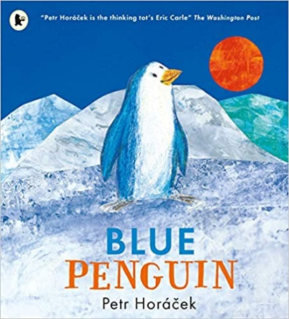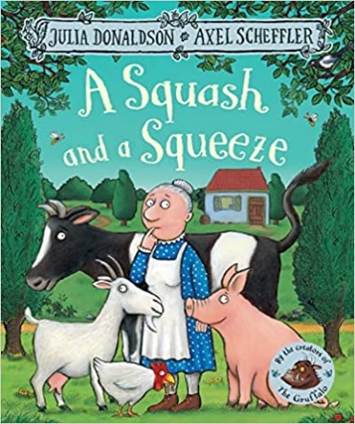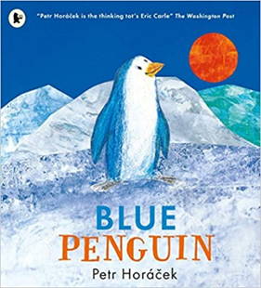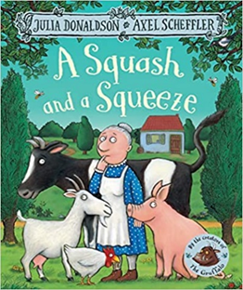

Maths

Children will be continuing learning they began in FS1. They will be representing and comparing numbers 1, 2 and 3. They will be matching and sorting items and comparing different amounts, extending their mathematical language. Children will continue to learn number songs and nursery rhymes to support their learning in Maths.

Expressive Arts and Design

The craft area will be set up with materials to encourage children make their very own homes. They will also make representations of places they can visit in their local area such as The Pier and the Grimsby Town Football Club.

Key Questions

1. What do you live in?
2. Do you know the name of your street?
3. Can you tell me a place you have visited?
4. Does the Blue Penguin live in a house?
5. What is different?

Parent Map Foundation Stage

Enquiry Question: What buildings can we see that are mega in size?

Understanding the World

Children will be given chance to learnt about different types of homes and will be asked to make comparisons between them. They will look at places to visit in their local area particularly local buildings that they have visited or would like to visit in the future. Children will compare different climates.

P.E

Children will be learning how to balance and control their bodies. They will use apparatus such as mats, beanbags and hoops.

Literacy

We will be reading the books A Squash and a Squeeze and the Blue Penguin. Children will learn new vocabulary whilst exploring the story and the knowledge extracted from the text.

Children will begin to bring home a reading book that links with of Phonics Programme Monster Phonics. They will be required to say the sound of the graphemes they have learnt.

Communication and Language

As always, learning areas within the classroom will be designed to encourage children to talk to each other and ask questions. Teaching staff will model and introduce new vocabulary to children. During the Megastructure topic children will be encouraged to talk about their homes.

Please send any photos to Tapestry!

PSED

Children we be settling back into the daily school routine to build their independence up. Children will begin to make new friends and be given time to talk about their experiences with adults and peers. Teaching staff will be getting know children and will build up relationships with them.