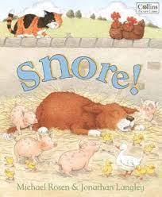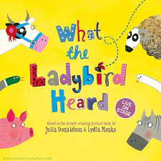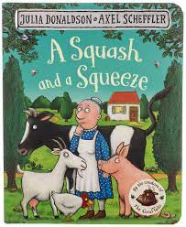

Maths

Children will be concentrating on learning the days of the week. We will also look at describing the weather each day. Children are beginning to learn how to touch count accurately and will be introduced to some of the numerals.

Expressive Arts and Design

Children will be encouraged to use their mark making skills to start to draw more detailed pictures of animals and farm vehicles. We will be completing a Friday drawing lesson focusing on a step by step guide to simple drawings.

Literacy

We will be reading the books A Squash and a Squeeze, What the Ladybird Heard and Snore!.

Children will become familiar with one of these stories and be able to talk about the story using the pictures.

Children are beginning to look at how to form some of the letters in their name.

PSED

Children will be helped to share and take turns when playing and talking as a group.

Children will be encouraged to be independent at school, we will support them in learning to get ready for outside play.

Understanding the World

Children will be looking at what happens on a farm through the season. We will talk about what animals and crops would be on a farm and how these contribute to our food. Children will look at the jobs a farmer does to look after a farm.

Physical Development

Children will be taking part in lots of active play. They will be encouraged to use skills to help them climb and balance.

Wake up Shake up, Dough Disco and Squiggle Wiggle will support and develop Gross and Fine Motor skills.

Key Questions

1. Can you name 5 animals you would see on the farm?
2. Can you talk about 3 things you would see a farmer do?
3. Can you tell me 3 foods that come from a farm?
4. What does a farm look like, can you talk about 3 things you would see on a farm?
5. Can you name any baby animals?

Communication and Language

As always, learning areas within the classroom will be designed to encourage children to talk to each other and ask questions. Teaching staff will model and introduce new vocabulary to children. During the Farm topic children will talk about if they have visited a farm. We will also use play to discover what you might see on a farm.

Please send any photos to Tapestry!

Parent Map Foundation Stage

Enquiry Question: What would you see down on the farm?