Maths

In maths we will be recognising, representing, sorting and composing numbers 1, 2 and 3. We will begin to learn to subitise numbers and match numerals to quantity.

We will also learn about 2D shapes and their properties and begin to use shapes to make pictures. Children will develop their positional language.

P.E

Children will be learning to move in lots of different ways. Children will be taught about how the changes to their body when they exercise.

Expressive Arts and Design

The craft area will be set up with materials to encourage children to discuss and recreate a camouflage print. They will make poppies, war medals to reinforce learning and vocabulary. Children will have an opportunity to dress up as characters from the Nativity story and retell the story in a role play area. Children will make Christmas cards and be taught how to weave. Children will take part in The Big Sing joining with other schools virtually.

cards

PSED

Children will discuss what it might feel like to be a soldier. They will discuss bravery and the importance of showing respect and gratitude to the soldiers and their families.

Understanding the World

Children will be taught the importance of Remembrance Day and how to show respect to others. They will also learn about the Hindu celebration of Diwali. They will discuss safety aspects around firework night and talk about family events such as Halloween. Children will learn about the Nativity story and share the experiences on how they celebrate Christmas.

Literacy

We will be reading the books My Mummy is a soldier.

Children will be segmenting and blending different words. This will be sent home in their homework along with a guide.

Children will be taught how to sing the alphabet and be introduced to new nursery rhymes.

Key Questions

1. Who are we remembering and why?
2. What date is Remembrance Day?
3. How can we show respect?

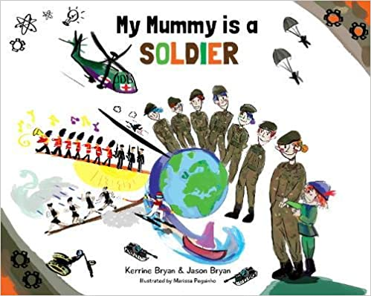

Communication and Language

As always, learning areas within the classroom will be designed to encourage children to talk to each other and ask questions. Teaching staff will model and introduce new vocabulary to children. During the Remembrance topic children will talk about being charitable and showing respect.

Please send any photos to Tapestry!

Parent Map Foundation Stage

Enquiry Question: Why is it important to remember?