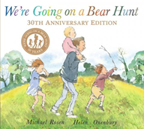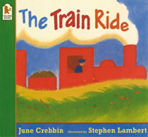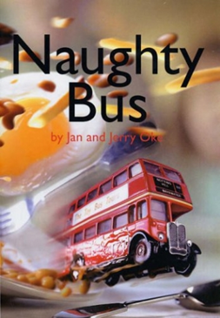

Maths

We will be mastering our knowledge of numbers up to eight, including comparing and composing them. We will also develop our knowledge of addition by combining two groups. We will explore mass, capacity, length and height and develop our mathematical vocabulary in relation to these concepts.

Literacy

We will be reading the books The Train Ride, We’re Going on a Bear Hunt and Naughty Bus.

Children will begin to read a few simple sentences independently and they will be encouraged to write cvc words using the phonetic knowledge they have learnt so far.

Children will be taught how to form lower-case and capital letters correctly.

Expressive Arts and Design

The craft area will be set up with materials to encourage children make their very own aeroplanes. Children will listen to music and be taught to identify the beat of a song. An airport role play area will be set up.

Communication and Language

As always, learning areas within the classroom will be designed to encourage children to talk to each other and ask questions. Teaching staff will model and introduce new vocabulary to children. During the Transport topic children will talk about vehicles they have travelled on and the places they have visited.

Please send any photos to Tapestry!

PSED

Children will discuss different types of feelings and as a group, children will begin to talk about how they could manage their feelings.

Children will be reminded of the 3 Elliston Diamond Rules that they are expected to follow.

Understanding the World

Children will be taking a look at different types of transport and talking about journeys and adventures they have had with their family. They will learn about The Wright Brothers and look at aeroplanes from the past.

Key Questions

1. What is a journey?
2. What vehicles could I ride on?
3. How would people go on a journey in the past?

P.E

Children will be listening to a variety of music tracks, discussing how the music makes them feel and expressing themselves through music. They will Progress towards a more fluent style of moving, with developing control and grace.

Parent Map Foundation Stage

Enquiry Question: Does every journey look the same?