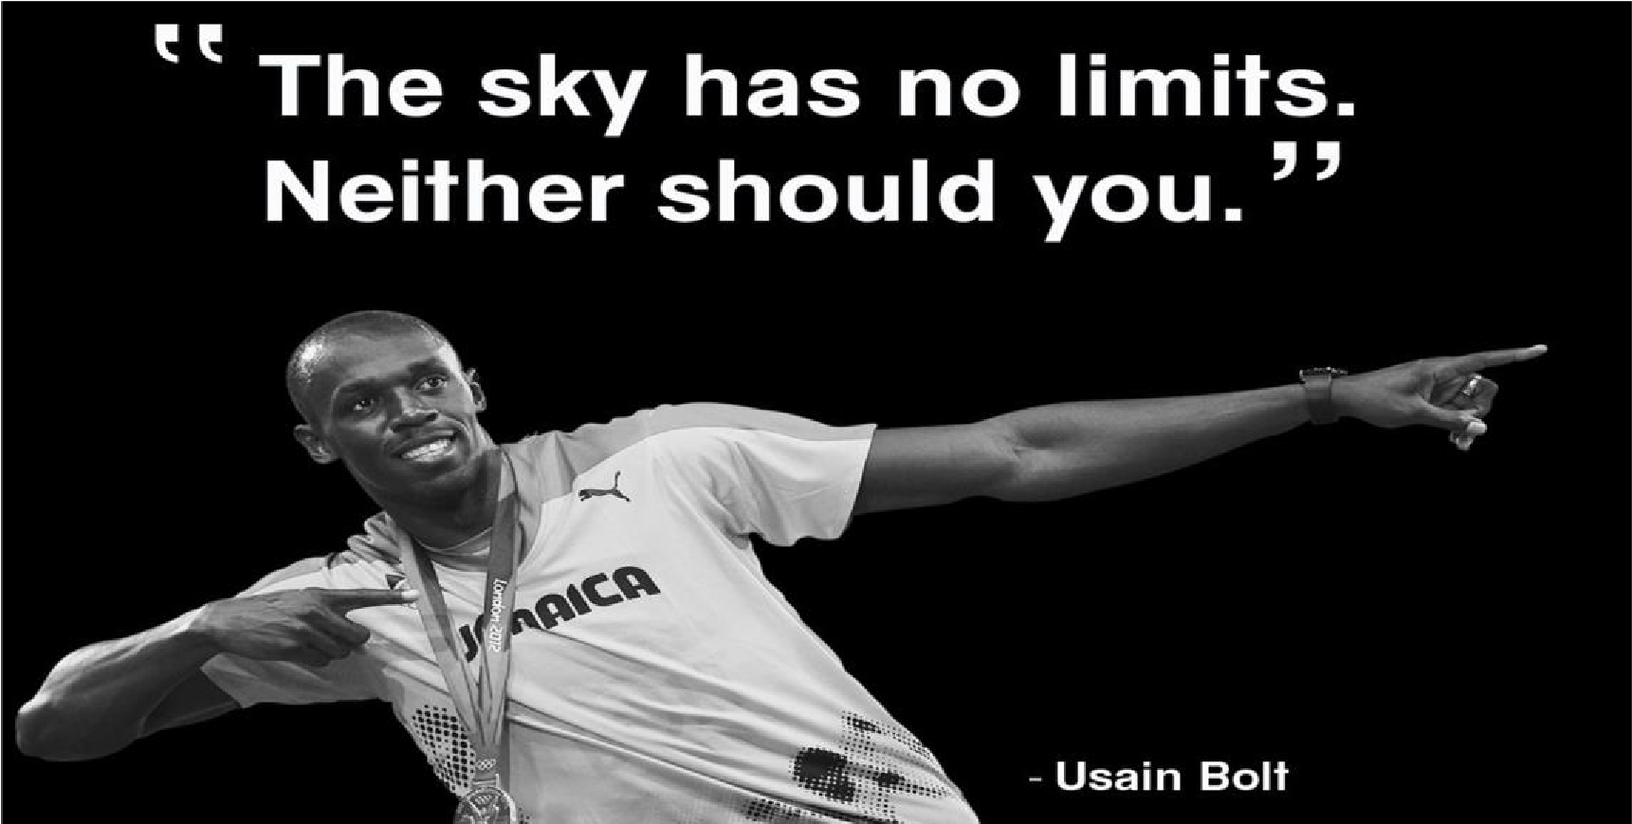
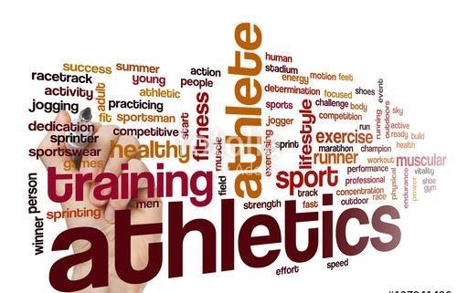

Elliston Primary

PE Progression of Skills and End Points

Progression of Skills

 | EYFS |  | Y1/2 | Y3/4 |  | Y5/6
To develop practical skills in order to participate,  and lead a healthy  lifestyle | Games  - Know how to play games honestly with consideration of the rules.  - Know how to use ball skills with developing competence and accuracy.  - Know how to play co-operatively and take turns with others.  Dance  - Know how to use movement skills with developing strength, balance and co-ordination showing increasing control and grace.  - Know how to combine movements, selecting actions in response to the task.  - Know how to have confidence to try new challenges and perform in  front of others  Gymnastics how to combine movements,  - Know how to demonstrate balance  - Know how to combine movements, selecting actions in response to the task and apparatus  - Know how to use movement  - skills with developing strength, balance and co-ordination showing increasing control and grace.  - Know to have confidence and safely use a range of large and small apparatus. |  | Games  - Use the terms ‘opponent’ and ‘team-mate’.  - Use rolling, hitting, running, jumping, catching and kicking skills in combination.  - Develop tactics.  - Lead others when appropriate.  Dance  - Copy and remember moves and positions.  - Move with careful control and coordination.  - Link two or more actions to perform a sequence.  - Choose movements to communicate a mood, feeling or idea.  Gymnastics  - Copy and remember actions.  - Move with some control and awareness of space.  - Link two or more actions to make a sequence.  - Show contrasts (such as small/tall, straight/ curved and wide/narrow).  - Travel by rolling forwards, backwards and sideways.  - Hold a position whilst balancing on different points of the body.  - Climb safely on equipment.  - Stretch and curl to develop flexibility.  - Jump in a variety of ways and land with increasing control and balance. | Games  - Throw and catch with control and accuracy.  - Strike a ball and field with control.  - Choose appropriate tactics to cause problems for the opposition.  - Follow the rules of the game and play fairly.  - Maintain possession of a ball (with, e.g. feet, a hockey stick or hands).  - Pass to team mates at appropriate times.  - Lead others and act as a respectful team member.  Dance  - Plan, perform and repeat sequences.  - Move in a clear, fluent and expressive manner.  - Refine movements into sequences.  - Create dances and movements that convey a definite idea.  - Change speed and levels within a performance.  - Develop physical strength and suppleness by practising moves and stretching.  Gymnastics  - Plan, perform and repeat sequences.  - Move in a clear, fluent and expressive manner. Refine movements into sequences. •  - Show changes of direction, speed and level during a performance.  - Travel in a variety of ways, including flight, by transferring weight to generate power in movements.  - Show a kinaesthetic sense in order to improve the placement and alignment of body parts (e.g. in balances experiment to find out how to get the centre of gravity successfully over base and organise body parts to create an interesting body shape). |  | Games  - Choose and combine techniques in game situations (running, throwing, catching, passing, jumping and kicking, etc).  - Work alone, or with team mates in order to gain points or possession.  - Strike a bowled or volleyed ball with accuracy.  - Use forehand and backhand when playing racket games.  - Field, defend and attack tactically by anticipating the direction of play.  - Choose the most appropriate tactics for a game.  - Uphold the spirit of fair play and respect in all competitive situations.  - Lead others when called upon and act as a good role model within a team.  Dance  - Compose creative and imaginative dance sequences.  - Perform expressively and hold a precise and strong body posture.  - Perform and create complex sequences.  - Express an idea in original and imaginative ways.  - Plan to perform with high energy, slow grace or other themes and maintain this throughout a piece.  - Perform complex moves that combine strength and stamina gained through gymnastics activities (such as cartwheels or handstands).  Gymnastics  - Create complex and well-executed sequences that include a full range of movements including: travelling, balances, swinging, springing, flight, vaults, inversions, rotations, bending, stretching and twisting, gestures and linking skills.  - Hold shapes that are strong, fluent and expressive.
 | • | Know how to negotiate space safely with consideration for myself and others |  | • | Swing and hang from equipment safely (using hands).  Swimming  - swim competently, confidently and proficiently over a distance of at least 25 metres  - use a range of strokes effectively [for example, front crawl, backstroke and  - breaststroke]  - perform safe self-rescue in different water-based situations | •  •  •  •  • | Include in a sequence set pieces, choosing the most appropriate linking elements.  Vary speed, direction, level and body rotation during floor performances.  Practise and refine the gymnastic techniques used in performances (listed above).  Demonstrate good kinaesthetic awareness  (placement and alignment of body parts is usually good in well-rehearsed actions).  Use equipment to vault and to swing (remaining upright).

 | EYFS | Y1/2 | Y3/4 | Y5/6
To develop practical skills in order to  participate, compete and lead a healthy lifestyle |  | Athletics  Athletic activities are combined with games  and fundamental skills | Athletics  - Sprint over a short distance up to 60 metres.  - Run over a longer distance, conserving energy in order to sustain performance.  - Use a range of throwing techniques (such as under arm, over arm).  - Throw with accuracy to hit a target or cover a distance.  - Jump in a number of ways, using a run up where appropriate.  - Compete with others and aim to improve personal best performances.  Outdoor and Adventurous Activities  - Understand the need to show accomplishment in managing risks.  - Show an ability to both lead and form part of a team  - Support others and seek support if required when the situation dictates.  - Show resilience when plans do not work and initiative to try new ways of working.  - Use maps, compasses and digital devices to orientate themselves. | Athletics  - Combine sprinting with low hurdles over 60 metres.  - Choose the best place for running over a variety of distances.  - Throw accurately and refine performance by analysing technique and body shape.  - Show control in take off and landings when jumping.  - Compete with others and keep track of personal best performances, setting targets for improvement.  Outdoor and Adventurous Activities  - Identify possible risks and ways to manage them, asking for and listening carefully to expert advice.  - Embrace both leadership and team roles and gain the commitment and respect of a team.  - Empathise with others and offer support without being asked.  - Seek support from the team and the experts if in any doubt.  - Remain positive even in the most challenging circumstances, rallying others if need be.  - Use a range of devices in order to orientate themselves.

 | End Points in Learning in the Physical Education Curriculum
 | Year 2 | Year 4 | Year 6
 | - Pupils can develop fundamental basic movement skills, become increasingly competent and confident and access a broad range of opportunities in physical education  - Pupils can participate as a team member  - Pupils can perform simple dances and movement patterns  - Pupils can engage in competitive sport (both against self and against others)  - Pupils can perform in co-operative physical activities, in a range of increasingly challenging situations  - Pupils can display and extend their agility, balance and coordination, individually and with others  - Pupils can develop simple tactics for attacking and defending | - Pupils can develop a broader range of skills, learning how to use them in different ways and to link them to make actions and sequences of movement  - Pupils can enjoy communicating, collaborating and  - competing with each other  - Pupils can develop an understanding of how to improve in different physical activities and sports and learn how to evaluate and recognise their own success  - Pupils can become physically confident in a way, which supports their health and fitness  - Pupils can perform dances using a range of movement patterns  - Pupils can run, jump, throw and catch in isolation and in combination  - Pupils can develop flexibility, strength, technique control and balance  - Pupils can swim 25 metres or more use a range of strokes and perform self rescue techniques | - Pupils can compete in sport and other activities build character and help to embed values such as fairness and respect  - Pupils can develop competence to excel in a broad range of physical activities  - Pupils can be physically active for sustained periods of time  - Pupils can engage in competitive sports and activities and respond appropriately  - Pupils can explain how to lead healthy, active lives  - Pupils can become physically confident in a way which supports their health and fitness  - Pupils can develop an understanding of how to improve in different physical activities and sports and learn how to evaluate and recognise their own success

