Y3/4 – Which type of bag would be most suitable to carry cake in to Grandma’s house? Why?

Procedural knowledge
Disassemble products to understand how they work. choose suitable techniques to construct products.
Design a product to meet a range of requirements, using an accurately labelled diagram.
Create a plan, which shows the equipment and tools needed.
Carefully selecting materials, cut them accurately and safely by selecting appropriate tools.
Strengthen materials using suitable techniques.
Understand the need for a seam allowance and join textiles with appropriate stitching.
Refine work and techniques as work progresses, continually evaluating the product design.
Improve upon existing designs, giving reasons for choices.
Select the most appropriate techniques to decorate textiles.

Factual and Conceptual knowledge
Why are some fabrics more suitable than others?
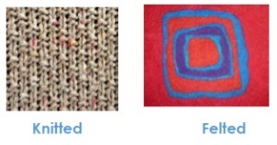
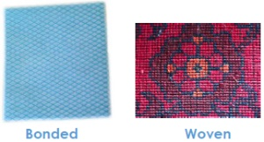
Some fabrics have been constructed so they are stronger, waterproof or more flexible than others.

How can cutting techniques be used for accuracy?
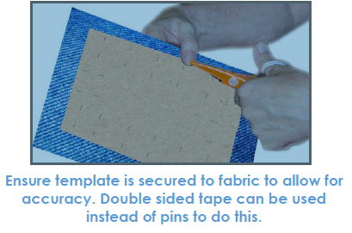
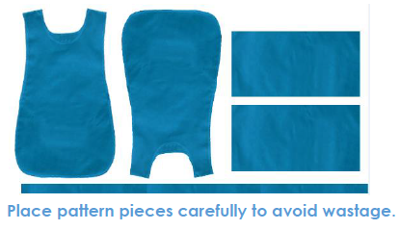
How can fabrics be joined using stitching?  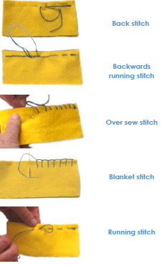 | 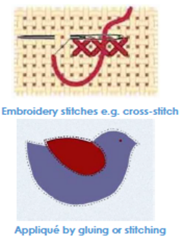  How can fabrics be decorated? | 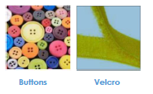  How can fastenings be used?  Buttons and press studs can be used to fasten two pieces of fabric together. Velcro and zips can also be used for larger joins.
Key Vocabulary  function, fastening, zip, button, structure, strength, weakness, stiffening, prototype, aesthetics, applique, seam allowance, |  |  | Links  Tell Me a Story 1/2 A

