Y1/2 – How can we bring traditional tales and stories to life?

Procedural knowledge
Explore how products have been created.
Design products that have a clear purpose and an intended user, using diagrams to show my design.
Develop a design criteria for a product.
Choose the right materials for making a product according to the properties needed.
Demonstrate a range of joining techniques such as gluing and using running stitch.
Colour and decorate textiles, using techniques such as dying or adding sequins.
Evaluate my design or product against my own design criteria and suggest improvements.

Factual and Conceptual knowledge
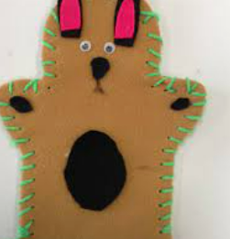  What is puppetry?  Puppets are figures that are moved by a person, usually for a performance. These figures can be of a person, an animal, an object, or even a made-up creature. People throughout the world use puppets to entertain each other and to teach lessons. People who handle puppets are called puppeteers. The simplest are finger puppets. Hand puppets have a hollow body that fit over the puppeteer’s hand. The head and arms of the puppet can be moved by the puppeteer’s fingers. Rod puppets are moved using rods. |  | What are textiles?  Textiles are flexible materials woven from fibres, such as wool, silk, cotton, nylon, felt and polyester.  These materials are used to make fabrics, which clothing, sheets, towels, linen, carpets, rugs and toys like puppets.
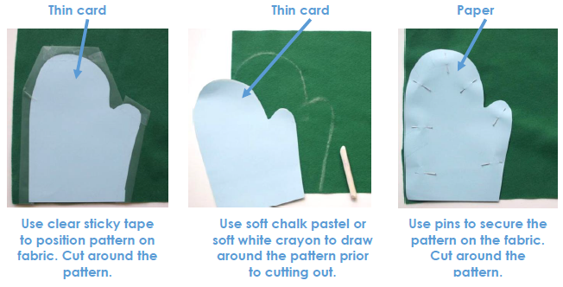
How are shapes created from fabrics?

Templates should be used to draw then cut around, producing accurate shapes and patterns. Templates can be made out of card, paper, cardboard and other materials.

How can fabrics be joined together?  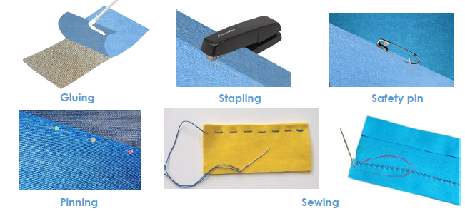  There are lots of different ways of joining fabrics together. Some joins are quicker (e.g. stapling, safety pin) whilst some are more secure (e.g. sewing, gluing). Some joining techniques are easier to hide. | How can fabrics be decorated?  Glitter, sequins and fabric crayons can all be used to decorate fabrics.
Key Vocabulary
design, evaluate, template, pattern piece, mark out, fabric, needle, thread, sew, join, seam, glove puppet

