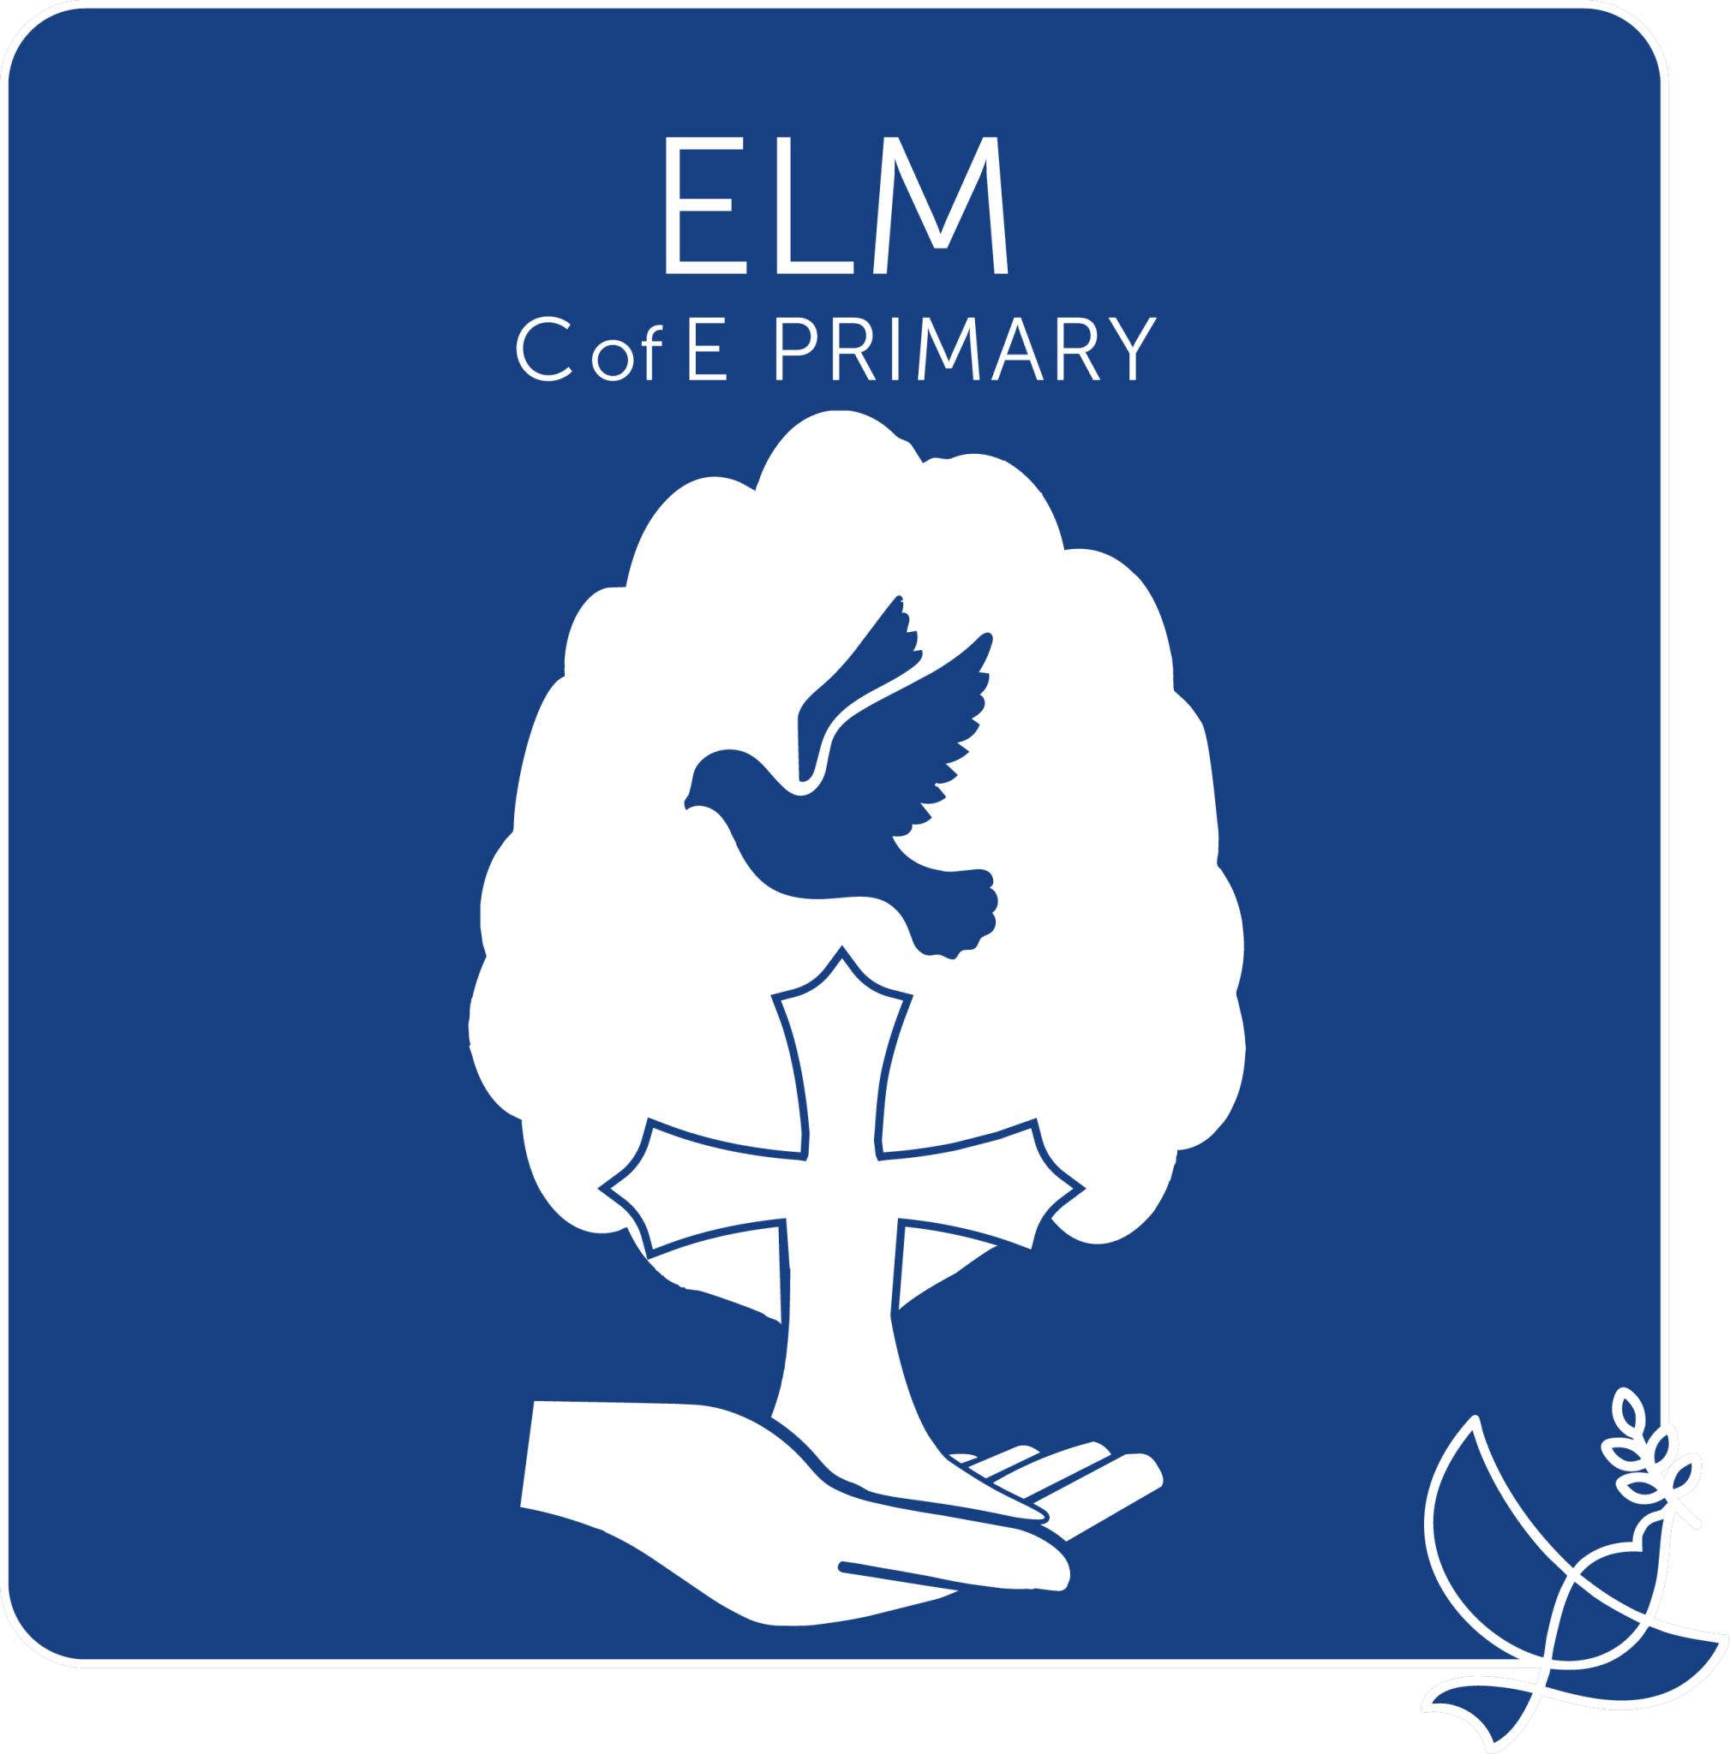
SEN Information Report

Phone: 01945 860295
Email: office@elm.graceschools.org.uk
SENCO: sendco@elm.graceschools.org.uk
Headteacher: Jackie Mills Deputy Head: Natalie Broda-Kaye
Review Date: This Information report will be reviewed in September 2027

Children are at the heart of everything that we do, ensuring access to education, regardless of any learning difference or disability, and facilitating learning by overcoming any potential barriers. All staff at Elm C of E Primary School will be ambitious and aspirational for students with SEND.

We have access to a range of professional services provided by the Local Authority which include the Educational Psychology Service, Specialist Teachers and Specialist Practitioners.

Our children in school will get support that is specific to their individual needs. This may all be provided by the class teacher through Quality First Teaching or may involve:
- Advice and support from the School’s Special Educational Needs Co-ordinator (SENCO) and other members of staff within the school.
- Professionals who visit the school from the Local Authority central services such as the Educational Psychologist and Specialist Teachers.
- Staff who visit from outside agencies such as the Speech and Language Therapy (S&LT) Service and mental health and wellbeing services.
The guide to our provision for children with Special Educational Needs at Elm C of E Primary School

Identification of SEND at our School
How do we identify that a child has a special educational need? |  | - Information from your child’s pre-school or previous school  - Reports from Professionals  - Parental/Carers Concerns  - Assessments carried out within the school setting  - Observations of the child within school  - At Elm C of E Primary School, we have a four wave graduated approach to identifying and supporting children with additional needs
If my child is having difficulty with an area of learning, how will the school staff deal with this issue? |  | - If you have a concern about your child’s development or an area of learning, you can discuss this with your child’s class teacher and/or Miss Short who is the SENCO.  - Where a member of staff has a concern about a child’s development or a difficulty, they will discuss the concern with you, the parent/carer first. The teacher may fill in a referral form and give it to the SENCo, who will look at the evidence and begin to identify what the specific difficulty is. The SENCo will help support the class teacher to adapt what they do in class to help your child overcome their difficulty.  - The class teacher and/or SENCo will meet with you, the parent/carer, to discuss the issue and inform you of what the barrier to learning is and what they are going to try with your child to help to overcome that barrier.  - A SEN Support Plan may be put in place which will follow the statutory process of Assess, Plan, Do, Review. You will be part of this process so you can see how your child is progressing. The SSP will evidence the target to be worked towards and the method of achieving it through interventions in order to close the learning gap. As parents/carers, you may be asked to participate in the intervention through repetition of skills or learning at home, or providing real life experience of classroom learning.  - Your child may be added to the SEN register which means we recognise that your child has a global difficulty (across all areas of learning) or a specific difficulty with learning. This will be addressed through targeted provision from the class teacher, additional support from learning support assistants and/or intervention groups. Where necessary, external agencies will be consulted with to ensure that the provision is appropriate for your child’s needs and will help them make progress. The SENCo will monitor your child’s progress throughout this process.
How do we encourage you to raise your concerns? |  | - You can raise concerns at any time about your child by discussing concerns with the class teacher and/or the Special Educational Needs Coordinator (SENCo) Mary-Ann Short  - Each term, formal parent consultations will be offered, when your child’s progress and attainment can be discussed. This is an opportunity to explore any difficulties your child may be having and find out about what support is in place to meet their needs and how you can help your child at home.
Support for your Child

Who will oversee the education plan for my child and explain it to me and my child? |  | All children on the SEN register have a SEN Support Plan that is written by the class teacher and monitored by the SENCo. This plan outlines their needs and the strategies that are used to meet those needs. This is known as an Assess, Plan Do, Review cycle. These will be collaboratively written with you either at parent consultations or discrete SSP meetings, where we ask for your views. This is your chance to talk to us about any concerns you have or successes that your child has experienced through the school year. You may also be asked to implement homework with your child that will reinforce the learning they are doing in school.  Children with an Education, Health and Care plan will also have a SEN Support Plan to ensure that all the outcomes on the EHCP are being worked towards. The class teacher ensures the plan is being carried out and the SENCo will oversee and monitor that this is effective and is having the desired outcome.
Who will be working with my child? | On a day-to-day basis:  - The class teacher is responsible for the needs of every child being met.  - Learning support assistants under the direct supervision of the class teacher.  - The SENCo will monitor SEN provision.  Weekly:  - Some children access Speech and Language Therapy through a referral process. A package of support may be offered after an assessment with a therapist.  - SEND Services may provide packages of support for individual children or small groups. This is accessed through a referral system.  At varied intervals:  - SEND Services may provide a specialist practitioner, specialist teacher or educational psychologist to help parents, school and the child, unpick the child’s needs and offer advice and recommendations.
How does my child know how they are getting on with their learning? | - Each day your child will receive verbal feedback on whether they have achieved the learning objective and help them move their learning forward. This is called ‘in the moment marking’. This instant feedback is crucial for developing the child’s ability to make changes to their practices or feeling the success of their achievements.
How will Elm C of E Primary School monitor the effectiveness of its SEND arrangements and provision? | - Termly, reviewing the progress the children have made and carrying out pupil progress meetings.  - Half termly pupil progress meetings, learning walks and observations by the Senior Leadership Team.  - Representatives from the Grace Schools central Team carry out quality assurance across the Trust in the form of detailed audits of provision, training and staffing. We have a Director of Inclusion for the Trust who is a well-respected professional in this field. This ensures that our SEND practice develops and we strive to do the best for all our children, ensuring they make progress from their starting points and their needs are known, understood and met.
Curriculum Concerns
How is extra support allocated to meet children’s needs and requirements? | These needs may be met through:  - The class teacher making adaptations to meet your child’s needs allowing them to access the curriculum. This may be done through a variety of strategies such as granular steps (breaking the learning into smaller chunks or steps), providing and encouraging access to task specific resources, scaffolded worksheets, etc.  - Data-driven instruction enables the classteacher to assess children for the granular step being taught and allows for in the moment adaptive teaching.  - In-class support with short targeted intervention from the teacher or learning support assistant.  - Pupil progress meetings – interventions are identified each term to ensure progress is carefully monitored and accelerated where possible to help close the gap.  - All teaching staff work to ensure our setting is communication-friendly.  - Support from SEND Services to enhance teaching practice through programmes such as Colourful Semantics.

Partnership: Planning, Monitoring and Review
What do we offer at Elm C of E Primary School to parents/carers, to discuss progress, plan and review support and share specific approaches and programmes, in addition to the normal reporting arrangements? | - You will meet with the class teacher to discuss your child’s progress and review their achievements and targets.  - Each term, you will be asked to collaborate in writing the SSP based on the teacher’s assessment of your child’s needs. This is known as an APDR – Assess, Plan, Do, Review. Your views and your child’s views will be part of this process.  - If your child has an Education, Care and Health plan we will meet formally each year to review the plan, celebrate success and adapt the plan to continually reflect the needs of your child as they grow and change.  - Face to face meetings, telephone conversations and informal discussions will ensure a good partnership between home and school. The class teacher is your first point of contact, and the SENCo is available if you wish to arrange an appointment to meet should you have any concerns about your child.
General Support for Wellbeing

How do we offer pastoral, medical and social support to the children at Elm C of E Primary School? | - Children are supported by the class teacher and the learning support assistants within the classroom overseeing the wellbeing of children on a day-to-day basis.  - The Inclusion team, SENCo and Mental Health Leads, oversee the pastoral, medical and social support of all pupils  - We liaise with health professionals to ensure care plans are in place for children with medical needs.  - All staff have basic first aid training and most staff have specific Paediatric First Aid.  Other support and intervention are:  - After school clubs  - Themes worked on in school include – road safety, online safety, anti-bullying, etc.  - Play Leaders  - School Nurse  - Early Help  - Drawing and Talking practitioner

How do we encourage our children to contribute their views? | - Before or during parent consultations, we review the SSP (assess, plan, do and review) targets with your child so that we understand that our provision is right and working for each child.  - Surveys  - Class teacher discussions  - Termly pupil voice discussions with the SENCo  - School Council
Specialist Services/ Expertise Available
We employ specialist staff in the following areas | - Learning support assistants with Level 4 Teaching Learners with SEN.  - Learning support assistants who have ELKLAN Speech, Language and Communication training – Level 3.  - The SENCo holds the National Award for SENCos qualification.  - Specialist SEND HLTA (higher level teaching assistant)  - Forest School trained teacher  - Drawing and Talking practitioner
Our school accesses the following services |  | - Grace Schools Trust Director of Inclusion  - SEND Services 0-25  - Sensory Support Team – visual and hearing impairments  - School Nursing  - Speech & Language Service  - Occupational Therapy Service  - Mental Health Support Team  - Physiotherapy
Training
Staff Qualifications |  | - All teachers have QTS and Honours Degrees  - All staff are First Aid trained, most are Paediatric-specific First Aiders  - Two learning support assistants have ELKLAN Speech, Language and Communication training – Level 3  - Three learning support assistants with Level 4 Teaching Learners with SEN  - The SENCo holds the National Award for SENCOs qualification  - Trained Drawing and Talking practitioner.  - All teaching staff are ELKLAN trained
What training have staff received recently? | - All direct teaching staff are Sounds-Write trained  - All staff are Good Autism in Practice trained  - CanDoMaths training  - In-house Precision Teaching  - Safeguarding training September 2026  - Teachers and LSAs training for specific health needs (epilepsy/diabetes/allergic reactions)  - ELKLAN level 3  - ELKLAN Communication-Friendly Setting Award 2026  - Key stage 1 Colourful Semantics workshops  - Staff CPD cycle incorporates training for meeting the needs of all learners, refining questioning for pupils with SEND and making reasonable adjustments to ensure all children can succeed  - All teachers undertake termly book scrutinies with leaders to ensure that there is consistency in feedback and high expectations for all  - All staff have access to bespoke training from the SENCo to support your child’s needs through their teaching, helping your child make progress from their starting points  - All staff are expected to maintain compliance with SMARTLOG training.  - Whole school Recovery Through Relationships introductory training  - Drawing and Talking foundation training
We plan to undertake the following training/ disability awareness sessions(s). |  | - Training is organised linked to the needs within the school. There are five training days within the school year and they are dedicated to the needs of the children within school  - Teachers have weekly staff inset linked to the curriculum and other educational concerns  - Learning support assistants also have timetabled training to support their needs and needs of the children  - Grace Schools curriculum training
Accessibility
We provide the following to ensure that all children/ young people in our school can access all of the activities offered. | - The school is wheelchair friendly and ensures that children are able to move around the school  - Within the school building we have three large disabled toilets one of which has a shower room and changing facilities  - Teachers and learning support assistants take account of a child’s individual needs and may support with specific resources, visual aids, etc.
How do we enable children to access all activities? |  | - Ensuring the building and classrooms are accessible to all children  - Adults are supportive of the needs of the children  - Pre-planning for trips and visits to ensure children can access learning beyond the classroom  - Where needed, we will devise a risk assessment/safety plan for a child to ensure they are safe and have full access to the curriculum
How are parents and carers involved in the planning? |  | - Transition meetings are held between parents/carers, the current setting, professionals and the school  - Annual Reviews ensure that parents/carers are involved the children’s education  - Meeting in person or communicating by telephone  - Parent consultations
How can parents/carers give their feedback? |  | - Attending parent/carers consultations  - Parent questionnaires given out annually  - Parent/carers views included in SSP meetings and EHCP Annual Reviews  - Teachers are available each day to speak to parents at the beginning and end of the school day
How can parents/carers make a complaint? |  | On the website there is the “Grace Schools Complaints Policy” which informs parents/carers what to do if they have a complaint. They can also request a copy from the school office.
Transitions
What arrangements help children and their parents to make a successful transfer to Elm C of E Primary School? | - Parents of the children coming into Reception are invited into meetings within school and home visits are carried out by the Reception teachers.  - Transition meetings are held between pre-school staff, professionals who work with the family, the SENCo and staff from school.  - All children joining us in Reception are invited to Stay & Play sessions in the previous Summer Term. Some children may also be invited for additional sessions to help them, if it is deemed their transition might be more challenging.  - With transition into secondary school, parents/carers are invited to meetings at the secondary school and transition meetings are organised between the staff from the secondary school, other professionals and the SENCo at Elm C of E.

How do we prepare children to make their next move? | - We have “Move-up” days whereby children go to the new classroom and do activities with their new teacher.  - Using Social Stories to support transition (where appropriate)  - With Y6, a visit to the new school happens in July and staff from the secondary schools come and meet the children. There are meetings held for staff at both settings to ensure a smooth hand-over  - Home visits for new EYFS children  - Hand over meetings between the current and next teacher to ensure smooth transitions – teachers will discuss strategies that help your child overcome barriers to learning
Resource Allocation
Our SEND budget is allocated according to | The needs of the children.
Funding is matched to SEND by | The Headteacher and Trust oversees budget decisions and these are shared with regional governing boards and hub directors for their information and comments as part of their monitoring.
Our decision making process when matching support to need is | Decided by the Senior Management Team under the guidance of the SEND staff.
Parents/ carers are involved through | Annual Reviews, Parent consultations, SSP meetings, formal or informal meetings/discussions.
Contact Details
Who should I contact if I want to discuss my child’s progress or difficulties? | - Your child’s class teacher is always your first point of contact. They are always available to speak to each morning in the playground when the children arrive at school and you can arrange an appointment to see them later after school should you wish to.  - The SENCo is available to discuss any issues or concerns about your child’s welfare, their learning needs or medical needs.  - The Head teacher is happy to meet to discuss needs and ongoing support
Who is the SENCO? | - Our Special Educational Needs Co-ordinator is Mary-Ann Short - sendco@elm.graceschools.org.uk
Useful contacts | - Attendance champion: Natalie Broda-Kaye  - Attendance Officer: Tracey Gibbon - office@elm.graceschools.org.uk  - EYFS Lead: Hannah Hart  - Designated Safeguarding Lead: Jackie Mills  - Deputy designated Safeguarding Leads: Natalie Broda-Kaye/Kim Summers  - Headteacher: Jackie Mills office@elm.graceschools.org.uk
What other external support services for information or advice are there? | Education Inclusion Family Advisor: earlyintervention@cambridgeshire.gov.uk  SENDIASS: SEND Information, Advice and Support (SENDIASS)  Cambridgeshire County Council, SH1212, Shire Hall, Cambridge, CB3 0AP  Email - sendiass@cambridgeshire.gov.uk or the website is located at https://www.cambridgeshire.gov.uk/residents/children-and-families/local-offer/local-offer-care-and-family-support/send-information-advice-and-support-service-sendiass  The Local Offer for Cambridgeshire is located at:  https://send.cambridgeshire.gov.uk/kb5/cambridgeshire/directory/home.page

