

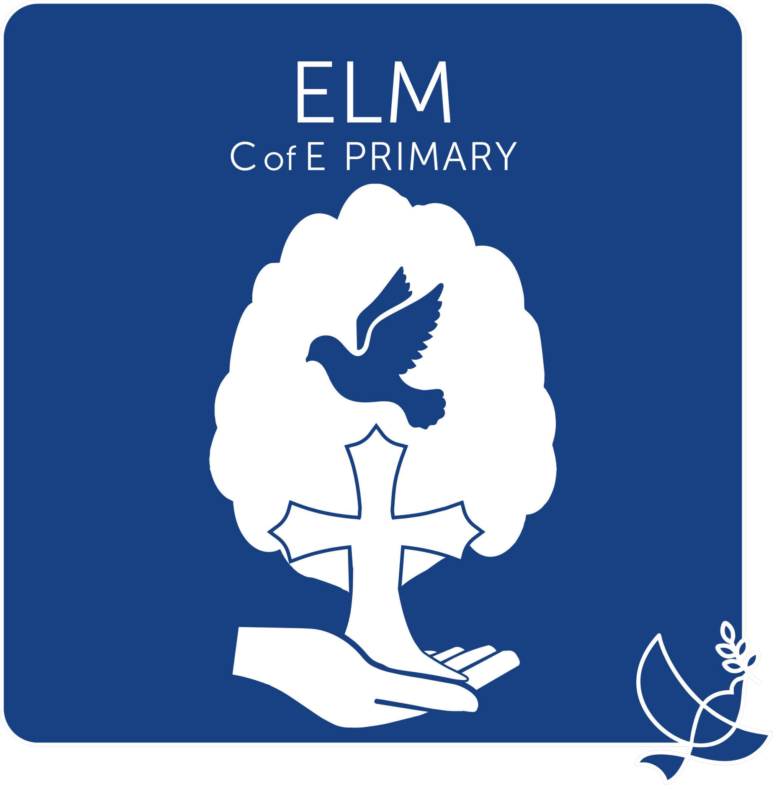

SEN Information Report

Phone: 01945 860295
Email: office@elm.graceschools.org.uk
SENCO: sendco@elm.graceschools.org.uk
Headteacher: Jackie Mills Deputy Head: Natalie Broda-Kaye
Review Date: This Information report will be reviewed in September 2027

The aim of this report is to provide parents, carers and young people with information about what is provided and what they should expect to receive in terms of SEND provision at Elm C of E Primary School. We are committed to giving all pupils the support that is required for their individual needs in order to make the best possible progress.

SENCo: Mary-Ann Short

What is Special Educational Needs and Disability?
The SEND Code of Practice (2015) states that:
“A child or young person has SEND if they have a learning difficulty which calls for special educational provision to be made for them. A child of compulsory school age or a young person has a learning difficulty or disability if they:

a) Have significantly greater difficulty in learning than the majority of others the same age.
b) Have a disability which prevents or hinders them from making use of educational facilities of a kind generally provided for others of the same age in mainstream schools.”

Within the Code of Practice (2015) four broad areas of need are identified as:

1. Communication and interaction
2. Cognition and learning
3. Social, mental and emotional health
4. Sensory and/or physical

How do we identify that a child has a special educational need?
Information is gathered from a number of different sources. The two primary sources are through parents raising concerns and class teacher assessment. All children are assessed throughout the year, which allows for early identification of a special need and then for targeted action to be put in place. Classroom observations are used to identify needs that are not academic which may require specific assessment.
Information concerning special needs is passed to the school from the pre-school provider, and reports from professionals are used to formulate the best interventions and outcomes.
At Elm C of E Primary School, we have a four wave, graduated approach to identifying and supporting children with additional needs.

If my child is having difficulty with an area of learning, how will Elm C of E Primary School deal with this issue?
As a parent, if you are concerned about areas of learning or development of your child, you can discuss this with their class teacher or make an appointment to see the SENCo.
Where a member of staff has a concern about a child’s development or a difficulty, they will discuss the concern with you, the parent/carer first. The teacher will make the SENCo aware and further action will be discussed. The class teacher will be supported to make adaptations to the curriculum as needed and if necessary referrals to external agencies may be made. You, as the parent, will be involved and included every step of the way.
The child may be added to the SEN register. In some cases, this is temporary – a need has been identified, the teacher will implement an adaptation, progress will be tracked and if significant progress is made the child will be removed from the register. In other cases, a child may need additional support longer term. All additional support is provided through the graduated approach, which is a system of assessment, planning to meet need, doing an action and then reviewing the impact.
If after two or three rounds of assess, plan, do, review, if the child is not making progress, external agencies may be asked to provide further advice to support school staff or implement specialist teaching practice.
Agencies we work with include:
- Mental Health Schools Team
- Specialist Teaching Team (specialist teachers, educational psychologists, specialist practitioners)
- Speech and Language Therapy Service
- Occupational Therapy Service and Physiotherapy Service
- Consultant Community Paediatrician
- Children’s Services (family workers)

How are children supported at Elm C of E Primary School?
The needs of every child are important to us at Elm C of E Primary School. We aim for all children to feel included in a safe and secure environment which meets their needs and helps them flourish. We have high expectations for all learners, and provide a challenging but achievable level of learning throughout the school.
All children on the SEN register have a plan with strategies and goals written initially by the class teacher with support from the SENCo and offered for collaboration with you, the parents/carers. We encourage participation and offer a collaborative process with parents, so that you feel informed and included in your child’s education. Parents/carers are asked to support and encourage children at home too. All staff working with the child will have access to the plan so that everyone is working towards the same goals using the same strategies.
Our main aim is to keep all children in the classroom, working at a level appropriately challenging for their needs and with the appropriate level of adult support. There are times when children will be given targeted interventions in small groups or one-to-one out of the classroom environment. These are for short periods of time and causing minimal disruption to their work in class.
Class teachers monitor and continually assess the effectiveness of adaptations made in the classroom as part of their high quality teaching, of specific interventions and progress being made. Before the review stage, if they feel the child’s needs are not being met, changes can be made to the plans through a consensus of agreement with parents, SENCo and other interested parties including the child. If the child has a SEN Support Plan, these changes will be documented in the review section.

What support is offered at Elm C of E Primary School?
All children are supported by a highly qualified teacher and learning support assistants with experience and training in specific interventions. In-class interventions may include: access to specific equipment, sound and word mats, memory aids, special pencils, pencil grips, wobble cushions, etc.
We can offer targeted interventions in fine motor skills, phonics, spellings, writing and maths using a range of intervention tools to address particular gaps in learning and/or development.
Our inclusive ethos in school is reflected in our core offer that can be accessed by all children regardless of specific need. Our offer to everyone includes access to our mental health lead and mental health first aiders, paediatric first aid staff, after school clubs, themed work on road safety, online safety, etc.

If you would like further information or advice.
Please come and speak to us if you have any concerns or would like further information or just a chat. Your child’s class teacher will be happy to help or an appointment can be made to speak to the SENCo during the school day or after school. There are many other organisations (some listed below) that may be able to provide assistance.
The local offer from Cambridgeshire County Council can be found here: https://send.cambridgeshire.gov.uk/kb5/cambridgeshire/directory/home.page
Pinpoint - A registered Cambridgeshire charity that provides help and support for parents with children who have special needs. It is run by parents for parents and gives straightforward guidance on the services children are entitled to and how to access them.
http://www.pinpoint-cambs.org.uk/home
Special Educational Needs and Disability Information, Advice and Support Service (SENDIASS) – offers impartial and confidential information, advice and support to parents and carers who have a child or young person with special educational needs or a disability.
https://www.cambridgeshire.gov.uk/residents/children-and-families/local-offer/local-offer-care-and-family-support/send-information-advice-and-support-service-sendiass
The Education Inclusion Family Advisor can offer help with challenging behaviour, establishing routines, raising self-esteem, increasing confidence and improving family relationships at the email address below.
earlyintervention@cambridgeshire.gov.uk
https://spectrum.org.uk/ - provides events, sessions, and support for families of children with Autism, additional needs, learning difficulties, and disabilities.

