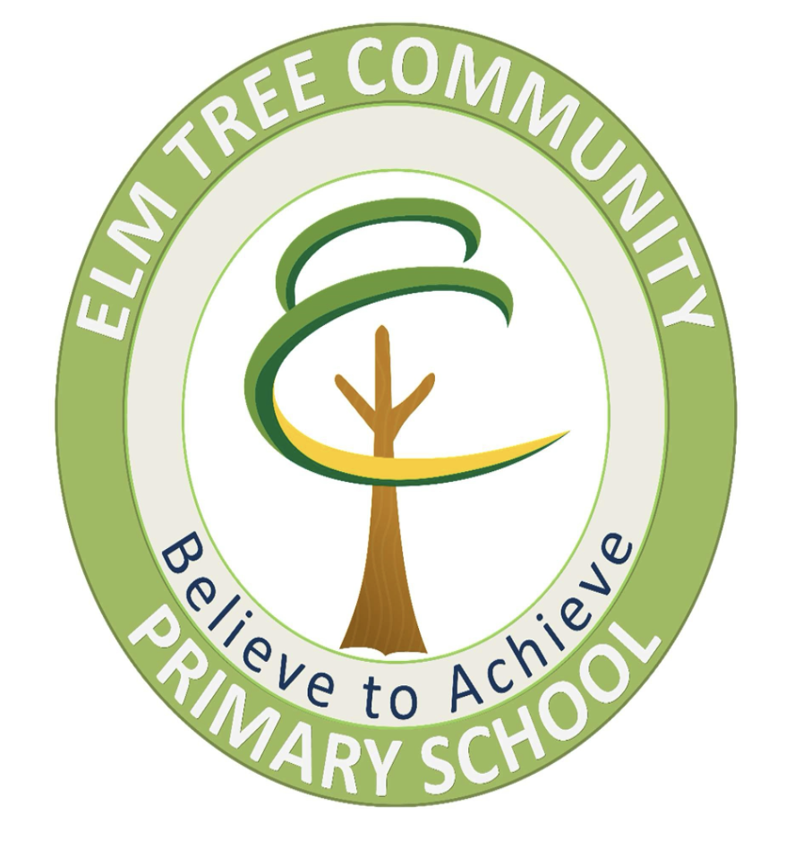

Updated: July 2025
To be Reviewed: July 2026

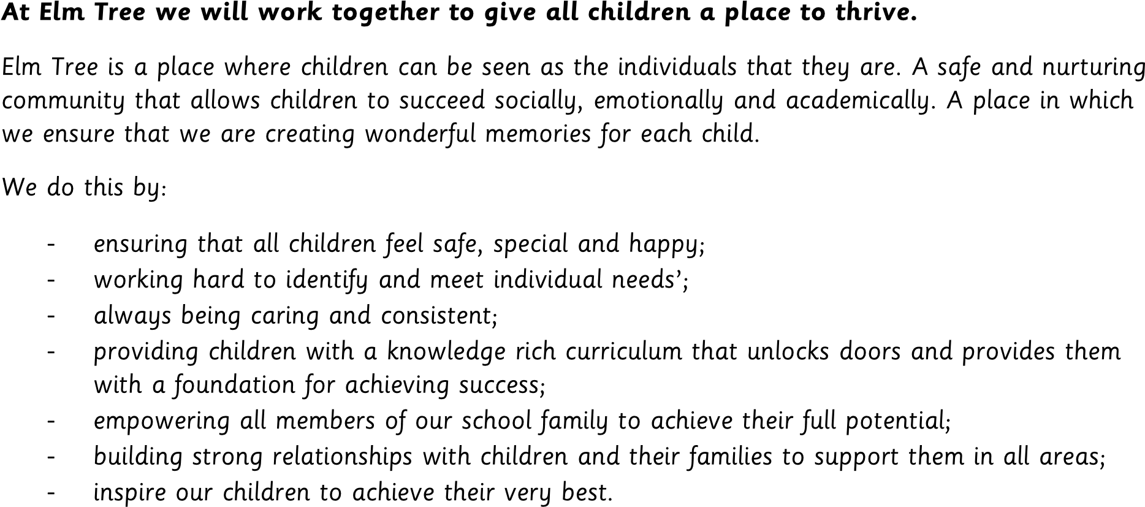
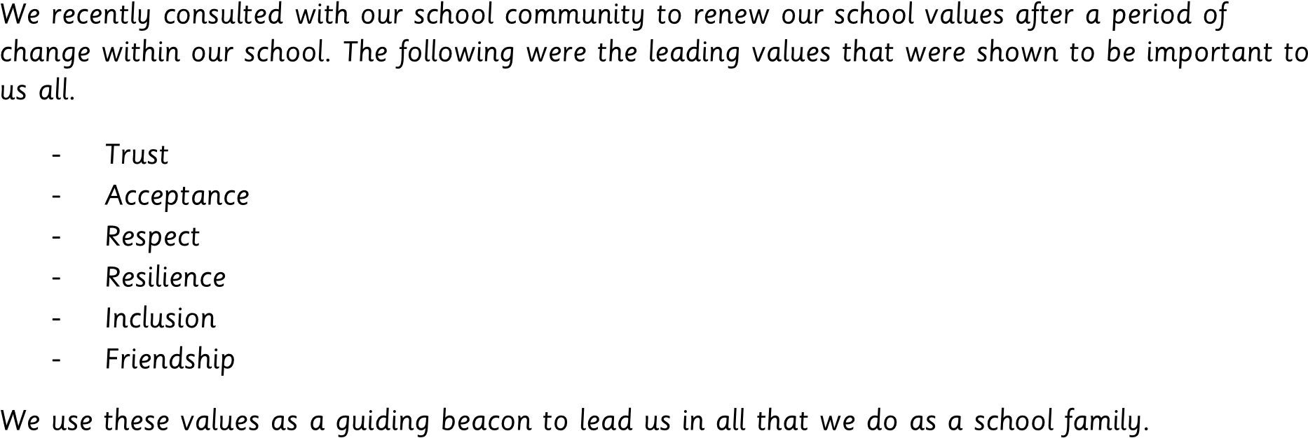

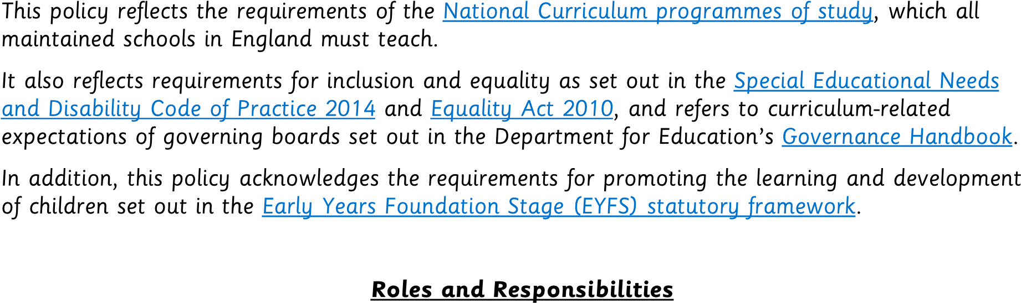

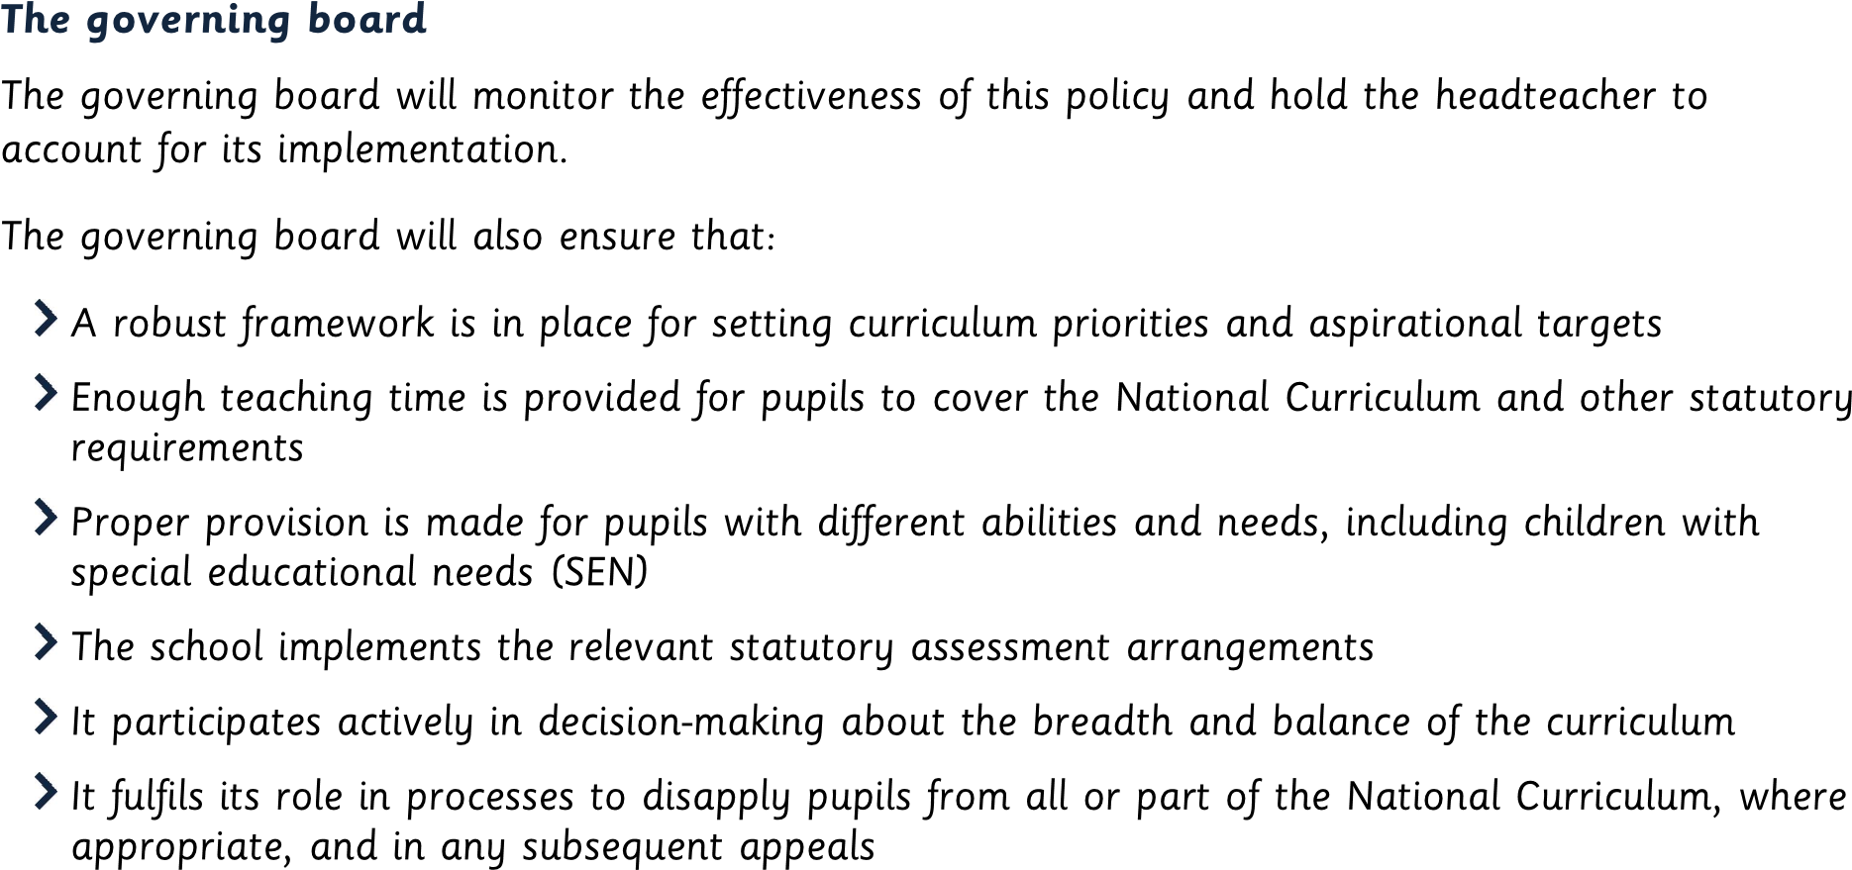
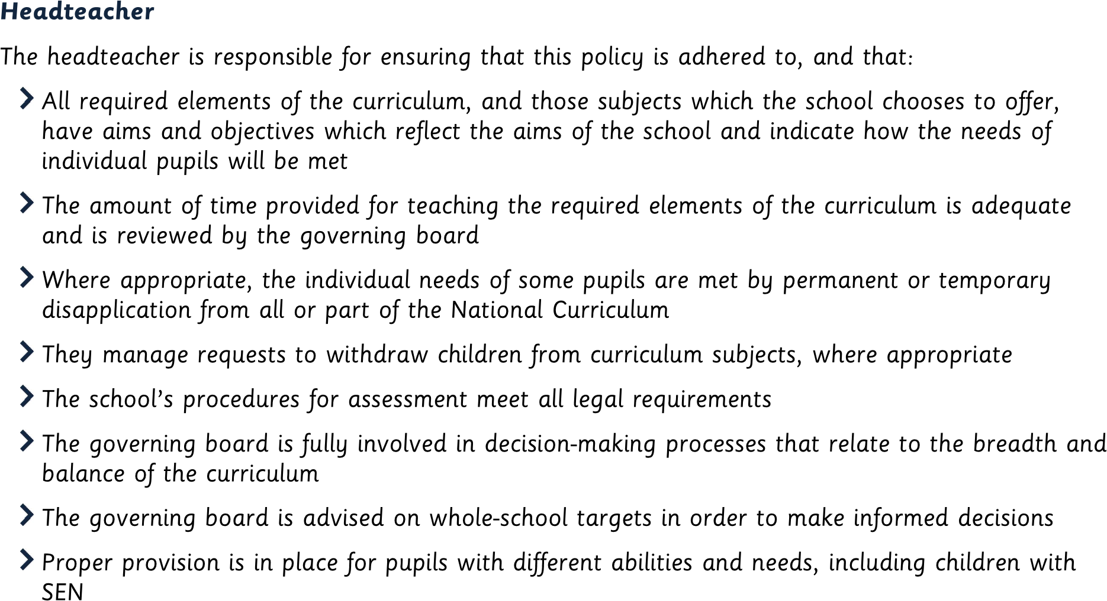
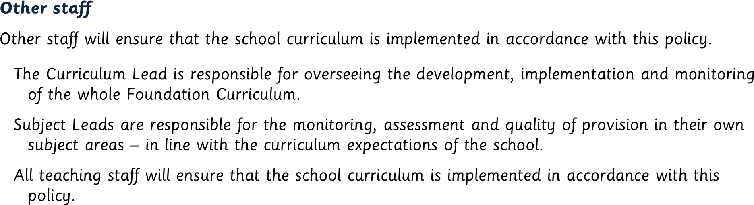
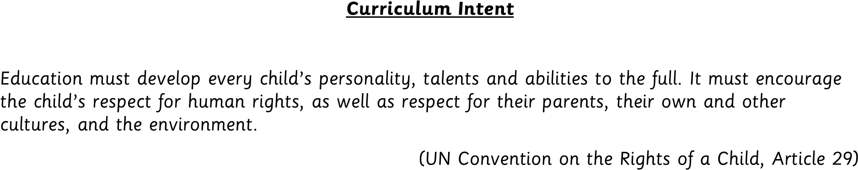

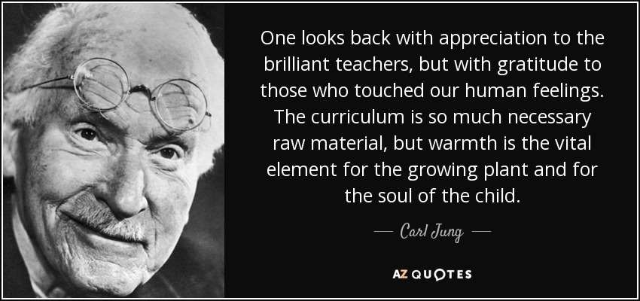
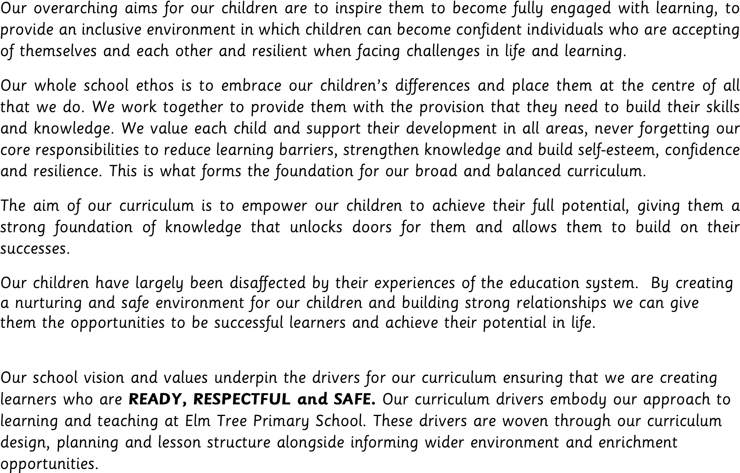

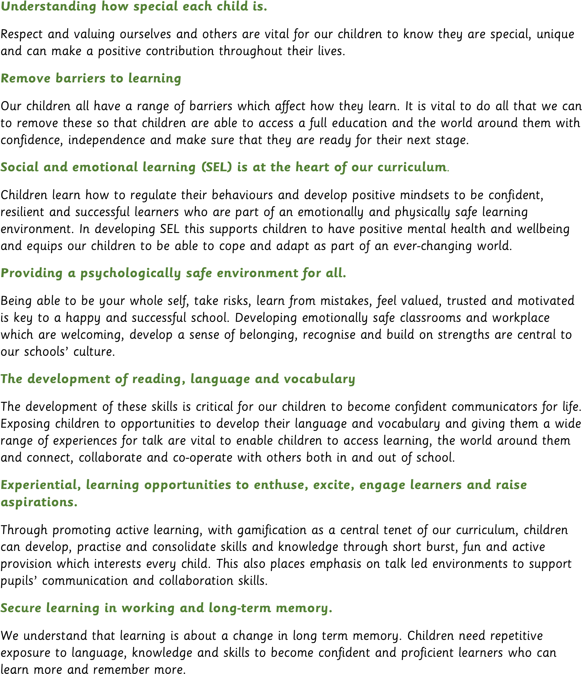

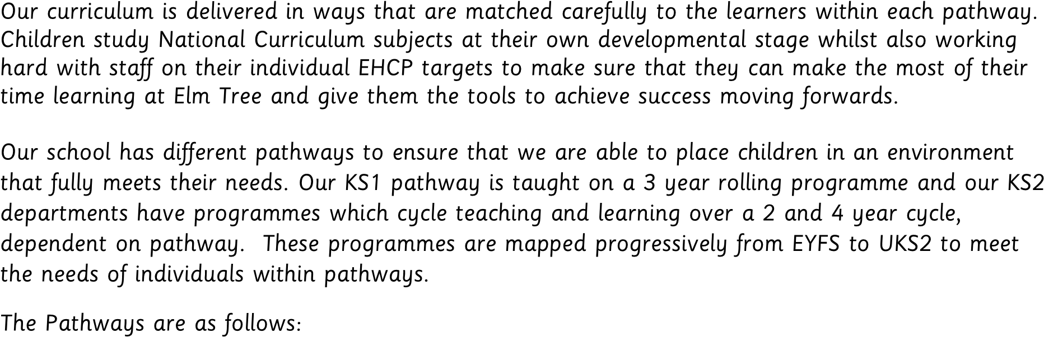
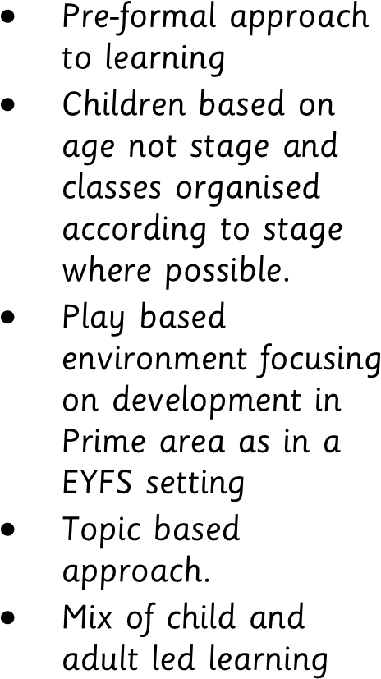 | 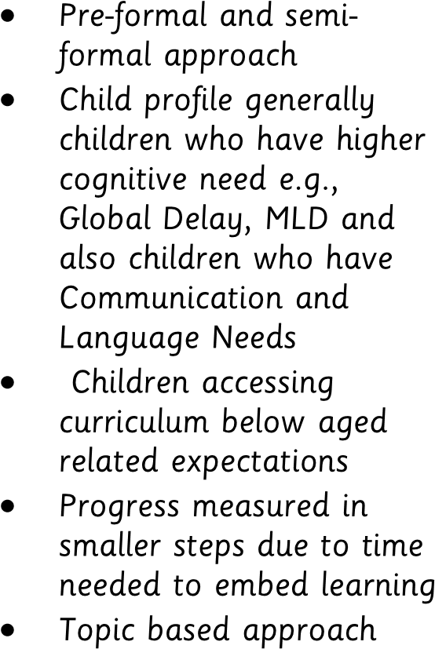 | 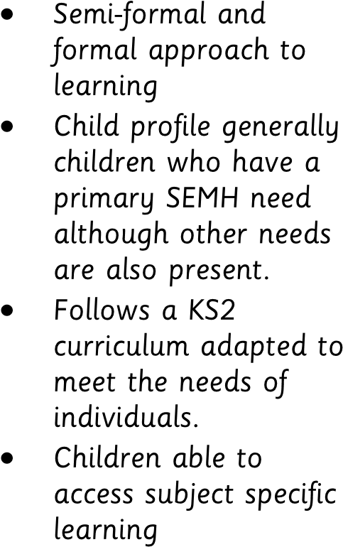
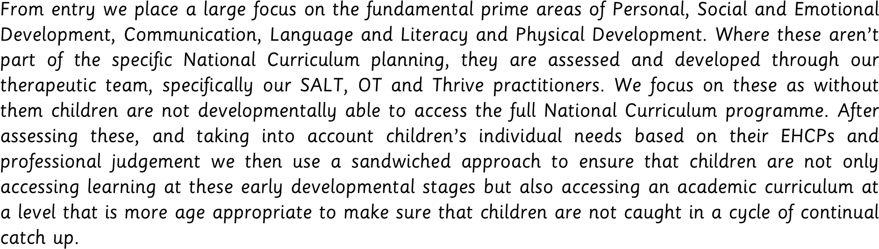
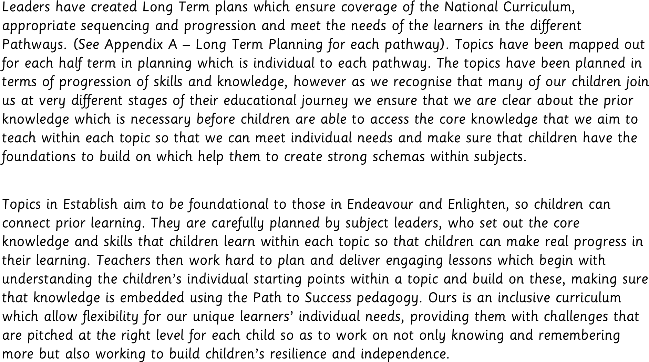
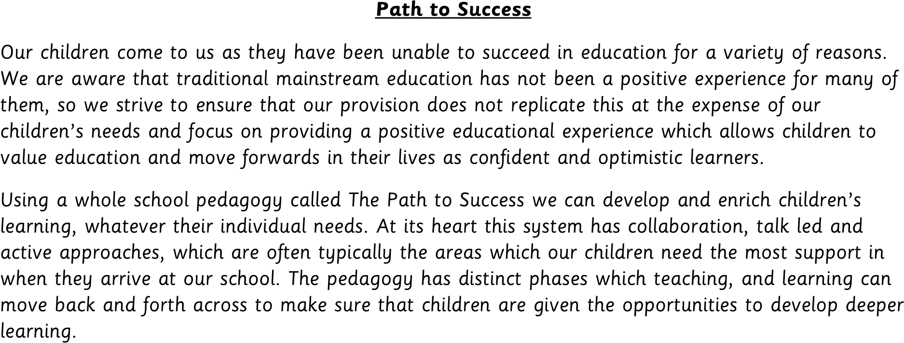
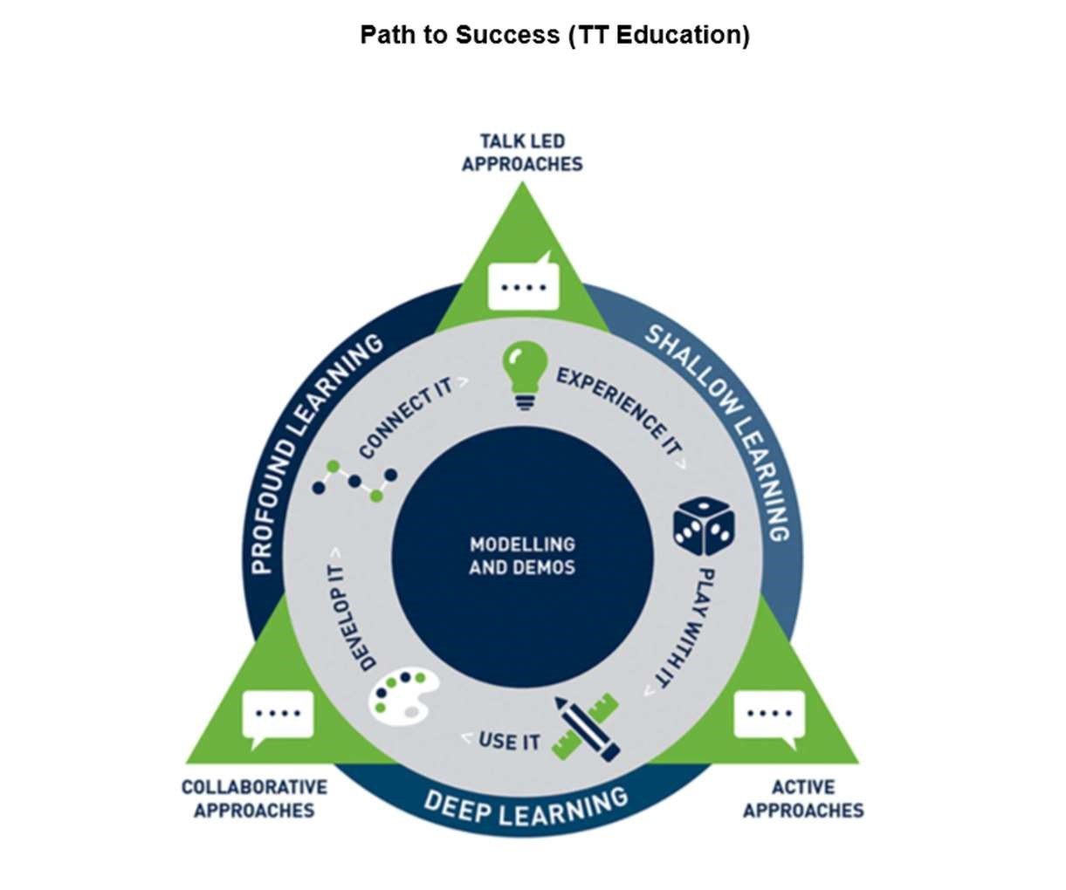
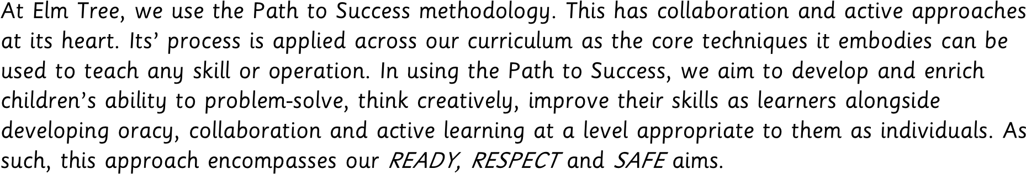
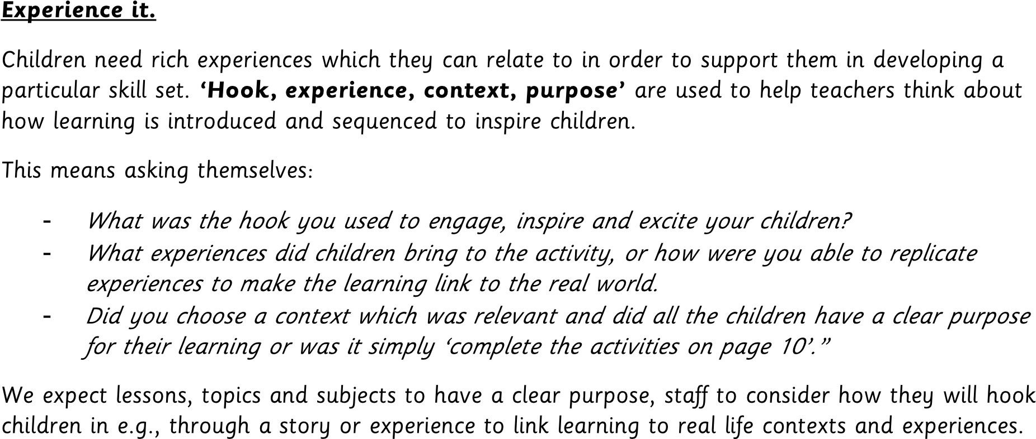
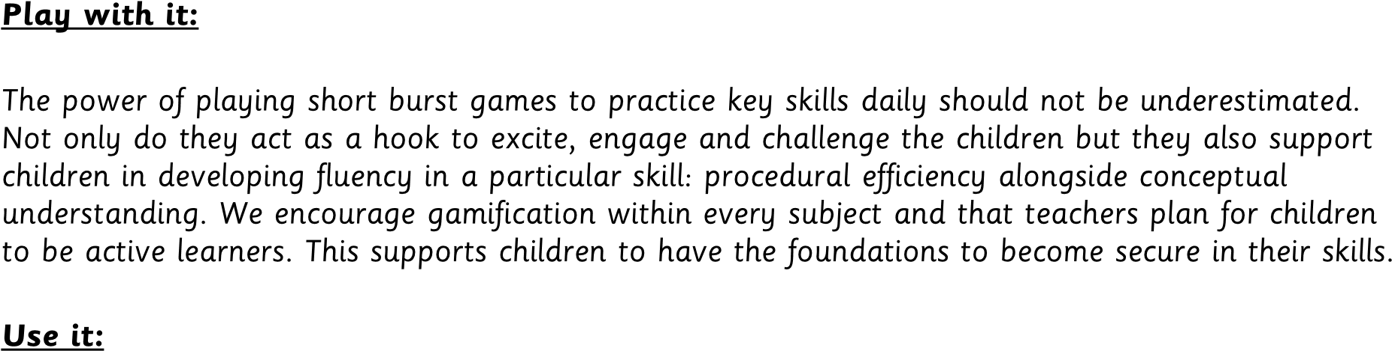

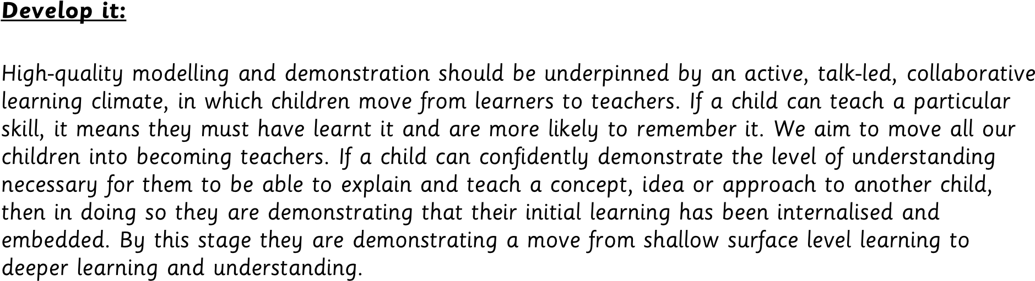
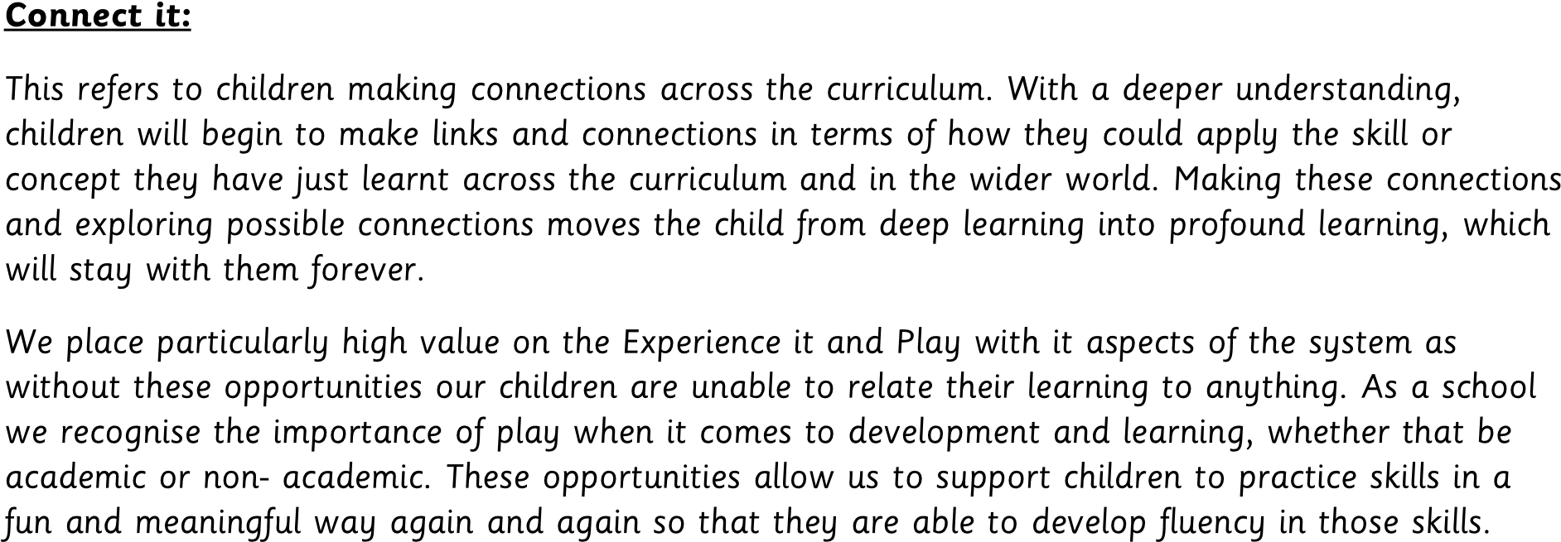

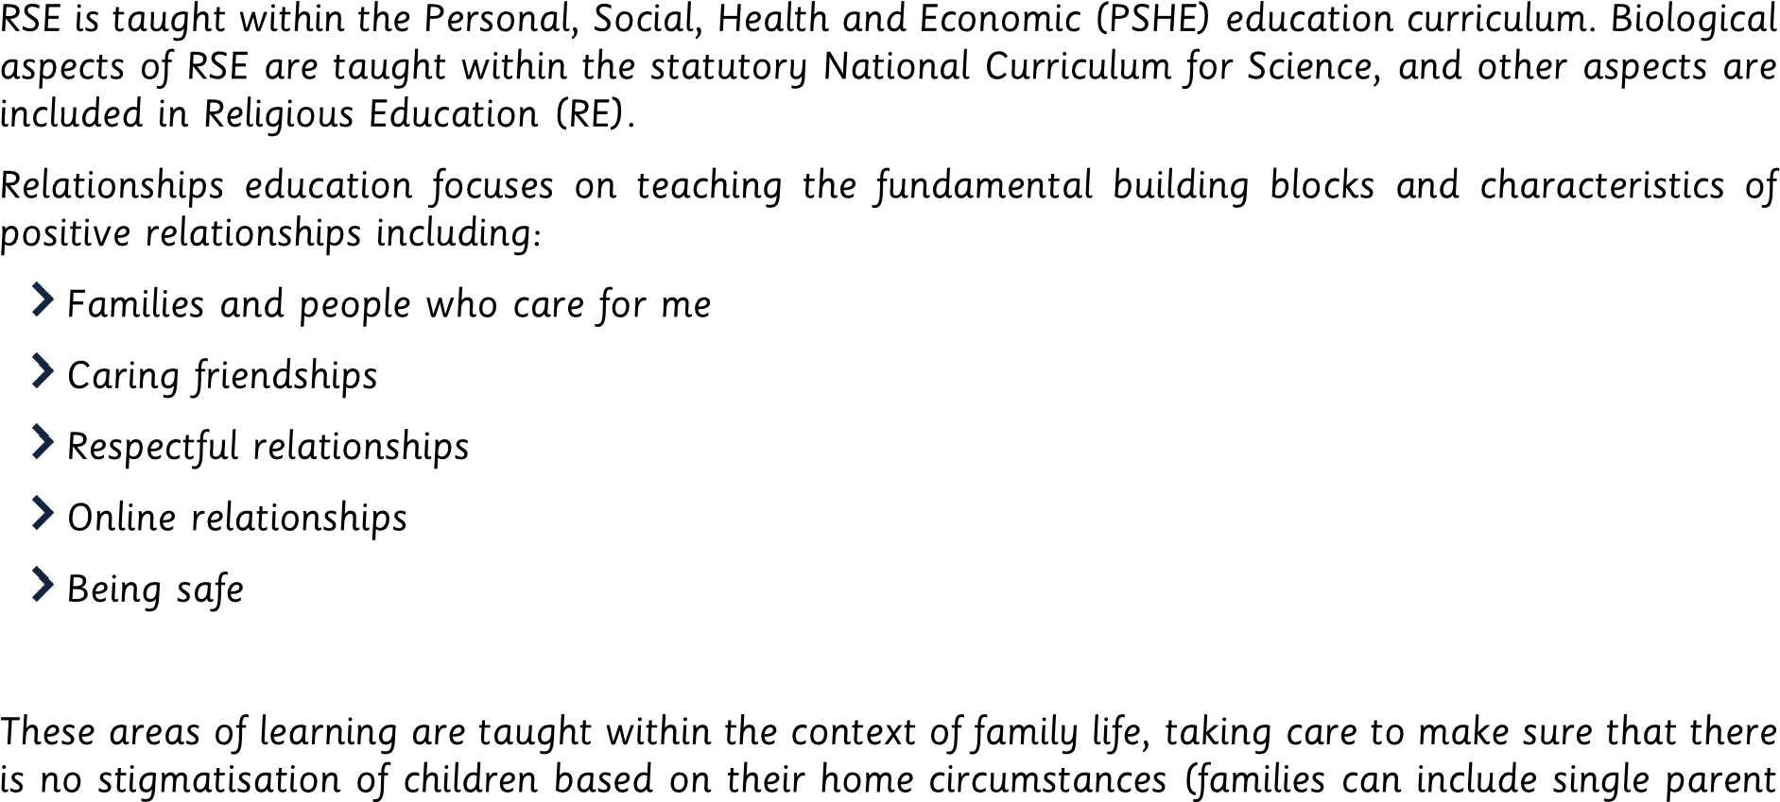
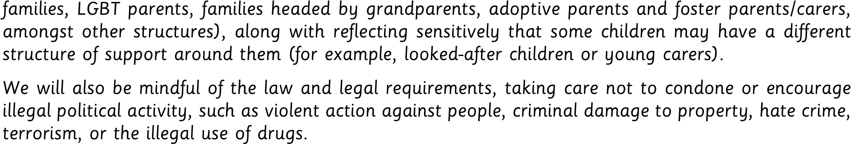
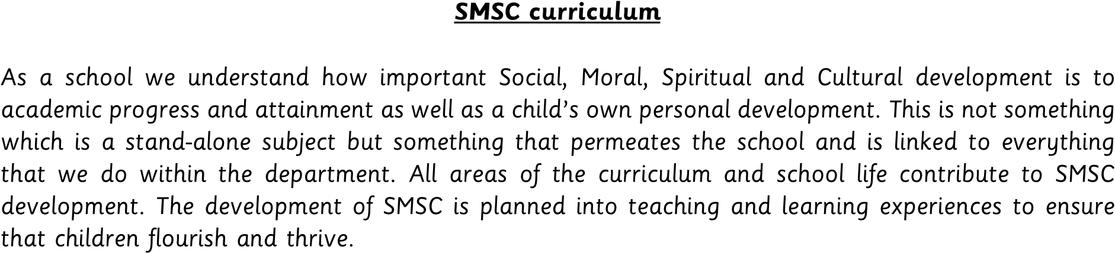
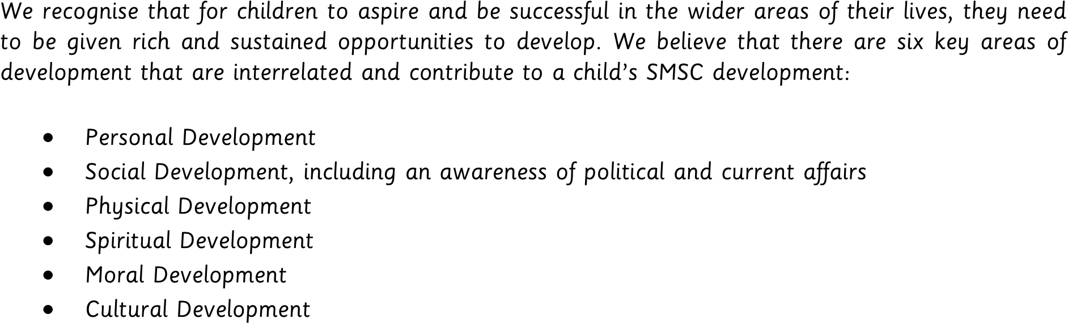

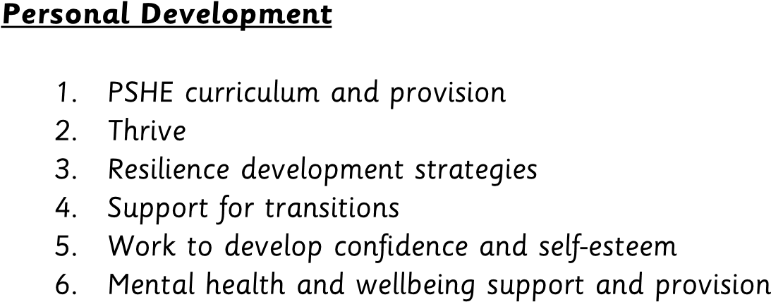
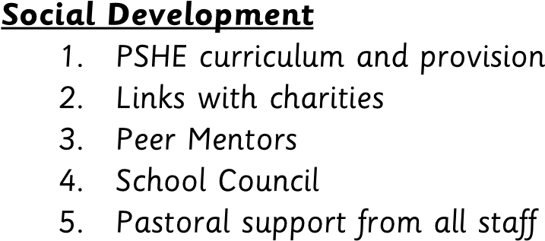
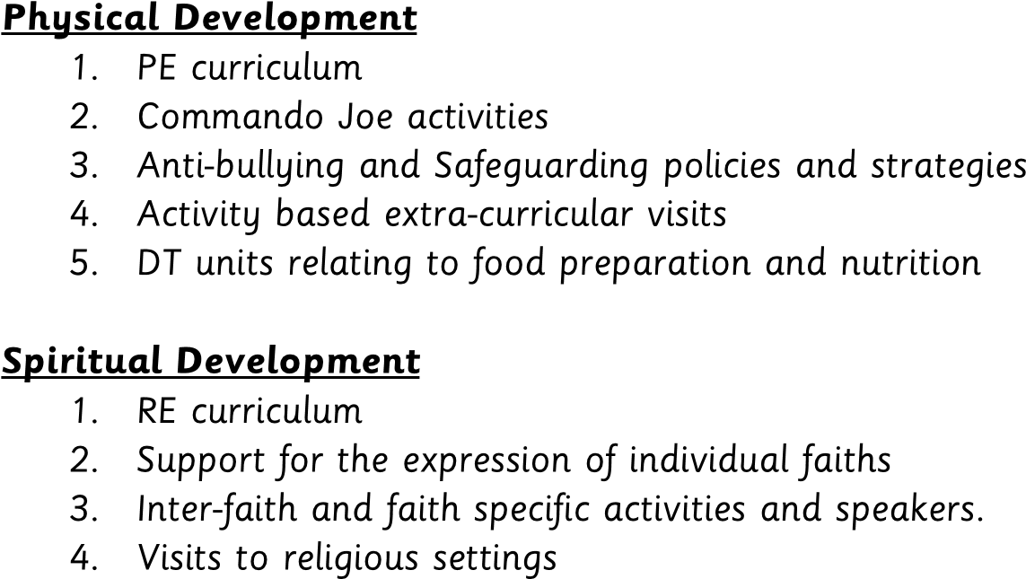
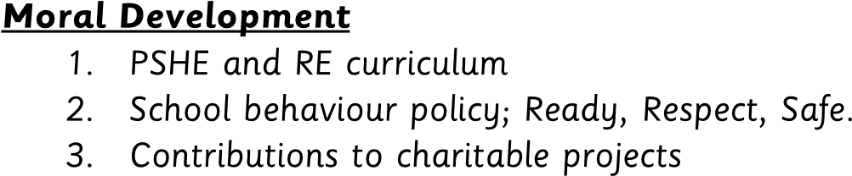
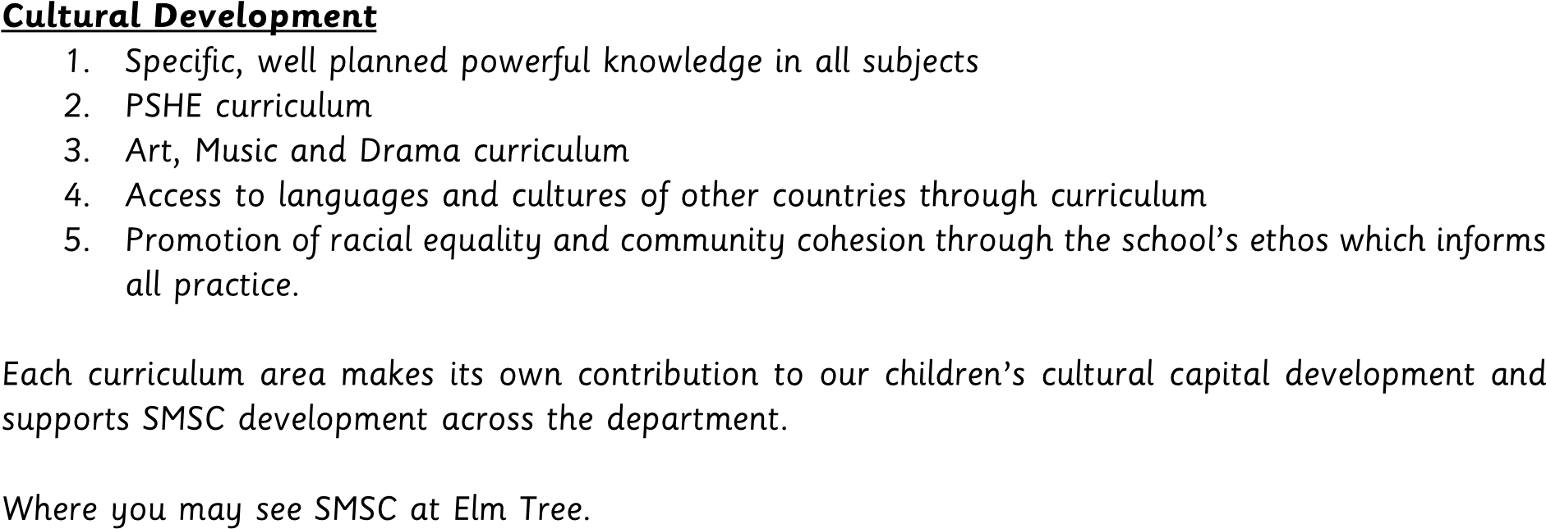

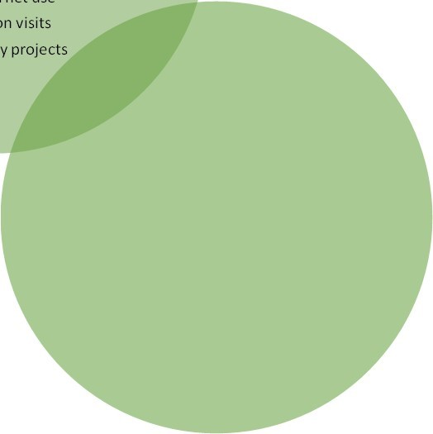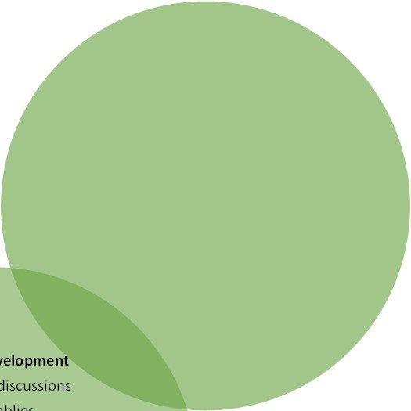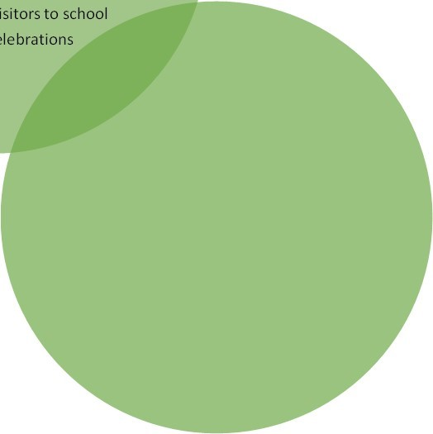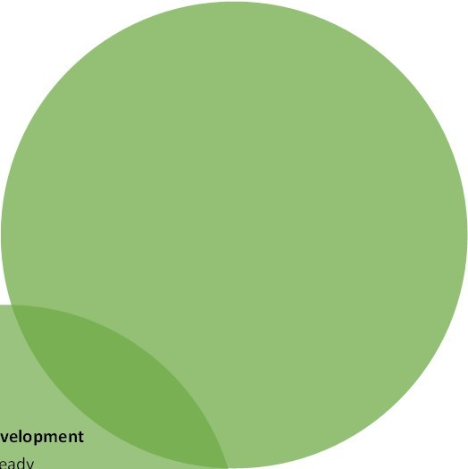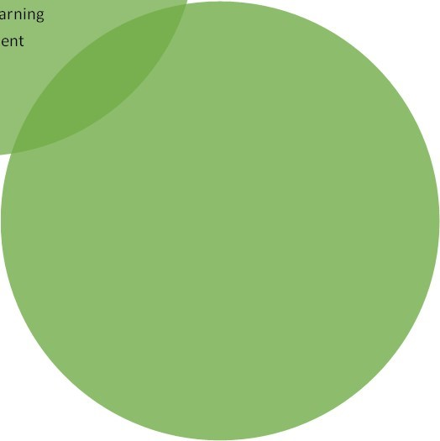
Personal Development
-
PSHE curriculum
-
THRIVE right time learning
-
THRIVE 1:1 restorative sessions
-
Development of self-understanding,
empathy and healthy, productive
relationships
Eating healthily
-
Safe internet use
-
Transition visits
-
-
Community projects
Spiritual Development
Classroom discussions
-
Assemblies
-
Activities which develop characteristics
-
of spiritually developing person
-
Yoga
-
Meditation
-
Reflection
Charity connections
-
Social Development
-
Collaboration in learning
Breakfast and snack time
-
-
Group working within class and across
classes
-
Peer Mentors
-
Me Time
Class trips and visitors to school
-
-
Religious celebrations
Moral Development
Ready
-
Respect
-
-
Safe
-
Pupil assemblies
Making the right choices
-
Group games
-
-
Role play
Physical Development
PE lessons
-
Commando Joe activities
-
Daily Mile
-
Food and nutrition teaching
-
Occupational Therapy support and
-
activities
Gross and fine motor activities
-
Outdoor learning
-
Enrichment
-
Cultural Development
Planned powerful knowledge
-
RE teaching and learning
-
MFL curriculum
-
MFL culture days
-
Festivals around the world
-
-
Appreciating artists from a variety of
cultures
Celebrating diversity
-
-
World Book Day











