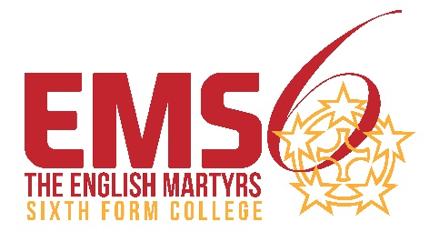

Further Education Free Meals Application Form 2025-26

Students aged between 16 and 18 on 31st August 2025 will be eligible for free meals in the 2025-26 academic year if they meet the eligibility criteria below. Students who turn 19 during their study programme will remain eligible until the end of the academic year in which they turn 19 or to the end of their study programme, whichever is sooner.

**Personal Information** Complete all fields

|  |  |  |  |  |  |
| --- | --- | --- | --- | --- | --- |
| Surname |  | Forenames |  | Date of birth |  |

|  |  |  |  |  |  |  |  |  |  |
| --- | --- | --- | --- | --- | --- | --- | --- | --- | --- |
| Age @ 31-8-25 |  |  | | | | Home Address |  | | |
|  | | | | | |  | | | |
| Have you been resident in the UK for the last 3 years? | | | Yes □ | No □ |  |
|  | | | | | |
| Are you an Asylum Seeker? | | | Yes □ | No □ |  |
|  | | | | | |
| Do you have Refugee Status? | | | Yes □ | No □ |  |  | | Post Code |  |

|  |  |  |  |
| --- | --- | --- | --- |
| Home Tel number |  | Student Mobile Number |  |

|  |  |  |
| --- | --- | --- |
| You may be eligible if you or your parents are in receipt of one or more of the following benefits: | | |
| Income-related Employment and Support Allowance (ESA) | Letter dated in last 3 months/last 3 months bank statements |  |
| Income-based Jobseekers Allowance | Letter dated in last 2 weeks/latest bank statements |  |
| Income Support | Letter dated in last 3 months/last 3 months bank statements |  |
| The guarantee element of State Pension Credit | Award notice/evidence of Pension Income |  |
| Child Tax Credit – Provided you are not entitled to Working Tax Credit | Award notice dated April 23 onwards (provided you are not entitled to Working Tax Credit) |  |
| Support under part VI of the Immigration and Asylum Act 1999 | Supporting Evidence |  |
| Working Tax Credit run-on | Paid for 4 weeks after you stop qualifying for Working Tax Credit |  |
| Universal Credit | Letter dated in last 3 months/last 3 months bank statements |  |

If you wish to apply for free meals you must supply evidence of the qualifying benefits, please tick which benefit evidence listed above you are supplying.

**Please note that although you may be eligible for Further Education Free Meals you may not be eligible for the College Bursary as the criteria differs. However, if you are supplying evidence that is relevant for both applications then one copy/original document will be sufficient.**

|  |  |  |  |  |
| --- | --- | --- | --- | --- |
| Please read the statements below and tick the boxes to confirm your agreement, then sign and date: | | | | |
| I have enclosed all required evidence to support my application | | | |  |
| I have provided evidence which is accurate and true. I understand that the College may carry out checks to verify the evidence provided, and may take action deemed appropriate if any information I have given is proven to be incorrect or false. | | | |  |
|  | | | | |
| Student signature |  | Date |  | |
| Name of Student |  |
| Signature of Parent/Guardian |  | Date |  | |

|  |  |  |  |  |  |  |  |
| --- | --- | --- | --- | --- | --- | --- | --- |
| Office Use | | | Free School Meals Approved | | Yes □ No □ |  | |
|  | | | | | | | |
| Assessed by: Initials |  | Approved By: Signature | |  | | |  |