T3NPlklkhk
Key Skills English
Writing
Pupils can:
-Accurate spelling of some prefixes and suffixes e.g. –ly and -ation
-Accurate spelling of common homophones e.g. there, their and they’re.
-In narratives, creating settings, characters and plot
-In non-narrative writing, use simple organisational devices, e.g. headings and sub-headings.
-Assess the effectiveness of their own and others’ writing and suggesting improvements

Reading Pupils can:
-Draw on contextual evidence to make sense of what is read. -Ask questions to improve understanding of the text. -Make comparisons within and across different texts. -Make predictions based on details stated and implied by the author. -Explain and discuss their understanding of what they have read. -Drawing inferences such as inferring characters’ feelings, thoughts and motives from their actions. -Retrieve and record information from non-fiction texts.
Grammar Pupils can:
-Extend sentences with more than one clause by using a range of conjunctions, for example when, if, because, although
-Use adverbs and prepositions to express time and cause
-Using inverted commas and punctuating direct speech.

Mathematics Pupils can:
-Count in multiples of 4, 8, 50 and 100 and know times tables to 12 x 12.
-Find 10 or 100 more or less than a given number
-Recognise the place value of each digit in a three digit number (hundreds, tens and ones)
-Solve number problems and practical problems involving place value
-Add and subtract numbers mentally including three digit numbers. -Count up and down in tenths: recognize that tenths arise from dividing an object into 10 equal parts. -Measure, compare, add and subtract: lengths, mass, volume and capacity -Identify right angles and whether angles are greater than or less than a right angle -Add and subtract amounts of money to give change using both £ and p -Interpret and present data using bar charts, pictograms and tables -Tell and write the time from an analogue clock -Recognize, find and write fractions of numbers and objects

Endeavour Academy


Supporting your child’s learning at home.
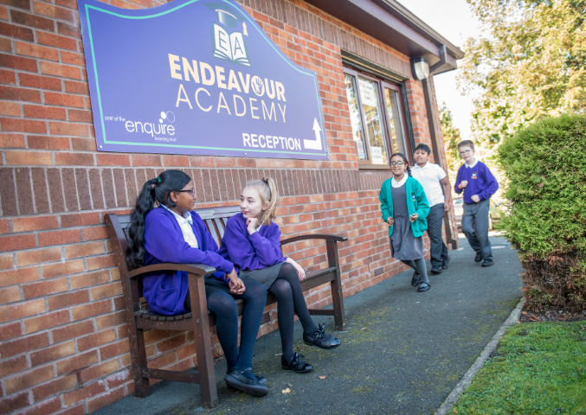

Year 3

``
Recommended Reads!
The BFG- Roald Dahl
The Monster Hunter- Guy Bass
The Great Troll Rescue- Tom Percival
The Dragon sitter to the Rescue- Josh Lacey
Vicious Vikings- Terry Deary
The Spell Thief- Tom Percival
George's Marvellous Medicine- Roald Dahl
Diary of a Wimpy Kid- Jeff Kinney
Apps and Useful Websites
★www.bbc.co.uk/bitesize/ks2 ★www.mathszone.co.uk ★www.topmarks.co.uk ★www.woodlands-junior.kent.sch.uk ★www.coxhoe.durham.sch.uk ★www.horrible-histories.co.uk
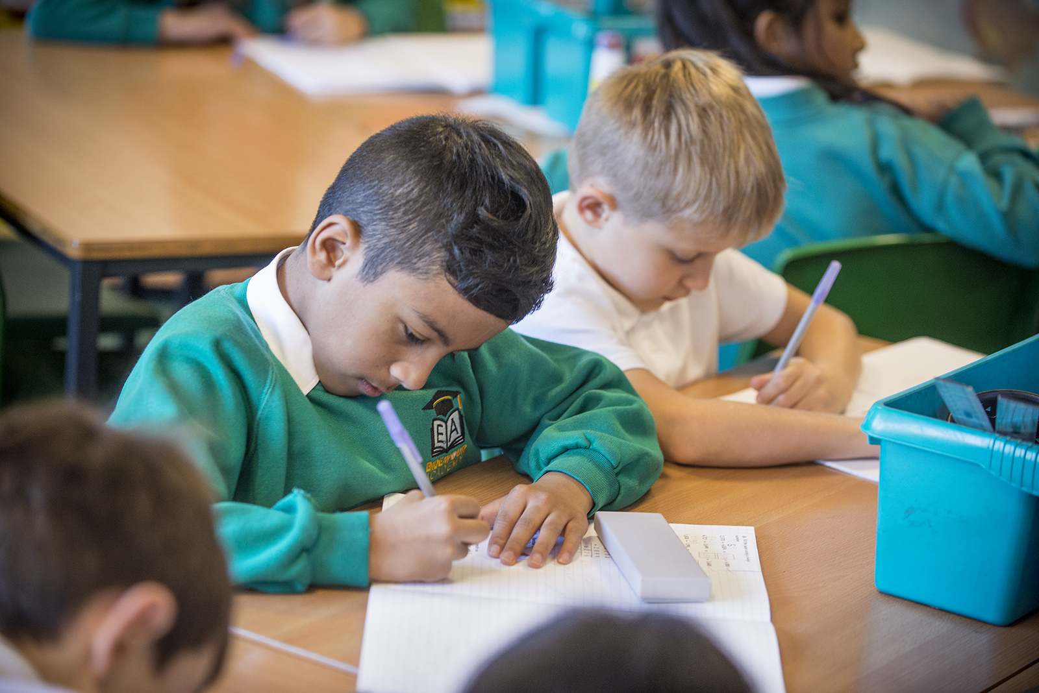
Calculation strategies
Addition
789 + 642 =
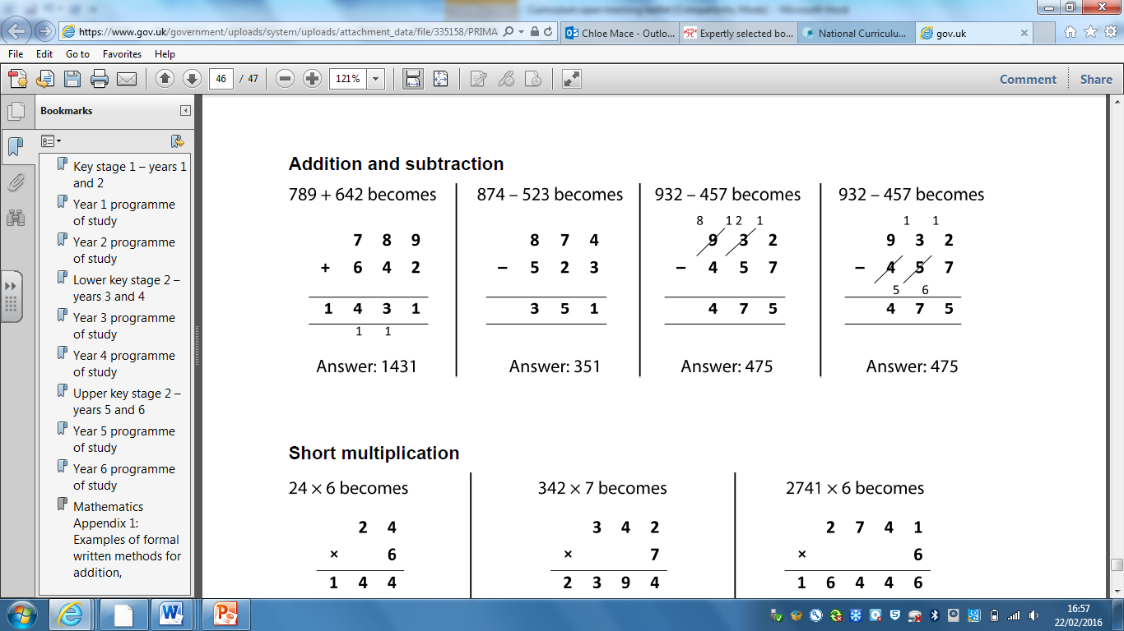
Subtraction
874 - 523 =
Multiplication
4 x 3 = 12
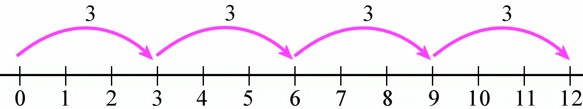
Division
15 ÷ 5 = 3
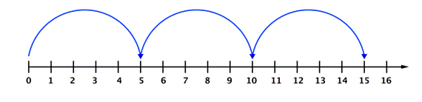

Learning and reflection
At Endeavour, we encourage children to talk about their learning experiences and to explain their reasoning. You can support your child be discussing their day at home.
Reading
What do you predict will happen after…? I predict that…
How do you think the character feels when…? The character feels… because…
Writing
How could you improve this sentence? I would improve it by…
What advice would you give…? My advice would be…
Maths
Do you agree with this calculation?
I agree/disagree because…
How could you prove that…?
To prove that….you need to…
Is this statement/calculation correct?
The …..is/isn’t correct because…
I can prove this by….

General
How were you successful today? I was successful because…
What was the most interesting thing you learnt today? The most interesting thing was… because…

General learning

