T3NPlklkhk
Key Skills English
Writing
Pupils can:
- identify the audience and purpose for their writing
- select appropriate grammar and vocabulary
- in writing narratives, considering how authors have developed characters and settings
- using expanded noun phrases to convey complicated information
- ensure the consistent and correct use of tense throughout a piece of writing
- proofread their writing and use a dictionary to check spellings
- assess the effectiveness of their own and others’ writing
Reading
Pupils can:
- check that the book makes sense to them, discussing their understanding and exploring the meaning of words in context
- infer characters’ feelings, thoughts and motives from their actions, and justifying inferences with evidence
- predict what might happen
- summarise the main ideas drawn from more than one paragraph
- identifying how language, structure and presentation contribute to meaning
- retrieve, record and present information
- participate in discussions about books that are read
- explain and discuss their understanding of what they have read
- provide justifications for their views.

Grammar Pupils can:
- use commas in a list and to clarify meaning
- use expanded noun phrases
- use relative clauses beginning with who, which, where, when, whose, that or with an implied (i.e. omitted) relative pronoun
- recognise vocabulary and structures that are appropriate for formal speech and writing
- use a colon to introduce a list
- punctuate bullet points consistently

Mathematics Pupils can:
- read, write, order and compare numbers up to 1 000 000
- add and subtract whole numbers with more than 4 digits, including using formal written methods (column addition and subtraction)
- divide numbers up to 4 digits by a one-digit whole number
- solve addition and subtraction multi-step problems in contexts, deciding which operations and methods to use and why
- compare and order fractions whose denominators are all multiples of the same number
- convert between different units of metric measure [e.g., kilometre and metre; centimetre and metre; centimetre and millimetre; gram and kilogram; litre and millilitre]
- know rules for angles and apply them

Endeavour Academy


Supporting your child’s learning at home.
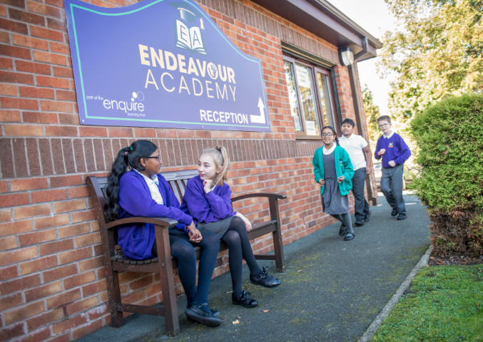

Year 5

``
Recommended Reads!
- Charlotte’s Web by E.B. White
- Clockwork by Philip Pullman
- Danny the Champion of the World by R.Dahl
- The Falcon’s Malteser by A.Horowitz
- The Ghost of Thomas Kempe by P.Lively
- Stig of the Dump by Clive King
- Harry Potter Collection by J.K Rowling
- A Series of Unfortunate events by L. Snicket
- Aquila by Andrew Norris

Apps and Useful Websites
★www.bbc.co.uk/bitesize/ks2 ★www.mathszone.co.uk ★www.topmarks.co.uk ★www.woodlands-junior.kent.sch.uk ★www.coxhoe.durham.sch.uk ★www.horrible-histories.co.uk

Calculation strategies
Addition Subtraction
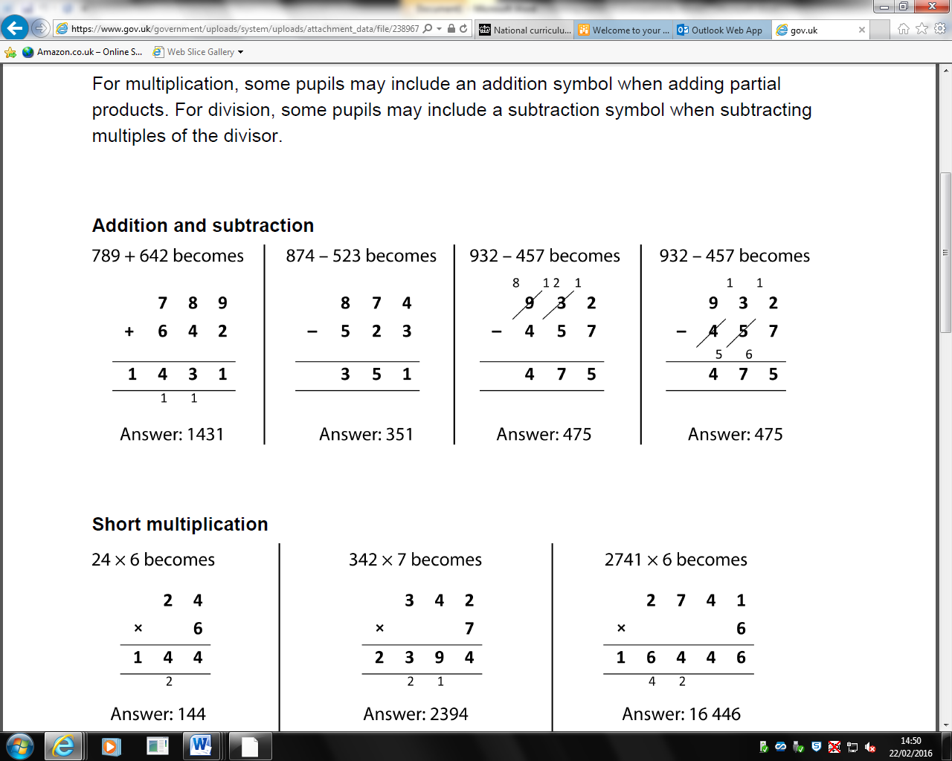 Multiplication
Short Multiplication Long Multiplication

Division
Short Division

Long Division
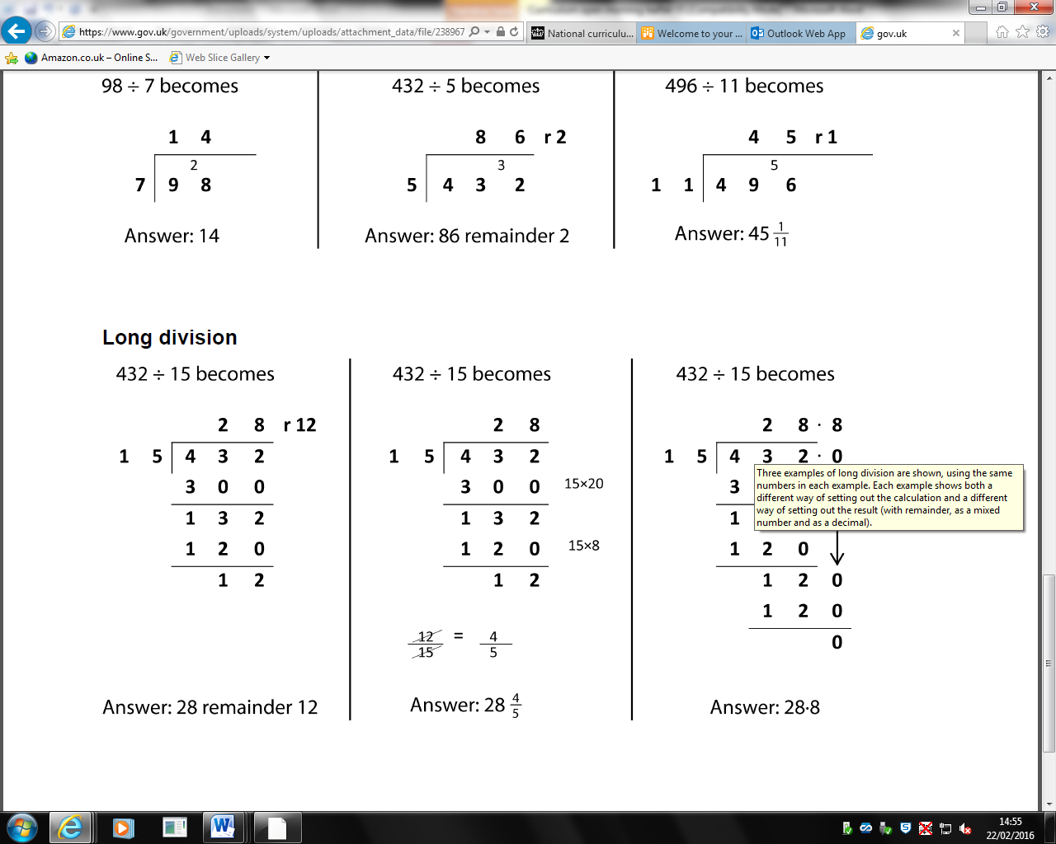

Learning and reflection

At Endeavour, we encourage children to talk about their learning experiences and to explain their reasoning. You can support your child be discussing their day at home.

Reading
- How did the author make you feel? Why?
- How did the character make you feel about…?
- Who else would/wouldn’t enjoy this book? Why?

Writing
- How do you want the author to feel when writing…? Why? What is the intended impact?
- What does your choice of verbs/adverbs tell the reader about your character?
- As an author, how does your writing interest the reader and make them want to continue reading?

Maths
- Can you explain what is wrong with the example below and correct the error?
- Do you agree with this calculation?
I agree/disagree because…
- How could you prove that…?
To prove that….you need to…
- Is this statement/calculation correct?
The …..is/isn’t correct because…
I can prove this by….
To demonstrate this you can…

General
- Is there anything you have learned that will help you with another learning challenge?
- What were your useful learning mistakes?
- When could you apply your learning to another situation?

