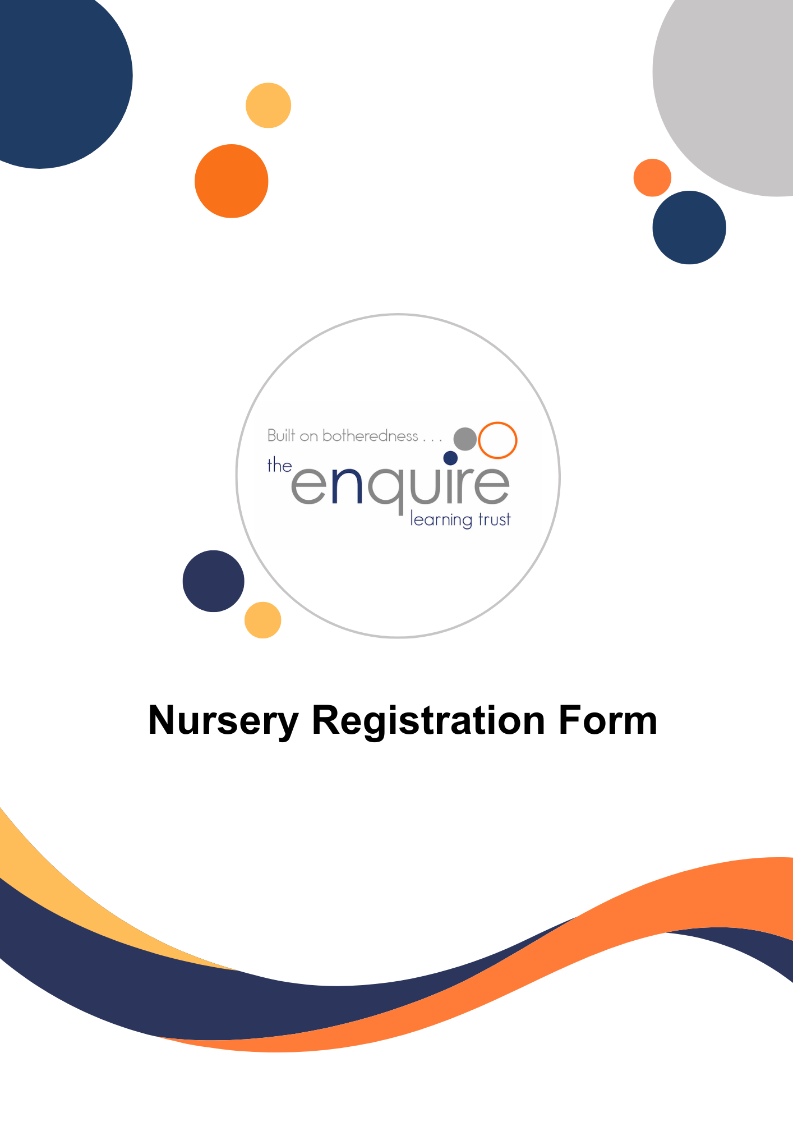


Registration form
Step 1: Registering your interest
Child’s full name
Date of birth |  |  | Gender | Female / Male
Child’s preferred name
(if different)
Home address
Home address | Postcode:
Does your child have any special conditions, disabilities or allergies? |  |  |  | Yes / No
If yes, please describe:
Any other relevant information about the welfare of your child
My child has a Funding code: (please insert code) |  |  |  |  | You can check your eligibility for free childcare at www.childcarechoices.gov.uk.

Details of parents / carers
 | Details of Parent/Carer | Details of Parent/Carer
Full Name
Parent date of birth
Relationship to child
Home Address (if different from Child’s address above)
Employer and address
Home Tel No
Mobile Tel No
Work Tel No
Email Address 1
Email Address 2
Parent National Insurance Number

Details of Nursery place required:
2 year old provision: Full Time / Term Time 3-4 year old provision: Full Time / Term Time
(circle required provision)
Requested date of admission to nursery ____/____/____.
Registration forms will be dealt with in the order that they are received and will be subject to availability of sessions/days required.

Preferred Sessions | Monday | Tuesday | Wednesday | Thursday | Friday
Morning 8.45 – 11:45 (3 hours)
Lunch Session 11.45-12.15 (30 mins)
Afternoon: 12:15 – 3:15 (3 hours)
Morning breakfast club
7:45 – 8.45 (1 hour)
After session club: 3:15 – 5:45
(2.5 hours)
Is there flexibility with your preferred sessions (please circle) | Yes / No | Yes / No | Yes / No | Yes / No | Yes / No

Step 2: Enrolment – your child’s health and safety
Child’s doctor
Address
Telephone number

Child’s health visitor
Address
Telephone number

Does your child require regular medication or have an allergy? |  |  |  | Yes/No
If yes please give details
Has your child been immunised against:
Diphtheria Yes/No | Whooping Cough Yes/No | Tetanus Yes/No | Polio Yes/No | MMR Yes/No

Collection of your child and Emergency contacts
In the interests of safety, children can only be collected by written authorised contacts for whom the nursery has seen photograph identification (such as Drivers Licence or Passport).
Please supply these when enrolling your child. In the case of short notice changes, use of a password provided by the parent/carer may be used in place of photo ID and until this can be provided.
Agreed parental password: __________________________________________________________
Please nominate 2 local emergency people to collect your child if you are not able to collect them (in the event of illness they may need to collect your child within one hour) and give their details below.
Please note: we will require a photograph of each emergency contact to ensure we are releasing your child into safe hands.
Children will only be released into the care of a responsible adult over 18 years old
1st Emergency contact
Name
Address
Phone number
Relationship to child
2nd Emergency contact
Name
Address
Phone number
Relationship to child

The Enquire Learning Trust - Terms and conditions

- Introduction
These terms and conditions apply to all children enrolled at (Nursery Name) and their parents or carers. By enrolling your child, you agree to abide by these terms and conditions.
- Child Protection
If nursery staff are concerned about a pre-existing injury on a child, they have a duty to talk to the parents about it. If there are continuing grave concerns about a child’s welfare the nursery reserves the right to contact the local safeguarding team without permission of the parents in line with our statutory responsibilities to maintain the health and welfare of each child. We are unable to legally deny access of a child to either parent/carer unless there is an active restraining order notified and on our file.
- First Aid
Trained first aiders are always on site to ensure the safe and appropriate treatment of the inevitable minor cuts and bruises that are part of childhood. Every accident that needs treatment is recorded and staff will ensure you are informed of the circumstances and treatment at the end of the day. If a child has any injury to the head, you will be informed immediately as it may be necessary to collect your child early.
- Sickness and Medication
Children should not be brought to Nursery whilst they are suffering with sickness, diarrhea or any other infectious illness until their symptoms have been clear for 48 hours. If a child becomes ill whilst at Nursery, a member of our team will contact you by telephone to ask you to collect your child immediately. If we are unable to contact, you or other parent/guardian we will call the emergency contacts. If serious and required, we will call the child’s doctor.
Prescription and non-prescription medicines will only be administered at school:
- When it would be detrimental to the pupil’s health or school attendance not to do so and
- Where we have parents’ written consent
- Pupils will not be given medicine containing aspirin unless prescribed by a doctor.
Anyone giving a pupil any medication (for example, for pain relief) will first check maximum dosages and when the previous dosage was taken. Parents will always be informed.
The school will only accept prescribed medicines that are:
- In-date
- Labelled
- Provided in the original container, as dispensed by the pharmacist, and include instructions for administration, dosage and storage
The school will accept insulin that is inside an insulin pen or pump rather than its original container, but it must be in date.
All medicines will be stored safely. Pupils will be informed about where their medicines are at all times and be able to access them immediately. Medicines and devices such as asthma inhalers, blood glucose testing meters and adrenaline pens will always be readily available to pupils and not locked away.
Medicines will be returned to parents to arrange for safe disposal when no longer required.
- Sun Care
Parents must provide suncream for their child.
- Special Requirements
If your child has an ongoing medical condition or allergic reaction to certain textures or food, you must inform staff and complete the appropriate nursery medical forms. It is your responsibility to keep staff informed and updated so that relevant and appropriate action can be taken where necessary.
- Dressing for Nursery and Lost Property
We ask that children wear normal day clothes to attend the Nursery, and we recommend that children aged 2 -3 years bring a daily change of clothing in a labelled rucksack. To assist our staff team, we ask that all clothes are labelled, in particular, outdoor garments for use in the garden such as wellington boots, hats, scarves and gloves. The Nursery does not accept liability for the loss of property, unless we have acted negligently, as all items brought in with your child should be clearly labelled.
- Registration / enrolment
If you would like to register your child, please complete our registration form and sign to confirm your agreement to the terms and conditions stated therein. Submitting the registration form does not guarantee you a place at the nursery, and the nursery reserves the right to decline admission based on space availability or other criteria.
Parents must also provide required documentation (i.e. proof of identity) and the nursery will notify parents if any additional information or documents are required.
- Changes to Sessions or cancellation of your nursery place
If you would like to arrange additional sessions at any stage, please contact the manager for availability. We ask for three calendar months’ notice in writing (excluding holiday periods,) if your child is leaving nursery or wishes to reduce sessions, otherwise fees will be charged in full.
- Hours of Operation & Late Collection
The nursery operates from 8.45 am to 3.15pm with wraparound care from 07:45 to 8.45am and 3.15pm to 5.45pm on weekdays, excluding public holidays.
Parents must ensure their child is dropped off and collected within operating hours. If your child is still at nursery after the closing time you will be contacted, along with authorised collectors to make emergency arrangements for your child’s collection. Staff will remain on site with your child for a reasonable time until collection. However, if we cannot contact you or the authorised collector’s staff may be required to contact the local Social Care team. Late pickups may result in additional charges (£5 per 30 mins). Persistent late collections my result in your place at wraparound being revoked for half a term.
- Fees and Payment
Fees are charged termly and must be paid within 14 days of receipt. Payment details will be provided upon registration. Fees must be paid in full even if the child is absent due to illness, holidays, or any other reason. A late fee of £20 may apply if payment is not made on time
- Refund for non-attendance
While the management team will at all times seek to keep the nursery open during the year to promote continuity of care, we will not refund fees if the nursery has to close due to “acts of God” infectious diseases, pandemics, environmental factors (such as snow or flooding), emergency repairs or any other situation outside of the nursery control.
- Photography & Media (Data Protection)
The nursery is required to obtain and process personal and sometimes sensitive information about children and families as part of its registration process for childcare services. The information kept is to support development, monitor progress and provide appropriate care for each child in our nursery. Parents have the right to access their child’s records upon request.
Consent will be gathered via the Trust multi purpose consent form.
- Documentation
A copy of your child’s birth certificate must be seen by the manager before your child can start attending nursery. Please provide this with these forms, it will be returned to you straight away.
Please provide the following information (to be found on entrance forms) that we require about your child in respect of:-
• Any known medical condition, health problem, allergy, or diagnosed dietary requirement;
• Any prescribed medication;
• Any family circumstances or court orders affecting the child
• Any concerns about the child’s safety
• Your contact details and those of your authorised persons who may collect the child
You must ensure that these details are accurate and kept up to date by promptly informing us via Bromcom whenever they
change
- Behaviour and Discipline
The nursery aims to foster a positive and nurturing environment for all children and parents must support the nursery in its efforts to manage behaviour appropriately. The nursery reserves the right to suspend or terminate a child’s placement if their behaviour is deemed disruptive or unsafe.
- Parental Involvement
Parents are encouraged to communicate regularly with the nursery staff about their child’s progress and well-being. Parents should attend parent meetings, events and reviews when scheduled, and any concerns or issues should be discussed with staff in a respectful and constructive manner.

- Withdrawal and Notice Period
A written notice period of 12 weeks (one term) is required if parents wish to withdraw their child from the nursery. The nursery reserves rights to terminate enrolment if fees are not paid or other terms of this agreement are violated.

- Nursery Holidays and Closures
The nursery will be closed on public holidays and Christmas holidays, fees will be adjusted to account for holiday closures where applicable.
- Liability and Insurance
The nursery holds liability insurance to cover accidents or injuries that may occur during nursery hours. Parents are required to notify the nursery of any changes to their child’s health status that may affect their care.

Before signing this registration form you acknowledge the following:
1. You have read the terms and conditions contained within this form
2. You understand the need for the sharing of information with another setting your child attends if appropriate
3. You give your consent for the nursery to hold and process pertinent information about your child

I/We agree that we have had the opportunity to read the nursery’s policies and procedures:
Please print name/s (Parent/Carer):
Signed: _________________________________________________________ Date: ___________________
Signatures: Please sign below to agree to abide by all terms and conditions set out in the registration document.
Please print name (Parent/Carer): ______________________________________________________
Signed: _________________________________________________________ Date: ___________________

Please print name (Parent/Carer): ______________________________________________________
Signed: _________________________________________________________ Date: ___________________
This form will remain in your child’s file in a locked cabinet in the office. If you require a copy please speak to the manager.

Complaints and concerns
Please address any complaint or concern to the manager in the first instance. Should your complaint remain unresolved please ask for a copy of our complaints and compliments policy for further information

