

English Medium Term Plan
Summer Term 1
Week commencing | Phonics focus | Reading focus | Writing focus
Week 1 | - Consolidation of Phase 2-5 | - Reading books from Phase 3 and Phase 5 of Phonics Bug  - Familiarising ourselves with key features such as title, author and blurb  - Noting expression, intonation and punctuation used throughout books  - Use VIPERS skills to discuss comprehension questions  - Reading a class text from our ‘love of reading’ basket | - Year 1 will be introduced to Place Value of Punctuation and Grammar.
Week 2 | - Consolidation of Phase 2-5
Week 3 | - Consolidation of Phase 2-5 |  | - Write a narrative based on Amara and the Bats by Emma Reynolds | 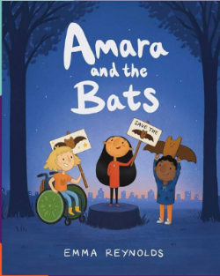
Week 4
Week 5 | - Consolidation of Phase 2-5 |  | - Record facts based on The Bee who Spoke by Al MacCuish and Rebecca Gibbon | 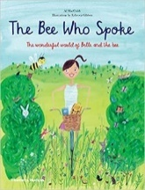
Week 6 | - Consolidation of Phase 2-5 |  | - Write a poem based on The Bee who Spoke by Al MacCuish and Rebecca Gibbon

