

English Medium Term Plan
Summer Term 2
Week commencing | Phonics focus | Reading focus | Writing focus
Week 1 | - Consolidate learning in preparation for Phonics Screening Check | - Reading books from Phase 3 and Phase 5 of Phonics Bug  - Familiarising ourselves with key features such as title, author and blurb  - Noting expression, intonation and punctuation used throughout books  - Use VIPERS skills to discuss comprehension questions  - Reading a class text from our ‘love of reading’ basket | Setting description of the stormy beach | 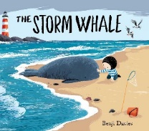
Week 2 | - Phase 6, units 28-30 |  | Setting description of the stormy beach
Week 3 | - Phase 6, units 28-30 |  | Instructions on how to help a stranded whale
Week 4
Week 5 | - Phase 6, units 28-30 |  | Label and caption the animals and what they are doing at the hotel | 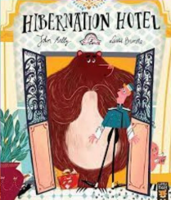
Week 6 | - Phase 6, units 28-30 |  | Retell the story of the Hibernation Hotel
Week 7
Week 8

