Intent
Our maths curriculum is designed to equip every child with the skills, knowledge, and confidence to understand and enjoy mathematics. We believe that maths is essential not only for everyday life—such as managing money, telling time, and solving problems—but also as a foundation for success in a wide range of professional fields, from science and technology to engineering and finance. Our curriculum is designed to develop a strong sense of number, logical reasoning, and problem-solving skills through practical, engaging, and meaningful learning experiences. By fostering a positive attitude and resilience in maths, we aim to ensure that all pupils see its relevance, feel confident in their abilities, and are well-prepared for the next stages of their education and future careers.

The national curriculum for mathematics aims to ensure that all pupils:
- Become fluent in the fundamentals of mathematics, including through varied and frequent practice with increasingly complex problems over time, so that pupils develop conceptual understanding and the ability to recall and apply knowledge rapidly and accurately.
- Reason mathematically by following a line of enquiry, conjecturing relationships and generalisations, and developing an argument, justification or proof using mathematical language
- Can solve problems by applying their mathematics to a variety of routine and non-routine problems with increasing sophistication, including breaking down problems into a series of simpler steps and persevering in seeking solutions.

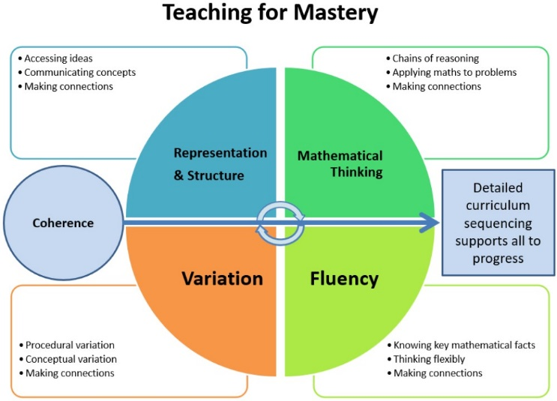
Mathematics is an interconnected subject in which pupils need to be able to move fluently between representations of mathematical ideas. Pupils should make rich connections through the ‘teaching for mastery’ approach to develop fluency, mathematical reasoning and competence in solving increasingly sophisticated problems. Our curriculum is built on these key mastery foundations of variation, fluency, mathematical thinking and representation and structure.

The expectation is that most pupils will move through the programme of study at broadly the same pace. However, decisions about when to progress should always be based on the security of pupils’ understanding and their readiness to progress to the next stage. Pupils who grasp concepts rapidly should be challenged through being offered rich and sophisticated problems before any acceleration through new content. Those who are not sufficiently fluent with earlier material should consolidate their understanding, including through additional practice, before moving on.

EYFS
In Early Years, mathematics involves providing children with opportunities to develop and improve their skills in counting, understanding and using numbers, calculating simple addition and subtraction problems; and to describe shapes, spaces, and measure.
Pupils are taught to:
Number
- Have a deep understanding of number to 10, including the composition of each number
- Subitise (recognise quantities without counting) up to 5
- Automatically recall (without reference to rhymes, counting or other aids) number bonds up to 5 (including subtraction facts) and some number bonds to 10, including double facts.
Numerical Patterns
- Children at the expected level of development will: Verbally count beyond 20, recognising the pattern of the counting system
- Compare quantities up to 10 in different contexts, recognising when one quantity is greater than, less than or the same as the other quantity
- Explore and represent patterns within numbers up to 10, including evens and odds, double facts and how quantities can be distributed equally.

Key Stage 1
The National Curriculum (2014) states that:
The principal focus of mathematics teaching in key stage 1 is to ensure that pupils develop confidence and mental fluency with whole numbers, counting and place value. This should involve working with numerals, words and the four operations, including with practical resources [for example, concrete objects and measuring tools].

At this stage, pupils should develop their ability to recognise, describe, draw, compare and sort different shapes and use the related vocabulary. Teaching should also involve using a range of measures to describe and compare different quantities such as length, mass, capacity/volume, time and money.
By the end of year 2, pupils should know the number bonds to 20 and be precise in using and understanding place value. An emphasis on practice at this early stage will aid fluency.

Pupils should read and spell mathematical vocabulary, at a level consistent with their increasing word reading and spelling knowledge at key stage 1.

Lower Key Stage 2
The National Curriculum (2014) states that:

The principal focus of mathematics teaching in lower key stage 2 is to ensure that pupils become increasingly fluent with whole numbers and the four operations, including number facts and the concept of place value. This should ensure that pupils develop efficient written and mental methods and perform calculations accurately with increasingly large whole numbers.

At this stage, pupils should develop their ability to solve a range of problems, including with simple fractions and decimal place value. Teaching should also ensure that pupils draw with increasing accuracy and develop mathematical reasoning so they can analyse shapes and their properties, and confidently describe the relationships between them. It should ensure that they can use measuring instruments with accuracy and make connections between measure and number.

By the end of year 4, pupils should have memorised their multiplication tables up to and including the 12 times table and show precision and fluency in their work.

Pupils should read and spell mathematical vocabulary correctly and confidently, using their growing word reading knowledge and their knowledge of spelling.

Upper Key Stage 2
The National Curriculum (2014) states that:
The principal focus of mathematics teaching in upper key stage 2 is to ensure that pupils extend their understanding of the number system and place value to include larger integers. This should develop the connections that pupils make between multiplication and division with fractions, decimals, percentages and ratio.

At this stage, pupils should develop their ability to solve a wider range of problems, including increasingly complex properties of numbers and arithmetic, and problems demanding efficient written and mental methods of calculation. With this foundation in arithmetic, pupils are introduced to the language of algebra as a means for solving a variety of problems. Teaching in geometry and measures should consolidate and extend knowledge developed in number. Teaching should also ensure that pupils classify shapes with increasingly complex geometric properties and that they learn the vocabulary they need to describe them.

By the end of year 6, pupils should be fluent in written methods for all four operations, including long multiplication and division, and in working with fractions, decimals and percentages.

Implementation
At Enfield, to make maths lively, hands-on and an interactive subject, we employ a variety of teaching methods including the concrete, pictorial and abstract approach to mastery maths. Children study mathematics daily, covering a broad and balanced mathematical curriculum including elements of number, calculation, geometry, measures and statistics. We focus not only on the mathematical methods, but also on mathematical vocabulary to broaden and deepen mathematical understanding.

We aim for each child to be confident in each yearly objective and develop their ability to use this knowledge to develop a greater depth of understanding to solve varied fluency problems as well as problem solving and reasoning questions. We follow the White Rose Scheme of Learning for maths, supplement this using a wide range of textbooks, resources from NCETM and online resources throughout the school to ensure a curriculum that is specific to each child’s learning needs.

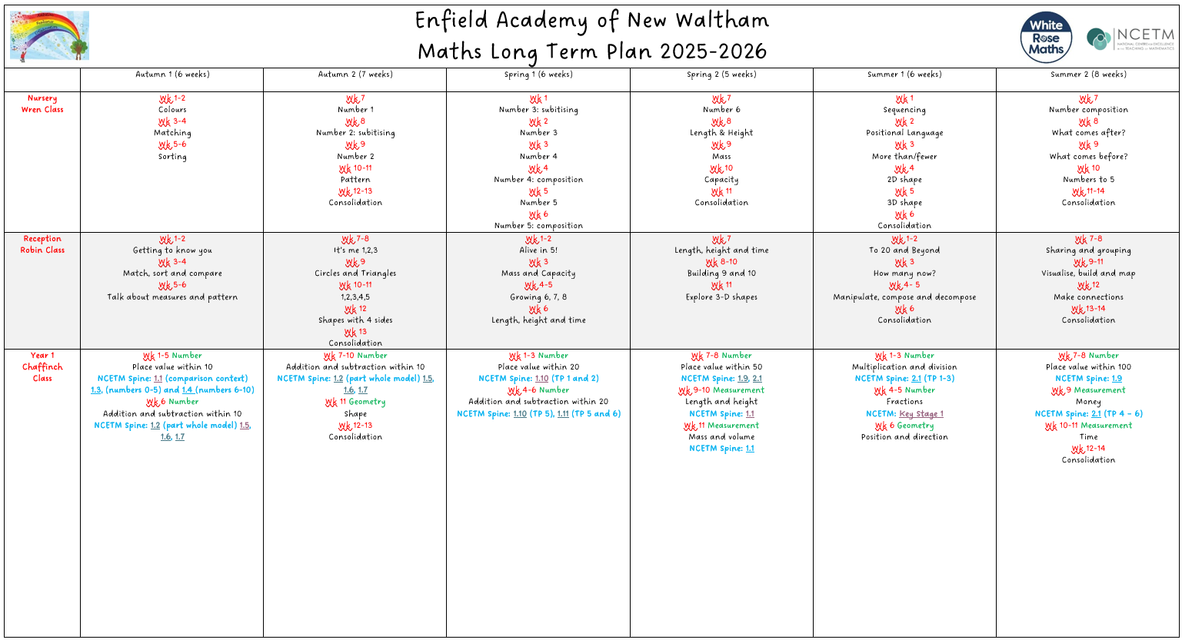

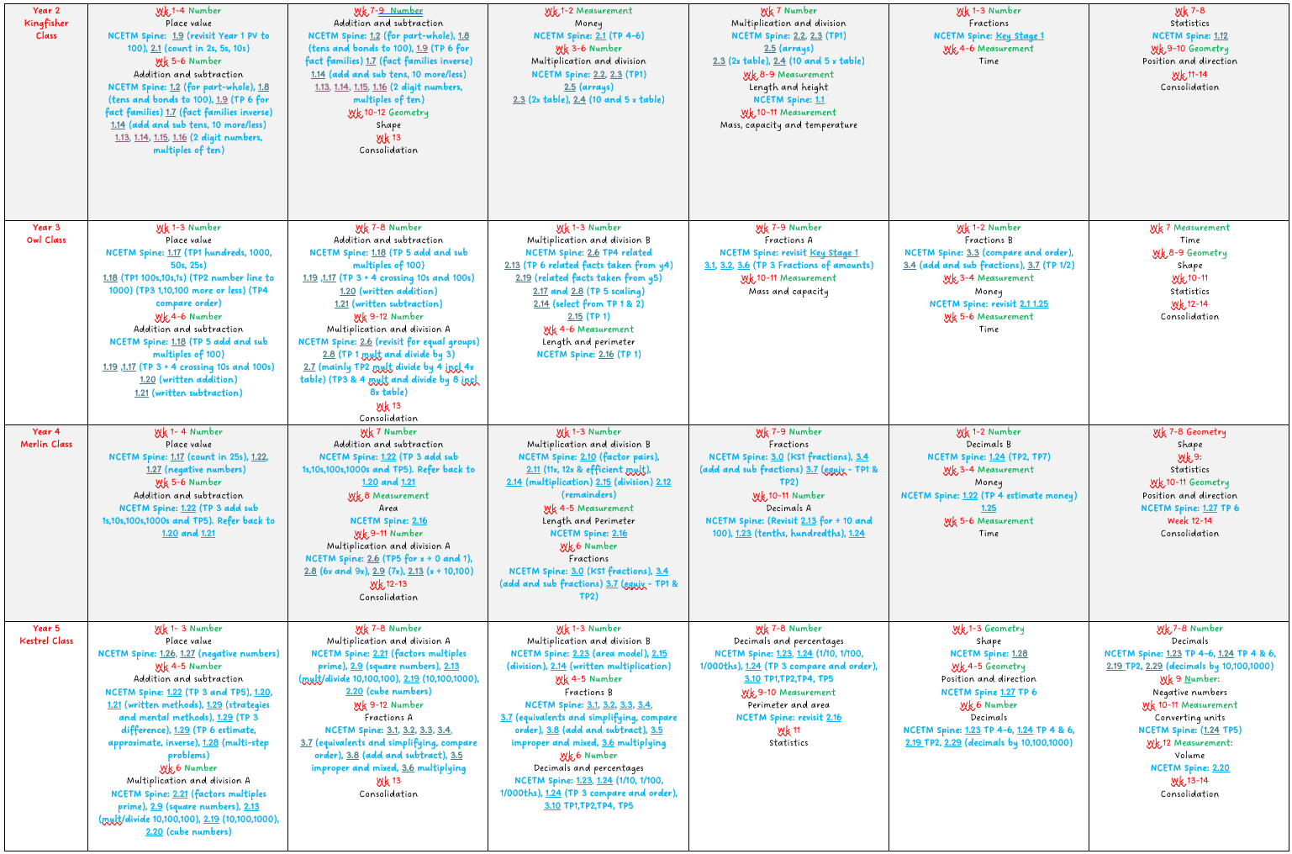
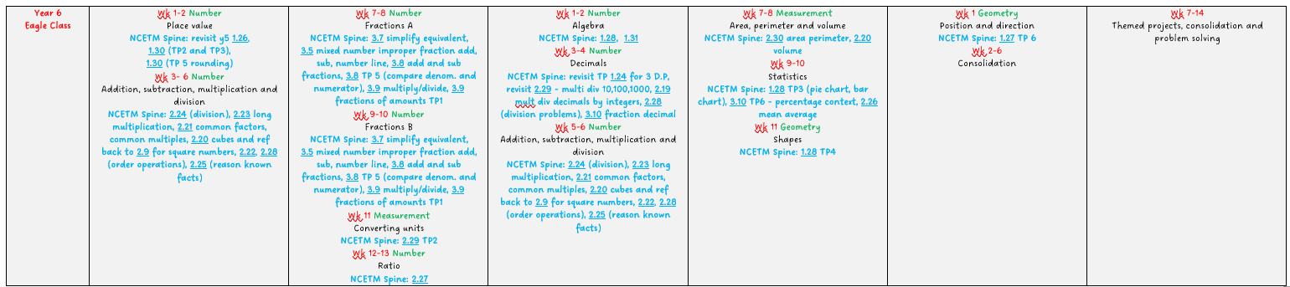

Agreed practices for Maths at Enfield Academy of New Waltham
At our school, we are developing a mastery approach to the teaching and learning of mathematics.
- Long term plans are provided by White Rose and these guide the teaching of mathematical concepts. MTP are supplemented with resources from the NCETM ready to progress and mastery materials (linked on LTP)
- Lessons reflect the school’s calculation policy, securing and supporting conceptual understanding through, concrete, pictorial and abstract approach at each stage of learning.
- Concrete resources and adult support are used to aid children in mastering maths
- Children are provided with daily opportunities to practise written arithmetic and rapid recall of number facts
- Children are provided with daily opportunities to revisit prior knowledge at the start of every maths lesson
- Regular opportunities are provided for children to work together to verbalise their thinking and explain, allowing them to ‘master concepts’, linking to our Voice 21 work
- Deeper learning opportunities, where the children reason and problem solve both verbally and in writing, are evident throughout school and allow the children to apply their skills in a variety of contexts including real life and cross-curricular ones
- Where appropriate, pictorial representations are used to help children to visually solve calculations and problems
- Evidence of practical reasoning activities should be recorded using photographs and shared to school social media
- Working walls in each classroom support children in maths they practise and use
- Teachers use Bromcom to formatively assess children and highlight misconceptions that need addressing regularly
- Planning addresses misconceptions and helps children overcome progress through providing feedback, allowing time for children to respond to this feedback and improve their work to make progress.
- A growth mind-set has been established for both staff and children where learning from mistakes is supported and celebrated
- Work is presented by using variation in questioning. All questions are placed on the left-hand side of the books and working out placed on the right
- Deeper learning questions should have a subheading to make clear from the rest of the work
- Lessons follow the ‘I do, we do, you do’ approach.

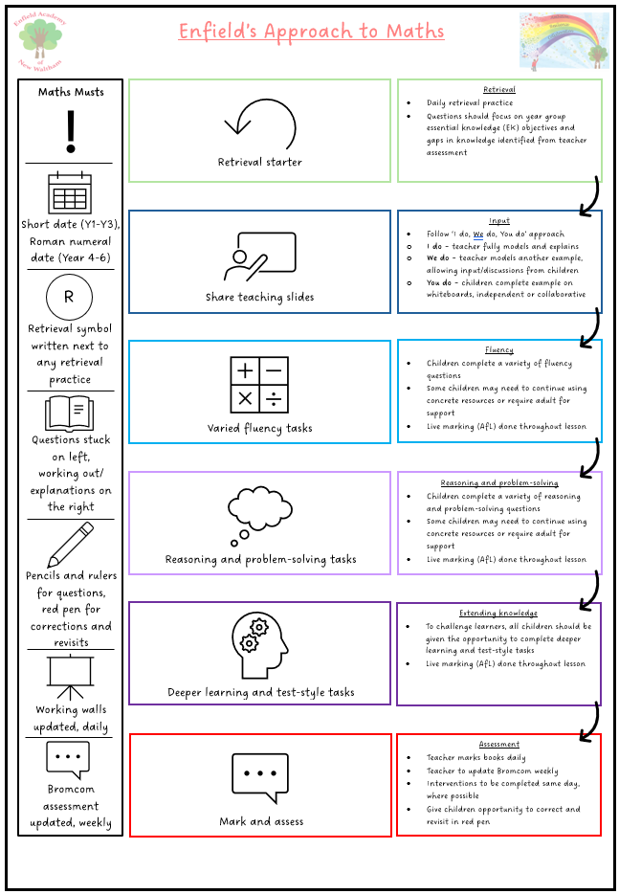

Impact
- Children from Enfield are fluent in the fundamentals of mathematics. Through varied and frequent practice with increasingly complex problems over time, pupils will have the conceptual understanding and the ability to recall and apply knowledge rapidly and accurately.
- Children are happy learners within mathematics. They experience a wide-ranging number of learning challenges in the subject and know appropriate responses to them.
- Children of all abilities and backgrounds achieve well in mathematics, reflected in outstanding progress that reveals a clear learning journey.
- Children talk enthusiastically about their learning in mathematics and are eager to further their learning in the next stages of their education.
- Clear outcomes focus and guide all mathematical development plans and drive improvement.
- Children will be able to reason mathematically by following a line of enquiry, conjecturing relationships and generalisations, developing an argument, justification or proof using mathematical language.
- Children will solve problems by applying their mathematics in a variety of problems with increasing sophistication, including breaking down problems into a series of simpler steps and persevering to seek solutions.
- Learning in mathematics will ensure children understand how mathematics is essential to everyday life, critical to Science, technology and engineering, and necessary for financial literacy and most forms of employment.

