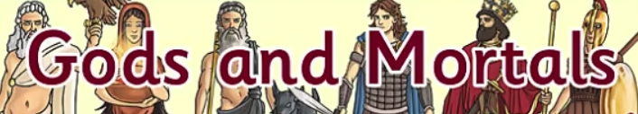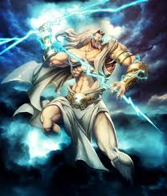

**PSHE**

Think about conflict in their modern daily life, suggesting ways of resolving differences and conflicts. Discuss everyday scenarios and act out ways of finding good solutions. Act as a jury to make a decision about given scenarios, what do they consider a fair resolution to the problem?

**Design Technology**

Make the Minotaur’s head, using a wide range of everyday recyclable materials.

.

**Computing**

Children could work in separate research homes, children, food and warfare would all make interesting research topics. Each group could then give a power-point presentation on their findings.

**History**

Learn about Ancient Greece – a study of Greek life and achievements and their influence on the western world.

Use a range of historical source materials, including books, artefacts, images and information books, to investigate the everyday life of the ancient Greeks, contrasting the lives of the rich and poor. Record their findings using drawings, labels, notes, ICT and written work.

Make connections between the past and present by comparing homes during ancient Greece and present day homes.

**Geography**

Locate Greece on a globe or map, identifying the continent on which it lies and its surrounding countries.

Look at pictures and photographs of the Greek landscape, making judgements about physical aspects of its geography, including weather, terrain and settlements.

