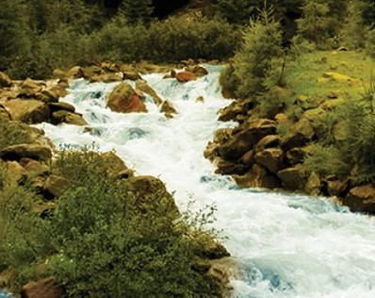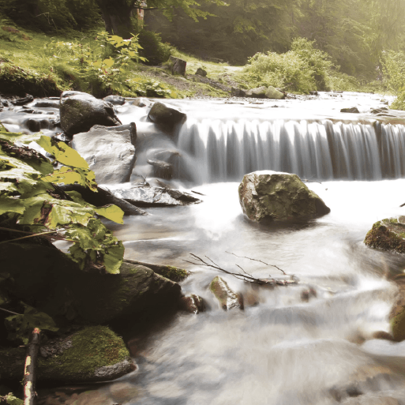

**PSHE**

Learn to identify; personal strengths, skills, achievements and interests and how these contribute to a sense of self-worth.

**Design Technology**

Understand and use mechanical systems in their products (for example, gears, pulleys, cams, levers and linkages).

.

**Computing**

Children could work in separate research homes, children, food and warfare would all make interesting research topics. Each group could then give a power-point presentation on their findings.

**History**

Learn about changes in Britain from the Stone Age to the Iron Age.

Discuss, share and compare their ideas. Use a UK map to find a local or nationally significant town or city situated next to or on a river and use the web and historical source materials to find out why it grew as a settlement. Record their findings using drawings, labels, notes, ICT and written work.

Make connections between the past and present by comparing homes during the iron-age and present day homes.

**Geography**

Children will be able interpret a range of sources of geographical information, including maps, diagrams, globes and aerial photographs to answer questions such as; What river features can be seen? Which animals and plants live there? Is there any human activity taking place along the river?'