

Child’s full name:
Date of Birth: |  | Age:
Gender:
Full Address (including postcode):

When would you like your child to join our setting:
My child has a 2 Year Old Funding code: (please insert code)
My child is entitled to 15 Universal Hour Funding: | You can check your eligibility for free childcare at www.childcarechoices.gov.uk.
Does your child have any suspected or diagnosed special educational needs? If so, please give details:

Parent/Carers with Parental Responsibility
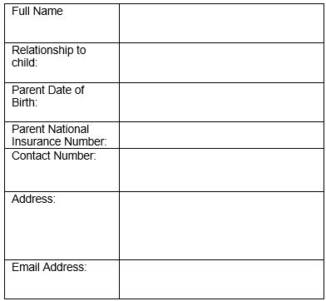
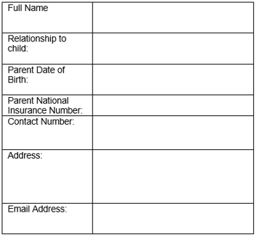

Preferred  Sessions | Before School  7:45am-8:45am | AM Session  8:45am-11:45am | Lunch Session  11:45am-12:15pm | PM Session  12:15pm-3:15pm
Monday
Tuesday
Wednesday
Thursday
Friday



Additional Information: If you have any other information regarding your child you feel we should be aware of, please make a note here.

