

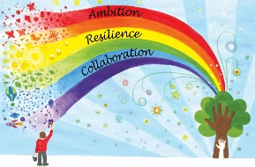
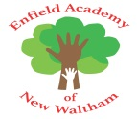
Week commencing | Phonics focus | Reading focus | Writing focus | Spelling focus
Week 1 | - Phonics baseline assessment | - Choosing our ‘love of reading’ books for the term | - Revisit writing our first name and surname confidently | - Can confidently spell their first name and surname  - Can confidently spell words using Phase 3 sounds.  - Can recognise syllables in words with support  - Can spell some year 1 common exception words: said, have, like, so, do, some, come
Week 2 | - Revisit Phase 2 and Phase 3 to consolidate our knowledge | - Reading books from Phase 2 and Phase 3 of Phonics Bug  - Familiarising ourselves with key features such as title, author and blurb  - Noting expression, intonation and punctuation used throughout books  - Use VIPERS skills to discuss comprehension questions  - Reading a class text from our ‘love of reading’ basket | - Picture book – Not Now Bernard by David McKee
Week 3 |  |  | - Traditional tale – Three Billy Goats Gruff
Week 4 |  |  | - Animation – Roadrunner
Week 5 |  |  | - Traditional tale – Little Red Hen
Week 6 |  |  | - Animation – Pink Panther
Week 7 | - Phonics assessment |  | - Picture book – Room on the Broom by Julia Donaldson
Some of the texts and animations we will be learning about this half term:
