

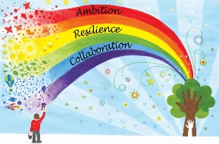
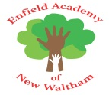
Week commencing | Phonics focus | Reading focus | Writing focus | Spelling focus
Week 1 | - Revisit and consolidate Phase 3  - Focus on blending  - Bug Club Phonics Phase 5, Unit 13-15 | - Reading books from Phase 3, 4 and 5 of Phonics Bug  - Familiarising ourselves with key features such as title, author and blurb  - Noting expression, intonation and punctuation used throughout books  - Use VIPERS skills to discuss comprehension questions  - Reading a class text from our ‘love of reading’ basket | - Picture book – The Story of Little Mole by Werner Holzwarth | - Can confidently spell their first name and surname  - Can confidently spell words using Phase 3 sounds.  - Can recognise syllables in words with support  - Can spell some year 1 common exception words: oh, their, people, Mr, Mrs, looked, called, asked, water, where
Week 2 |  |  | - Traditional tale – Chicken Licken
Week 3 |  |  | - Animation – The Magic Roundabout
Week 4 |  |  | - Picture book – Would you rather by John Burningham
Week 5 |  |  | - Traditional tale – The Gingerbread Man
Week 6 |  |  | - Animation – Captain Pugwash
Week 7 |  |  | - Picture book – The Christmas Pine by Julia Donaldson
Some of the texts and animations we will be learning about this half term:
