

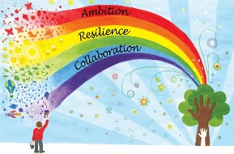

w/c | Phonics focus | Reading focus | Writing focus |  | Spelling focus
Week 1 | - Phase 5, unit 18  - Consolidation of Phase 3-5 | - Reading books from Phase 3 and Phase 5 of Phonics Bug  - Familiarising ourselves with key features such as title, author and blurb  - Noting expression, intonation and punctuation used throughout books  - Use VIPERS skills to discuss comprehension questions  - Reading a class text from our ‘love of reading’ basket | - Picture book – Superworm by Julia Donaldson | 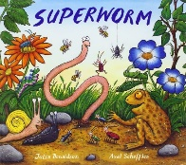 | - Can spell many year 1 common exception words  - Begin to spell words with the Phase 5 sounds  - Can use the ‘s’ suffix for plural nouns  - Can confidently recognise syllables in words.  - Can spell some compound words
Week 2 | - Phase 5, unit 19  - Consolidation of Phase 3-5 |  | - Traditional tale – Hansel and Gretel | 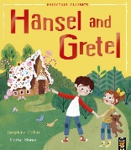
Week 3 | - Phase 5, unit 20  - Consolidation of Phase 3-5 |  | - Animation – Bananaman https://www.youtube.com/watch?v=nz8XTi4nc5Y | 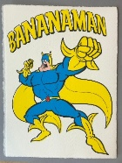
Week 4 | - Phase 5, unit 21  - Consolidation of Phase 3-5 |  | - ‘Ready to start’ Place Value of Punctuation and Grammar
Week 5 | - Phase 5, unit 22  - Consolidation of Phase 3-5
Week 6 | - Phase 5, unit 23  - Consolidation of Phase 3-5

