



Week commencing | Phonics focus | Reading focus | Writing focus |  | Spelling focus
Week 1 | - Phase 5, unit 24 | - Reading books from Phase 3 and Phase 5 of Phonics Bug  - Familiarising ourselves with key features such as title, author and blurb  - Noting expression, intonation and punctuation used throughout books  - Use VIPERS skills to start to write answers to comprehension questions  - Reading a class text from our ‘love of reading’ basket | - Write an invitation to the palace – Halibut Jackon by David Lucas | 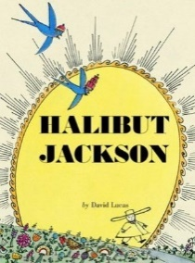 | - Can spell many year 1 common exception words  - Begin to spell words with the Phase 5 sounds  - Can use the ‘s’ suffix for plural nouns  - Can confidently recognise syllables in words.  - Can spell some compound words
Week 2 | - Phase 5, unit 25
 |  |  | - Write a retelling of the story – Halibut Jackson by David Lucas
Week 3 | - Phase 5, unit 26
Week 4 | - Phase 5, unit 27 |  | - Write a letter from Beegu to his parents back home – Beegu by Alexis Deacon | 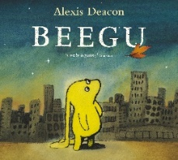
Week 5 | - Consolidation up to Phase 5
 |  |  | - Write a set of instructions guiding Beegu home – Beegu by Alexis Deacon
Week 6 | - Consolidation up to Phase 5

