



Week commencing | Phonics focus | Reading focus | Writing focus |  | Spelling focus
Week 1 | - Consolidation of Phase 2-5 with a focus on reading words | - Reading books from Phase 2 and Phase 3 of Phonics Bug  - Familiarising ourselves with key features such as title, author and blurb  - Noting expression, intonation and punctuation used throughout books  - Use VIPERS skills to discuss comprehension questions  - Reading a class text from our ‘love of reading’ basket | - Describe the hat that has gone missing | 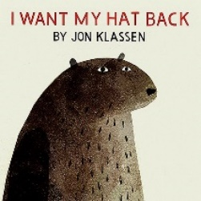 | - Can spell words with the prefix ‘un’  - Can spell words with the suffixes: ing, ed, er, est, where no change is needed to the root word  - Can spell most year 1 common exception words  - Can spell unfamiliar words using plausible graphemes. With support, can use the es suffix for plural nouns
Week 2 |  |  | - Write a poem about the bear
Week 3 |  |  | - Write a list of things Belle needs to pack in her bag | 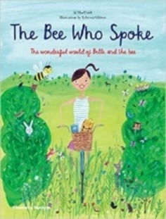
Week 4 |  |  | - Write a non-chronological report about bees
Week 5

