



Week commencing | Phonics focus | Reading focus | Writing focus |  | Spelling focus
Week 1 | - Consolidate learning in preparation for Phonics Screening Check | - Reading books from Phase 5 of Phonics Bug  - Familiarising ourselves with key features such as title, author and blurb  - Noting expression, intonation and punctuation used throughout books  - Use VIPERS skills to discuss comprehension questions  - Reading a class text from our ‘love of reading’ basket | - Write a setting description to describe the storm that took place | 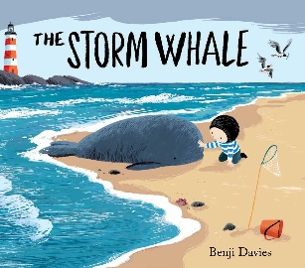 | - Can spell words with the prefix ‘un’  - Can spell words with the suffixes: ing, ed, er, est, where no change is needed to the root word  - Can spell most year 1 common exception words  - Can spell unfamiliar words using plausible graphemes.  - With support, can use the es suffix for plural nouns
Week 2
Week 3 | - Phase 6, units 28-30 |  | - Retell the story of The Storm Whale
Week 4
Week 5 |  |  | - Write a set of instructions for building our own ‘hibernation hotel’ | 
Week 6
Week 7 |  |  | - Write a non-chronological report on North American mammals
Week 8

