
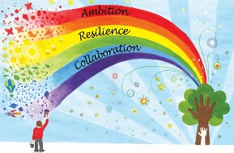
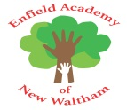
Week commencing | Unit focus | Lesson focus | Fluency focus
Week 1 | Consolidation | - Consolidating knowledge from EYFS | - Consolidating knowledge from EYFS
Week 2 | Place value (within 10) | - Sort objects  - Count objects  - Count objects from a larger group  - Represent objects | - Children will be introduced to the rekenrek, used to develop their understanding of numbers within 20 and the relationships between them
Week 3 | Place value (within 10) | - Recognise numbers as words  - Count on from any number  - 1 more  - Count backwards within 10 | - Children will explore how 5 can be composed of two parts and practise recalling bonds of 5
Week 4 | Place value (within 10) | - 1 less  - Compare groups by matching  - Fewer, more, same  - Less than, greater than, equal to | - Children will explore how the numbers 6, 7, 8 and 9 can all be composed of two parts where 5 is one of the parts
Week 5 | Place value (within 10) | - Compare numbers  - Order objects and numbers  - The number line | - Children will explore representations of the ordinal aspect of number: first, a ‘staircase’ pattern made with Numberblocks, then building blocks and a number track to deepen their understanding of ordinality
Week 6 | Addition and subtraction (within 10) | - Introduce parts and wholes  - Part-whole model  - Write number sentences  - Fact families – addition facts | - Children will consolidate their understanding of the composition of odd and even numbers
Week 7 | Addition and subtraction (within 10) | - Number bonds within 10  - Systematic number bonds within 10  - Number bonds to 10 | - Children will explore the composition of 6

