
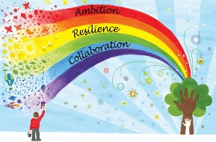

Week commencing | Unit focus | Lesson focus | Fluency focus
Week 1 | Multiplication and division | - Count in 2s  - Count in 10s  - Count in 5s | - This week’s activities begin by looking at how the numbers 11–15 can be composed of ‘10 and a bit’. The children will also represent the composition of these numbers themselves using part–part–whole diagrams and discuss why the ‘teen’ numbers have the digit 1, describing this as ‘one 10’.
Week 2 | Multiplication and division | - Recognise equal groups  - Add equal groups  - Make arrays  - Make doubles | - This week’s activities will provide opportunities for the children to practise comparing numbers by reasoning about their composition. The children will compare the numbers 10 to 15, reasoning about the size of the numbers using their knowledge that these numbers are composed of ‘10 and a bit’.
Week 3 | Multiplication and division | - Make equal groups – grouping  - Make equal groups - sharing | - This week’s activities will support the children to develop fluency in reading and writing expressions and equations to represent familiar number bonds within 10. The focus is on developing a deep understanding of expressions and equations involving the addition/+ and equals/= symbols, rather than calculating unknown sums.
Week 4 | Fractions | - Recognise half of an object/shape  - Find half of an object/shape  - Recognise half of a quantity  - Find half of a quantity | - This week’s sessions support the children to become more fluent in reading, interpreting and writing addition equations. They will explore how ‘first, then, now’ stories for addition can be represented by expressions and then equations, explaining how each number in an equation relates back to the story.
Week 5 | Fractions | - Recognise a quarter of an object/shape  - Find a quarter of an object/shape  - Recognise a quarter of a quantity  - Find a quarter of a quantity | - This week’s activities allow the children to recall the composition of the numbers 6, 7, 8 and 9.

