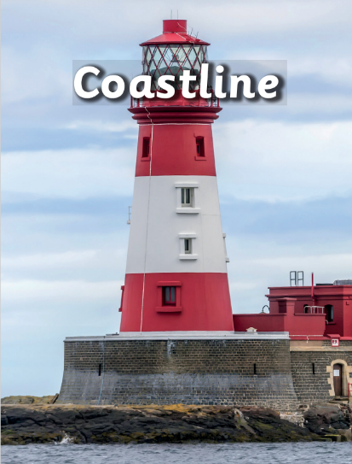

Art – Making a lighthouse

\* Name primary and secondary colours and mix paints to create secondary colours.

\* Join two clay parts together.

\* Cut, roll and coil materials.

PSHE – Families

\* Understand importance and diversity of families

\* Understand the characteristics of healthy, positive family relationships

\* Recognise when they may feel unsafe within a family, and how to ask for help

RE – Islam/Community

*Islam*

\* Understand how people worship

\* Identify and give reasons for key objects associated with prayer

\* Explain key festivals and practices associated with Islam

*Christianity*

Computing – Word processing

\* Organise digital content

\* Navigate the web to conduct simple searches

Design and Technology – Making a lighthouse

\* Use my own ideas to make something and plan what to do next.

\* Explain why I have chosen specific materials.

\* Measure materials to use in a model/structure.

PE –Net and Wall/Yoga

*Net and Wall*

\* Develop racket familiarsation

\* Develop placing an object

\* Use ready poition to defend space on court

\* Develop returning ball with hands

\* Develop returning a ball using a racket

\* Move an opponent to win a point

*Yoga*

\* Copy and repeat yoga poses

\* develop awareness of strength when completing yoga poses

\* Develop awareness of flexibility

\* copy action and linking them into a flow

\* create a flow and teach to a partner

\* explore poses and create a yoga flow

Geography – Human and physical

\* Use appropriate language when working with local maps

\* Can understand keys in a map

\* Explain how areas have been spoilt or improved and give reasons

\* Explain facilities that a town may need and give reasons

\* Explain the importance of the RNLI and beach safety

\* Compare coastlines over time

Science – Plants

\* Describe how seeds and bulbs grow into plants

\* Describe what plants need in order to grow and stay healthy.