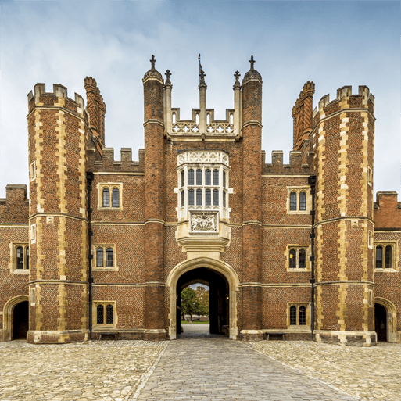

Science – Plants

\* Describe how seeds and bulbs grow into plants

\* Describe what plants need in order to grow and stay healthy.

\* Observe plants growing

\* Recognise deciduous and evergreen trees.

Art – Portraits

\* Examine portraits from the past.

\* Use existing portraits to influence our own artwork.

\* Create our own portrait using pencils and shading effects.

PSHE – Healthy Body, Healthy Mind

\* To understand how we can keep our bodies healthy.

\* Understand how we can keep ourselves safe at home

\* Recognising signs that we are not feeling well.

RE – Sacred Spaces

\* To explore different spaces and why they are special to us.

\* To use our senses to think why a place should be special.

\* To understand what the word sacred means.

\* To explaore religious sacred places.

Computing – Information Technology (taking photos)

\* To be able to take a good photograph and save it

\* To edit photos on an iPad.

\* To be able to collect photos for a Piccollage.

\* To be able to use the programme Paint.Net to edit our photos.

Design and Technology – Making a pupper

\* Choose our material carefully.

\* Explain why I have chosen specific materials.

\* Measure materials to use on a puppet.

\* To research exisiting examples and use these to support our own designs.

\* To evaluate our product using peer critique to support this.

PE – Fielding and striking and athletics

Athletice

\* Running at different speeds.

\* Jumping for distances

\* Throwing for distance

\* To work safely

\* To collaborate with others.

\* To be able to explore their ideas

*Striking and fielding*

\* To develop throwing and catching skills

\* To be able to track a ball

\* To develop skills and bowling and batting

\* To develop tactics

\* To work together as a team.

\* Develop sportsmanship.

History – Magnificent Monarchs

\* To be able to create a sovereign timeline.

\* To be able to examine portraits of historical figures and decide what it tells us.

\* To examine hierarchy and power.

\* To explain why these historial figures are important and the impact they’ve had.

\* To use historical terms and phrases linked to kings, queens and royalty.