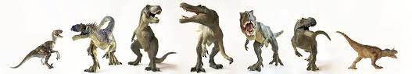  
  
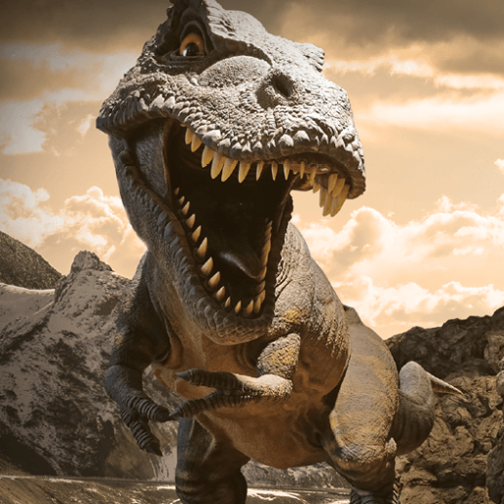

Orange Slices

* Display the Dinosaur skeleton picture cards and invite the children to talk about the fossilised bones. Explain that they are going to create a dinosaur skeleton using the art straws.
* Explain to the children that nobody knows what colour the dinosaurs were or what their skin looked like. Use this as a prompt for the dinosaur design activity exploring colour and texture.
* Display the Cave painting picture cards and the Prehistoric mammal picture cards. Offer the children black paper, chalks and pastels to draw pictures of the prehistoric animals. Create a cave painting mural with the children's artwork.
* Display the Ammonites picture cards and explain that ammonites were prehistoric snail-like animals that lived in the sea and all that remain is their fossilised shells. Look carefully at the pictures of ammonites together. Ask them to draw different sized spirals all over the paper. When they have completed this, offer watered-down, ready-mixed paint in a variety of colours and show the children how to paint over the marks to make a wax resist picture.
* Teach the children the tiny turtle song.
* Create salt-dough fossils.

Orange Slices

Children will engage with a range of varied ‘Finger Gym’ activities to encourage fine motor, these will include skills linked to dressing and basic self-care. Further, there will be a high importance placed upon self-hygiene and handwashing throughout the school day.

* Move like a dinosaur activity ft. Jurassic Park theme tune (using picture cards)
* Moving dinosaur split pin activity
* Play a game based on Duck Duck Goose with the children, but using stegosaurus and T rex.

In PE sessions we use ‘Get Set 4 PE’. This half term, the children will be taking part in a unit focused on ‘Dance’. In this unit, children will develop their expressive movement through the topic of 'everyday life'. Children explore space and how to use space safely. They explore travelling movements, shapes and balances. Children choose their own actions in response to a stimulus. They are given the opportunity to copy, repeat and remember actions. They are introduced to counting to help them keep in time with the music. They perform to others and begin to provide simple feedback.

Orange Slices

As part of this area of learning, we incorporate key festivities and significant occasions as they are met throughout the year.

* Prehistoric safari activity with spotting sheet
* Dinosaur shadow activity with torches and dinosaur models
* T-Rex letter prompt to inspire creating a map (class & individual) of Dinosaur Island

Orange Slices  
  
Fancy Matter personal use

Broadway Regular



We follow a Power of Reading approach to learning, which places children’s literature at the heart of all learning (see separate MTP). Alongside this, we enrich the children’s learning experience through further texts linked to their topic theme.

* Share the story ‘If I had a dinosaur’ by Gabby Dawnay. Discuss the things that the girl would do if she had a dinosaur for a pet. Invite the children to talk about what type of dinosaur they would like for a pet and why – use question prompts.
* Read the story ‘Dear Dinosaur’ by Chae Strathie. Invite the children to talk about the letters that T. Rex and Max sent to each other.
* When the children have asked their questions, explain that they are going to write a letter to a dinosaur. Provide them with the Dinosaur letter and postcard template, sound mats and the Dinosaur word mat.
* Set up an adventure reading trail using the Dinosaur trail pictures cards. Support the children to read the clues and then find the corresponding pictures.
* Hide the Dinosaur bones word cards in a sand tray with dry sand. Invite the children to take turns to dig out a card and read the word.
* Share the Dinosaur fun facts presentation with the children and invite them to share their thoughts about the facts that they have heard – explore question writing.
* Display the Dinosaur matching word cards and the Dinosaur matching picture cards. Explore which matches which.

Orange Slices

We follow the White Rose Scheme of Learning for maths, which offers clear progression to children’s learning (see separate MTP). Alongside this, we enrich the children’s learning experience through further mathematical learning experiences linked to the topic theme.

* Stegosaurus maths peg game
* Dinosaur shape activity. Invite the children to handle the shapes, name them and discuss their properties. Explain that they are going to use the shapes to create a dinosaur.
* How many dinosaurs? Counting/subitising activity
* Use the Tyrannosaurus footprint picture card to make a paper footprint. Ask the question 'How many of our footprints would fit inside the tyrannosaurus' footprint?'
* Favourite dinosaur class vote activity using pictogram

Orange Slices

* After watching the ‘Dangerous Dinosaurs’ video, explore what they already know and what they would like to know. They must only talk when they have the dinosaur toy.
* Display the Prehistoric animals’ picture cards – explore whether each animal is extinct or not. Use two hoops to help sort.
* Dinosaur egg activity. Invite the children to talk about what they think is in the box, using the clues on the outside.
* Volcano experiment activity exploring what a volcano is and showing visual representation using bicarb and vinegar.
* Display the Armoured dinosaurs picture cards and ask, 'Why do you think these dinosaurs have spikes, plates and horns?' Use understanding to design own dinosaur and label.
* Carnivore and herbivore sorting activity.
* Share the story Cave Baby by Julia Donaldson. After reading the story, show the children the Prehistoric mammal picture cards. Explore extinction and cave paintings through this.
* Ask the children the question 'Do dinosaurs still exist?' Use the presentation. Discuss the information in the presentation and encourage the children to describe the animals they have seen.

Orange Slices

* Share the story Tyrannosaurus Drip by Julia Donaldson. Invite the children to talk about how the different dinosaurs behaved in the story and discuss how we are all different. Ask the question 'If a dinosaur came to visit, what would it need to know so that it could follow our class rules?' Invite the children to share their answers.