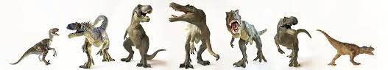  
  
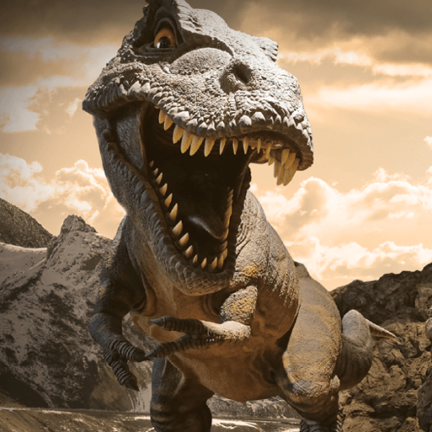

Orange Slices

* Children to make salt dough and use the small work dinosaurs to make different footprints..
* Explain to the children that nobody knows what colour the dinosaurs were or what their skin looked like. Use this as a prompt for the dinosaur design activity exploring colour mixing.
* Display the Cave painting picture cards get the children to use chalk and black paper to make shapes and marks, recreating their own artwork.
* Get the children to explore collage, can they use different coloured green paper to complete a dinosaur template. Children to be able to recognise the colours they are using, we will encourage talk about why they are choosing those colours.
* Teach the children the tiny turtle song.
* In the mud kitchen the children will be creating a dinosaur feast, using the available resources to pat, shape, scoop and sprinkle..

Orange Slices

Children will engage with a range of varied ‘Finger Gym’ activities to encourage fine motor, these will include skills linked to dressing and basic self-care. Further, there will be a high importance placed upon self-hygiene and handwashing throughout the school day.

* Move like a dinosaur activity ft. Jurassic Park theme tune (using picture cards)
* Make fossil prints in the playdough
* Play a game based on Duck Duck Goose with the children,but using stegosaurus and T rex.

Children will be outside daily using the provision. They will be encouraged to be explorers making obstacles, and working together to discuss how to get round any dangers that may occur. The children will spend time on the bikes and scooters focusing on spatial awareness. Can they move/ride safely around each other?

We will play musical dinosaurs, when the music stops we will freeze like a dinosaur, encouraging the children to think about balance and the shapes that they will make.

Orange Slices

As part of this area of learning, we incorporate key festivities and significant occasions as they are met throughout the year.

* Children to collect natural resources outside and sort them, discuss how they are being sorted.
* Explore shadows dinosaurs make, using toy dinosaurs and torches.
* Children to understand how we care for things.

**Wren MTP**  
  
Summer One

Broadway Regular



We follow the Drawing Club approach to learning, which places children’s literature at the heart of all learning (see separate MTP). Alongside this, we enrich the children’s learning experience through further texts linked to their topic theme.

* Share the story ‘If I had a dinosaur’ by Gabby Dawnay. Discuss what they would do if they had a dinosaur as a pet.
* Read the story ‘Dear Dinosaur’ by Chae Strathie. Invite the children to talk about when they might send a letter, children to visit the local post box and post a letter.
* When the children have asked their questions, explain that they are going to write a letter to a dinosaur. Provide them with the Dinosaur letter and postcard template.
* Set up an adventure reading trail using the Dinosaur trail pictures cards. Support the children to follow the clues and then find the corresponding pictures.
* Hide the Dinosaur bones word cards in a sand tray with dry sand. Invite the children to take turns to dig out a card and can they recognise letter/sounds?
* Share the Dinosaur fun facts presentation with the children and invite them to retell what they know about dinosaurs using small world resources.
* Write a code to make a dinosaur come and visit our classroom..

Orange Slices

We follow the White Rose Scheme of Learning for maths, which offers clear progression to children’s learning (see separate MTP). Alongside this, we enrich the children’s learning experience through further mathematical learning experiences linked to the topic theme.

* Children will be look at sequencing.
* We will be discussing positional language, encouraging the children to follow simple instructions ‘put the dinosaur on top of the brick’.
* Children will be looking at language more than and fewer.
* We will be building with 2D shapes and making shape print pictures.
* The children will be using wooden 3D blocks to build a dinosaur cave.

Orange Slices

* Enjoy listening to dinosaur stories and then retell them. They must only talk when they have the dinosaur toy.
* Display the Prehistoric animals’ picture cards and pets they may be familiar with, can they sort these into pets and animals that are extinct.
* Dinosaur egg activity. Invite the children to talk about what they think is in the box, using the clues on the outside.
* Volcano experiment activity children to extend sentences when discussing what they think might happen, discuss what a volcano is.
* Display the Armoured dinosaurs picture cards and ask, 'Why do you think these dinosaurs have spikes, plates and horns?' Can they express their own opinions on this?
* Look at creating a dinosaur world, where did they live?.
* Can they sort dinosaurs that fly and ones that don’t, why do they think this?.
* Ask the children the question 'Do dinosaurs still exist?' Use what they know to help them. Take turns and listen to each other.

Orange Slices

* Share the story Tyrannosaurus Drip by Julia Donaldson. Invite the children to talk about how the different dinosaurs behaved in the story and discuss how we are all different. Get the children to revisit Wren’s class rules. What rules do they need to teach the dinosaur when he comes to visit Wren class?