Autumn Topic 1 | Autumn Topic 2 | Spring Topic 1 | Spring Topic 2 | Summer Topic 1 | Summer Topic 2
Text:  Fortunately, the Milk by Neil Gaiman  ​​  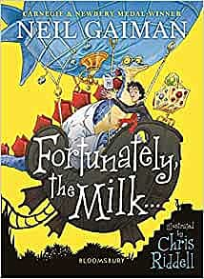 | Text:  Pugs of the Frozen North by Philip Reeve and Sarah McIntyre  ​ 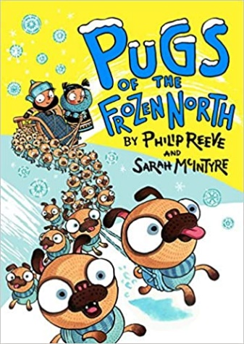 | Text:  I Was a Rat by Philip Pullman  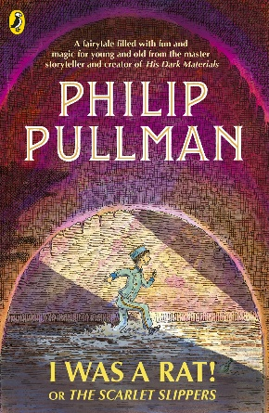 | Text:  Leon and the Place Between by Grahame Baker-Smith  ​​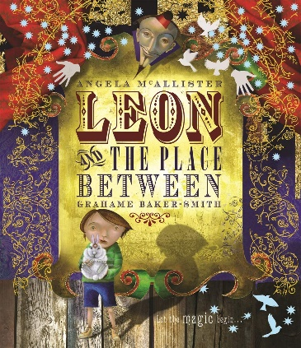 | Text:  Krindlekrax by Philip Ridley  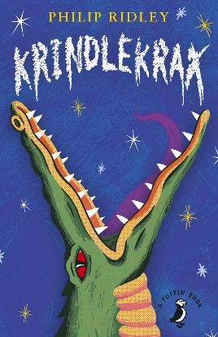 | Text:  The Boy who Grew Dragons  ​​  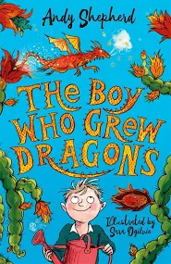
Text Types:  WE – Setting Description  WP – Informative poster | Text Types:  WI - Explanation - leaflet  WE - Stories | Text Types:  WI- Newspaper Report  WE - Story | Text Types:  WI - Letter  WE - Stories  WE - Poetry | Text Types  WE - Character description.  WP - Writing a letter to persuade  WI - biography | Text Types:  WP-Writing to persuade-poster  WI- Explanation- of plant growth  WE-Stories- an adventure to where.
Text Features  Setting Description  - Expanded noun phrases.  - Detailed description.  - Fronted adverbials.  - Paragraphs.  Informative Poster-  - Planned repetition  - Facts and Statistics  - Relative clause  SPaG Lesson Coverage  - Nouns & Pronouns for clarity  - Consonants & vowels  - Suffixes -ly  - Past Tense  - Subordinate Clauses | Text Features  Explanation  - Paragraphs used to group related ideas.  - Subheadings to label content.  - Relative clause.  Stories  - Detailed description - adjectives  - Paragraphs to organise in time sequence.  - Present perfect tense.  SPaG Lesson Coverage:  - Adjectives (recap)  - ‘A’ or ‘An’  - Present Tense  - Apostrophes  - Organisational devices  - Paragraphs | Text Features  Newspaper  - Layout features - headline ect.  - Paragraphs to organise in time sequence - time adverbials  - Paragraphs used to group related ideas.  - Direct speech for quotes.  Story  - Paragraphs used to group related ideas.  - Expanded noun phrases  - Setting description.  - Conjunctions  SPaG Lesson Coverage:  - Verbs inc: present perfect  - Compound Nouns (recap)  - Subordinating Conjunctions  - Inverted Commas | Text Features  Letter- to inform  - Letter layout Paragraphs used to group related ideas.  - Commas for a list  - Present perfect tense.  Story  - Setting description  Expanded noun phrases.  - Fronted adverbials.  Poem  - Oracy - performance  - Detailed description - Expanded noun phrases.  - Similes  - Alliteration.  SPaG Lesson Coverage:  - Adverbs - Time & Place & Cause  - Coordinating conjunctions | Text Features  Character Description  - Expanded noun phrases  - Paragraphs  Letter - Persuade  - Imperative verbs.  - Letter layout  - Rhetorical questions.  - Exaggeration  Biography  - Paragraphs used to group related ideas.  - Relative clauses  - Third person  - Chronological order  - Subheadings  - Facts  SPaG Lesson Coverage:  - Prepositions  - Time conjunctions  - paragraphs | Text Features  Persuasive Poster  - Use of colour and images.  - Planned repetition  - Use of 2nd person.  - Power of three  - Rhetorical questions  - Exaggeration  Explanation  - Paragraphs used to group related ideas.  - Subheadings to label content.  - Place and cause conjunctions  Story  - Use paragraphs to organise in time sequence- time adverbials.  - Expanded noun phrases  - Fronted adverbials  SPaG Lesson Coverage:  - Homophones  - Word families  - Place & cause conjunctions  - Editing and evaluating

Spelling Progression - Copyright © 2022 Education Shed Ltd

Year 3 | Autumn 1 | Autumn 2 | Spring 1 | Spring 2 | Summer 1 | Summer 2
Week 1 | Step 1  Words where the digraph  ‘ou’ makes an /ow/ sound  mouth, sprout, around, sound, spout, ouch, hound, trout, found, proud | Step 7  Words with the prefix ’re-’  redo, return, refresh, redecorate, reappear, review, replay, reaction, rebound, revenge | Step 13  Words with the digraph  ‘ai’ and tetragraph ‘aigh’  straight, strainer, fainted, claimed, waist, snail, painter, chained, failure, waiter | Step 19  Words ending in ‘al’  arrival, burial, comical, magical, emotional, national, personal, optional, survival, tropical | Step 25  Words with the suffix  ‘-er’  teacher, stretcher, dispatcher, catcher, butcher, richer, scorcher, preacher, cruncher, watcher | Step 31  Words ending in ’-sion’  vision, confusion, division, television, invasion, erosion,  collision, decision, fusion, revision
Week 2 | Step 2  Words where the digraph  ‘ou’ makes a /u/ sound touch, double, country, trouble, young, cousin, enough, couple, encourage, flourish | Step 8  Words with the prefix ’dis-’  disappoint, disobey, disappear, disapprove, disable, dislike, dislocate, disadvantage, dislodge, disagree | Step 14  Words with the digraph  ‘ei’ and tetragraph ‘eigh’  freight, vein, weigh, reins, eight, eighteen, reign, veil, neighbour, sleigh | Step 20  Words ending in ‘le’  battle, settle, article, humble, struggle, terrible, possible,  example, capable, adjustable | Step 26  Words where the digraph ‘ch’ makes a /k/ sound  scheme, chorus, echo, chemist, character, stomach,  monarch, school, anchor, chaos | Step 32  Challenge Words  special, strange, difficult, important, length, perhaps,  position, pressure, question, purpose
Week 3 | Step 3  Words where ‘y’ makes an /i/ sound  symbol, gym, myth, synonym, Egypt, lyrics, pyramid, system, mystery, gymnastics | Step 9  Words with the prefix ’mis-’  mistake, mislead, misbehave, misspell, misplace, misread, mistrust, misunderstanding, misuse, mislaid | Step 15  Words where the digraph ‘ey’ makes an /ai/ sound  obey, osprey, prey, disobey, they, convey, they, survey, surveyor, conveyor, grey | Step 21  Words ending in ‘-ly’ where the base word ends in ‘le’  gently, simply, humbly, nobly, durably, terribly, incredibly, responsibly, wrinkly, possibly | Step 27  Words ending in ‘-gue’ and ‘-que’  vague, league, plague, fatigue, antique, dialogue, unique, grotesque, plaque, mosque | Step 33  Revision Words  exactly, bravely, pleasure, dislocate, island, decide,  disadvantage, survey, ordinary, promise
Week 4 | Step 4  Words ending in  ‘-sure’  treasure, measure, leisure, pleasure, pressure, exposure, enclosure, closure, disclosure, composure | Step 10  Words where ‘-ing’, ‘-er’ and ‘-ed’ are added to multisyllabic words  developing, developed, limiting, covering, limited, gardening, gardener, covered, listening, listened | Step 16  Words with the  suffix ‘–ly’  calmly, exactly, deadly, bravely, boldly, gladly, deeply, clearly, hourly, quickly | Step 22  Words ending in ‘-ly’ where the base word ends in ‘-ic’  basically, frantically, logically, tragically, magically, publicly, dramatically, historically, automatically, specifically | Step 28  Words where the digraph  ‘sc’ makes a /s/ sound  science, scene, discipline, scissors, ascends, scented, fascinate, scenery, crescent, descend | Step 34  Revision Words  freight, hourly, missed, scented, suppose, plaque, grotesque, daily, descend, automatically
Week 5 | Step 5  Words ending in  ‘-ture’  adventure, future, picture, nature, creature, furniture, capture, sculpture, fracture, mixture | Step 11  Words where ‘-ing’, ‘-en’ and ‘-ed’ are added to multisyllabic words  forgetting, forgotten, beginning, propelled, preferred, permitted, regretting, committed, forbidden, equipped | Step 17  Words that are homophones  great, main, grown, missed, meet, grate, mane, groan, mist, meat | Step 23  Words ending in ‘-ly’; exceptions  truly, slyly, fully, duly, shyly, wholly, drily, coyly, happily, daily | Step 29  Words that are homophones  ball, bawl, break, brake, male, mail, fair, fare, berry, bury | Step 35  Revision Words  teacher, scheme, history, mention, bawl,  crescent, eighteen, regular, mane, disable
Week 6 | Step 6  Challenge Words  actual, bicycle, answer, circle, earth, enough, island, fruit, often, popular | Step 12  Challenge Words  centre, disappear, heart, minute, regular, decide, early, learn, notice, therefore | Step 18  Challenge Words  build, describe, imagine, library, natural, ordinary, promise, recent, suppose, weight | Step 24  Challenge Words  address, mention, arrive, occasionally, certainly, probably, experience, reign, history, sentence | Step 30  Challenge Words  accidentally, breathe, century, eight, consider, guard, heard, peculiar, possible, quarter | Step 36  Revision words  disappear, specifically, reaction, committed, misunderstanding, forbidden, capable, neighbour, personal, confusion

