Enfield Academy of New Waltham- History Long Term Plan 2024-2025
 | Autumn 1 | Autumn 2 | Spring 1 | Spring 2 | Summer 1 | Summer 2
 | Geography | Geography/PSHE | History | History | Geography | History
Nursery |  |  | Geography  Seasons and Weather  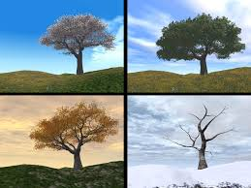 | Cultural Capital  On the Farm  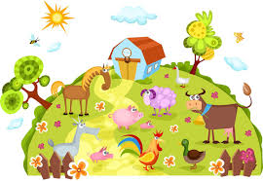 |  | Superheroes and Me  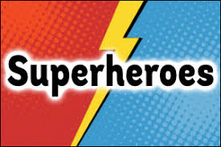
Reception |  |  | Geography  Seasons and Weather  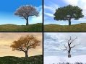 | Cultural Capital  On the Farm |  | Superheroes and Me
Year 1 |  |  | Hospitals and Healthcare    This unit explores how Florence Nightingale and Edith Cavell have had an impact on hospitals and healthcare today. The children will look at each of them in turn, exploring why they acted in the way they did and why they are still remembered. Comparisons are made between hospitals and healthcare of the past and the modern day. | Toys Through Time  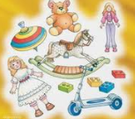  This unit looks at the changes in toys over the past 60 years. The children will begin by looking at and comparing modern-day toys. Each lesson then looks back a little further in time, with the children looking at the toys they played with when they were babies and the toys their parents had, and concludes with them looking at their grandparents’ toys. |  | Famous Explorers  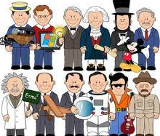  This unit looks at how explorers of the past have made significant discoveries and shaped the world that we live in. The lessons will look at the different places that have been explored so far, such as below the sea, the world’s continents and even space. Children will also have the opportunity to consider the places on Earth that are still to be explored.
Year 2 |  |  | Kings, Queens and Castles  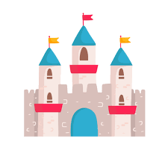  This unit explores where monarchs have lived in the past up to the present day. The children will look at the different kings and queens in time order, starting with King Charles III and going back in time until William I. The children will discuss and compare the different castles they lived in and the lives they led. | Then and Now  (Changes in Technology)  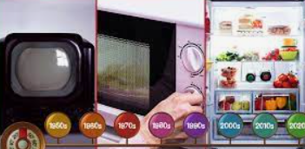  This unit explores how technology has changed over the past 60 years. Children will consider how technology has changed the way we talk, write and are entertained. The unit includes a focus on Tim Berners-Lee as a significant individual and explores his contributions to the advancement of the World Wide Web. |  | The Great Fire of London  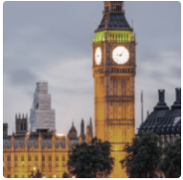  This unit explores the cause and consequences of the Great Fire of London. Children will go back in time and ‘meet’ the individuals involved and discuss how Londoners responded to the fire. Children will learn about significant individuals such as Samuel Pepys and Christopher Wren.
Year 3 |  |  | Stone Age  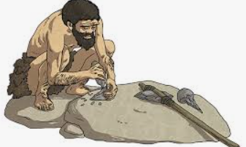  In this unit, children learn about prehistory in Britain and how we find out about prehistory. They discover what life was like through each of the main time periods of the Stone Age, right through to the Iron Age. Children learn about how civilisation started, and how agriculture became so important for survival and how different metals, such as bronze and iron, changed how we interacted with each other. |  |  | Ancient Egypt  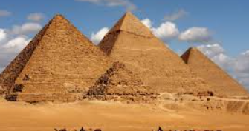  This unit explores how early civilisation started in Egypt. The children will discover how the upper and lower kingdoms joined together to create the Old Kingdom of Ancient Egypt. Comparisons are made between the timelines of Ancient Egypt and Neolithic Britain. The children will then learn all about the Egyptian gods, what Ancient Egyptians believed about the afterlife, how the pyramids were built and some of the greatest pharaohs in all of Egypt’s history.
Year 4/5 |  |  | Ancient Mayans  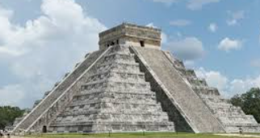  This unit explores the Ancient Maya civilisation and its achievements from 250 CE to 950 CE. The lessons cover who the Maya people were, when and where in the world they lived, and the reasons why they were so successful. The unit makes comparisons between the Ancient Maya civilisation and Anglo-Saxon Britain, focusing on the similarities and differences between the Maya city-states and the Anglo-Saxon kingdoms, drawing on the archaeological evidence available to us. |  |  | Local History  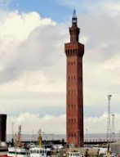  This unit explores the history of our local area. The children will study how several aspects of national history are reflected in the locality (this can go beyond 1066) and explore a significant site within the locality.
Year 5/6 |  |  | World War II and Local History  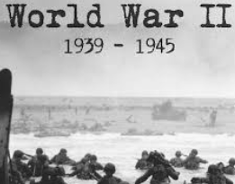  This unit explores how World War Two began and gives the children a wider understanding of how concepts such as empire influenced Hitler and his plan to dominate Europe. The children will explore the significance of the Battle of Britain and in lesson 7, complete a local study, looking at a range of sources from different regions of the United Kingdom. |  |  | Crime and  Punishment  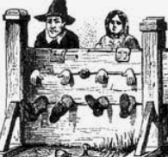  This unit explores how crime and punishment has changed over time in Britain. Children will explore what was seen as a crime over time and the different gruesome punishments that were handed out to criminals. The children will find out about the development of the police force from the Victorian period right through to the new millennium.

