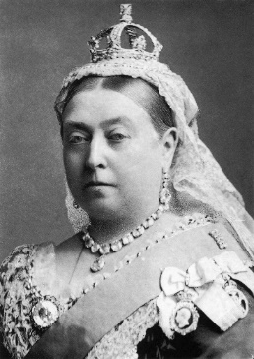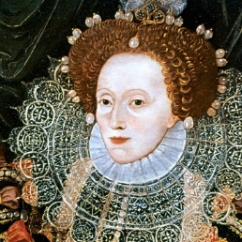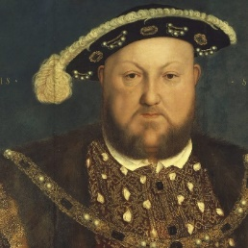

Magnificent Monarchs

Science – Plants

\* To identify and describe the functions of different parts of flowering plants: roots, stem/trunk, leaves and flowers.

\* To investigate the way in which water is transported within plants.

\* To explore the part that flowers play in the life cycle of flowering plants, including pollination, seed formation and seed dispersal.

\* Describe what plants need in order to grow and stay healthy

Art – Portraits

\* To evaluate portraits from the past.

\* To experiment with shading.

\* To draw an accurate representation of a person’s face.

PSHE – Sleep, food and hygiene

\* To learn simple self-care techniques.

\* To understand the importance of sufficient good quality sleep.

\* To understand what constitutes a healthy diet.

\* To understand about dental health and the benefits of good oral hygiene.

RE – Thankfulness

\* To understand the importance of giving thanks.

\* To understand and compare how other religions give thanks.

Languages – Introduction

\* To find France on a map.

\* To say how I feel in French.

\* To learn to count from 1 to 10 in French.

Design and Technology – Making a puppet

\* To select from a wide range of tools and equipment.

\* To generate, develop and communicate ideas.

\* To evaluate ideas against design criteria.

History – Monarchs

\* To understand events beyond living memory that are significant.

\* To sequence significant information in chronological order.

\* To study and evaluate royal portraits.

\* To evaluate the significance of historical figures.

Computing – Information Technology/Computer Science

\* To save and organise photos.

\* To use photo editing apps confidently.

\* To be able to use sending techniques such as AirDrop.

\* To understand basic coding conditions.

\* To create a simple algorithm.

\* To understand how to create simple movement.

PE – Striking and Fielding/Athletics

Striking and Fielding

\* To be able to track a rolling ball and collect it.

\* To develop accuracy in throwing techniques.

\* To develop striking for distance and accuracy.

\* To develop decision making.

Athletics

\* To develop the sprinting techniques.

\* To develop changeover in relay events.

\* To develop jumping techniques in a range of approaches and take off positions.

\* To develop throwing skills.