KS2 Languages LTP
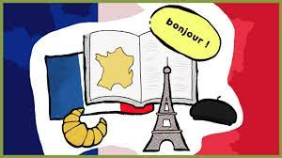
2023-24 version 2
 | Autumn 1 | Spring 1 | Summer 1
Year 3/4 Owl | Je me presente  (Presenting myself I) | La phonétique  (Phonics & Pronunciation)  Lesson 1 only  As Tu un animal?  (Animals E) | Je peux…  (I am able E)
Year 4/5 Kestrel | Je me presente  (Presenting myself I)  Numbers (0-20) | La phonétique  (Phonics & Pronunciation)  Lesson 2 and 3 only  Les Legumes  (Vegetables E) | Chez Moi  (My home I)
Year 6 Eagle | Ma Famille  (My family I)  Numbers (0-100) | La phonétique  (Phonics & Pronunciation)  Lesson 4 only  Les vetements  (Clothes I)  Numbers to 100 | Au salon de thé…  (At the Tea Room I)  Revision of Numbers/Day of the week/ Months of the Year
Language Angels
https://www.languageangels.com/schools/
PLEASE ALSO CONSIDER THE FOLLOWING STATEMENTS FROM THE NATIONAL CURRICULUM WHILST TEACHING THE UNITS ABOVE
- write at varying length, for different purposes and audiences, using the variety of grammatical structures that they have learnt
- discover and develop an appreciation of a range of writing in the language studied.
- appreciate stories, songs, poems and rhymes in the language

