KS2 Languages LTP
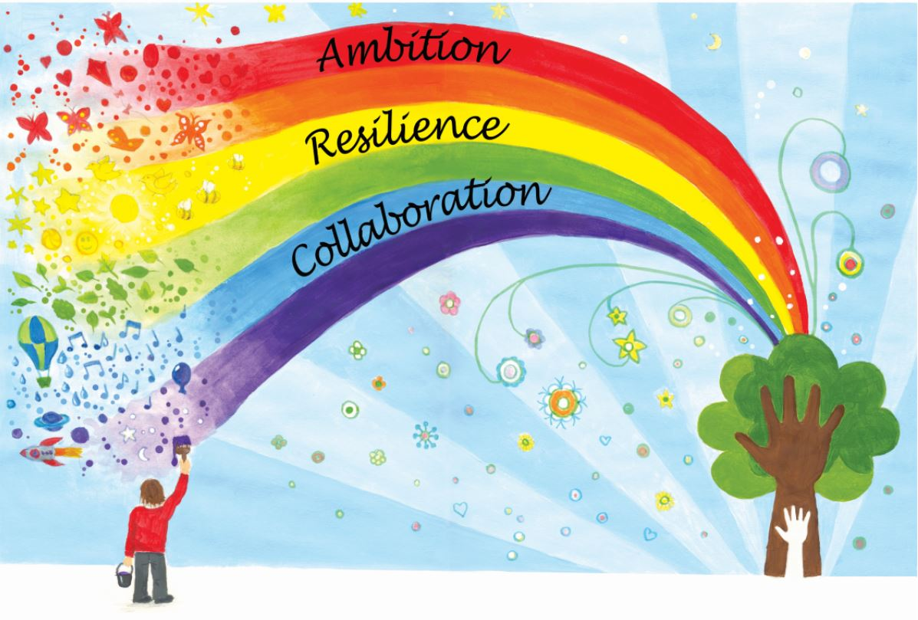
2021-22
 | Autumn 1 | Spring 1 | Summer 1
Year 4 Owl | Greetings  Asking And Saying How You Are  Numbers (0-10) | Simple Conversation  (Name, Age, Where You Live)  Animals  (Early)  Food (fruit and vegetables) | Days Of The Week  Months Of The Year  Colours and Numbers
Year 5 Kestrel | Greetings  Asking And Saying How You Are  Colours  Numbers (0-10) | What is the date  Days/Months of the Year  (intermediate)  Weather  (Intermediate)  Numbers to 50 | In the Classroom  (Intermediate)  I can  Je Peux  Numbers to 50
Year 6 Eagle | Shops in Town  Opening Hours | The family  (intermediate)  In the Classroom  (Intermediate)  Clothes  (Intermediate)  Numbers to 50 | Weather  (Intermediate)  Weather Forecast  The Home  (Intermediate)  At the Café  (Intermediate)  Revision of Numbers/Day of the week/ Months of the Year
Language Angels
https://www.languageangels.com/schools/
PLEASE ALSO CONSIDER THE FOLLOWING STATEMENTS FROM THE NATIONAL CURRICULUM WHILST TEACHING THE UNITS ABOVE
- write at varying length, for different purposes and audiences, using the variety of grammatical structures that they have learnt
- discover and develop an appreciation of a range of writing in the language studied.
- appreciate stories, songs, poems and rhymes in the language

