KS2 Languages LTP- Progression and coverage
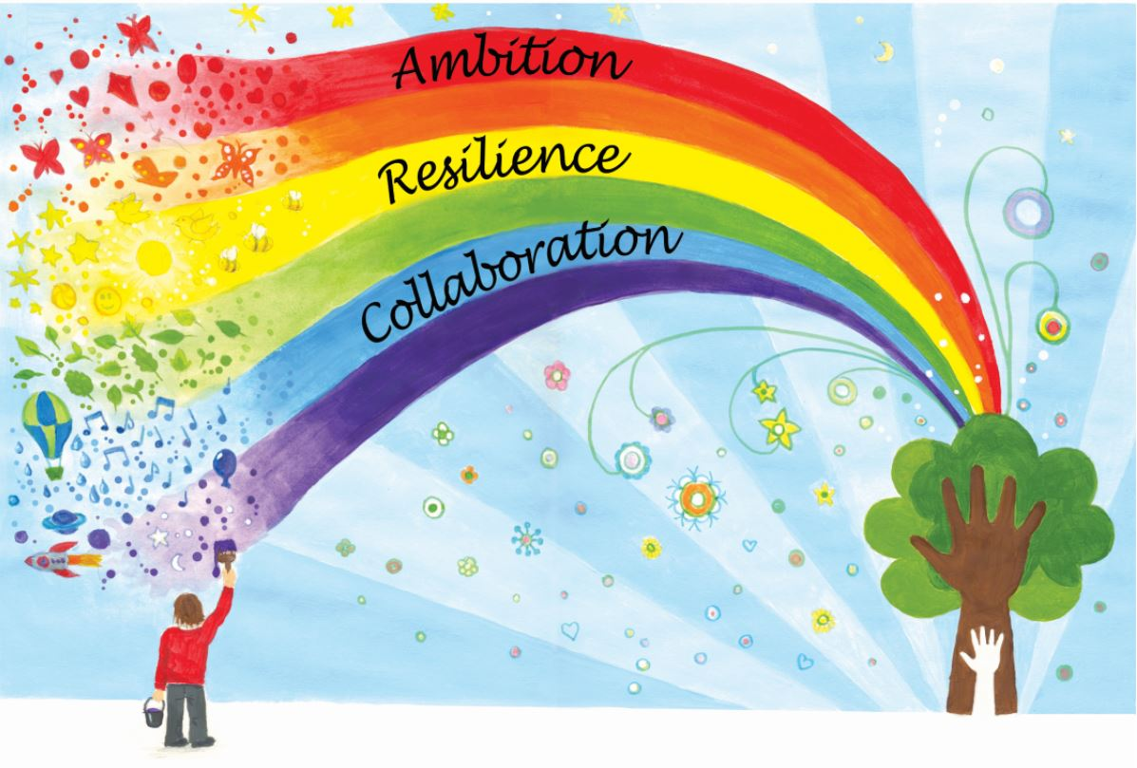
2023-24
 | Autumn 1 | Spring 1 | Summer 1
Year 3/4 Owl | Je me presente  (Presenting myself I)  Listening  - Listen attentively to spoken language and show understanding by joining in and responding  - Engage in conversations; ask and answer questions; express opinions and respond to those of others; seek clarification and help.  Speaking  - Engage in conversations; ask and answer questions; express opinions and respond to those of others; seek clarification and help.  - Speak in sentences, using familiar vocabulary, phrases and basic language structures  - Develop accurate pronunciation and intonation so that others understand when they are reading aloud or using familiar words and phrases.  - Present ideas and information orally to a range of audiences.  Reading  - Read carefully and show understanding of words, phrases and simple writing  - Broaden their vocabulary and develop their ability to understand new words that are introduced into familiar written material, including through using a dictionary.  Writing  - Write phrases from memory, and adapt these to create new sentences, to express ideas clearly  Grammar  - Understand basic grammar appropriate to the language being studied, including (where relevant): feminine, masculine and neuter forms and the conjugation of high‐frequency verbs; key features and patterns of the language; how to apply these to build sentences; and how these differ from or are similar to English. | As Tu un animal?  (Animals E)  Listening  - Listen attentively to spoken language and show understanding by joining in and responding.  Speaking  - Engage in conversations; ask and answer questions; express opinions and respond to those of others; seek clarification and help.  - Speak in sentences, using familiar vocabulary, phrases and basic language structures.  - Develop accurate pronunciation and intonation so that others understand when they are reading aloud or using familiar words and phrases.  - Present ideas and information orally to a range of audiences. Read carefully and show understanding of words, phrases and simple writing  Reading  - Broaden their vocabulary and develop their ability to understand new words that are introduced into familiar written material, including through using a dictionary.  Writing  - Write phrases from memory, and adapt these to create new sentences, to express ideas clearly.  - Describe people, places, things and actions orally and in writing.  Grammar  - Understand basic grammar appropriate to the language being studied, including (where relevant): feminine, masculine and neuter forms and the conjugation of high‐frequency verbs; key features and patterns of the language; how to apply these to build sentences; and how these differ from or are similar to English. | Je peux…  (I am able E)  Listening  - Listen attentively to spoken language and show understanding by joining in and responding.  Speaking  - Engage in conversations; ask and answer questions; express opinions and respond to those of others; seek clarification and help.  - Speak in sentences, using familiar vocabulary, phrases and basic language structures.  - Develop accurate pronunciation and intonation so that others understand when they are reading aloud or using familiar words and phrases.  - Present ideas and information orally to a range of audiences. Read carefully and show understanding of words, phrases and simple writing  Reading  - Broaden their vocabulary and develop their ability to understand new words that are introduced into familiar written material, including through using a dictionary.  Writing  - Write phrases from memory, and adapt these to create new sentences, to express ideas clearly.  - Describe people, places, things and actions orally and in writing.
Year 4/5 Kestrel | Je me presente  (Presenting myself I) Numbers (0-20)  Listening  - Listen attentively to spoken language and show understanding by joining in and responding  - Engage in conversations; ask and answer questions; express opinions and respond to those of others; seek clarification and help.  Speaking  - Engage in conversations; ask and answer questions; express opinions and respond to those of others; seek clarification and help.  - Speak in sentences, using familiar vocabulary, phrases and basic language structures  - Develop accurate pronunciation and intonation so that others understand when they are reading aloud or using familiar words and phrases.  - Present ideas and information orally to a range of audiences.  Reading  - Read carefully and show understanding of words, phrases and simple writing  - Broaden their vocabulary and develop their ability to understand new words that are introduced into familiar written material, including through using a dictionary.  Writing  - Write phrases from memory, and adapt these to create new sentences, to express ideas clearly  Grammar  - Understand basic grammar appropriate to the language being studied, including (where relevant): feminine, masculine and neuter forms and the conjugation of high‐frequency verbs; key features and patterns of the language; how to apply these to build sentences; and how these differ from or are similar to English. | Les Legumes  (Vegetables E)  Listening  - Listen attentively to spoken language and show understanding by joining in and responding.  Speaking  - Engage in conversations; ask and answer questions; express opinions and respond to those of others; seek clarification and help.  - Speak in sentences, using familiar vocabulary, phrases and basic language structures.  - Develop accurate pronunciation and intonation so that others understand when they are reading aloud or using familiar words and phrases.  - Present ideas and information orally to a range of audiences. Read carefully and show understanding of words, phrases and simple writing  Reading  - Broaden their vocabulary and develop their ability to understand new words that are introduced into familiar written material, including through using a dictionary.  Writing  - Write phrases from memory, and adapt these to create new sentences, to express ideas clearly.  Grammar  - Understand basic grammar appropriate to the language being studied, including (where relevant): feminine, masculine and neuter forms and the conjugation of high‐frequency verbs; key features and patterns of the language; how to apply these to build sentences; and how these differ from or are similar to English | Chez Moi  (My home I)  Listening  - Listen attentively to spoken language and show understanding by joining in and responding  - Engage in conversations; ask and answer questions; express opinions and respond to those of others; seek clarification and help.  Speaking  - Engage in conversations; ask and answer questions; express opinions and respond to those of others; seek clarification and help.  - Speak in sentences, using familiar vocabulary, phrases and basic language structures  - Develop accurate pronunciation and intonation so that others understand when they are reading aloud or using familiar words and phrases.  - Present ideas and information orally to a range of audiences.  Reading  - Read carefully and show understanding of words, phrases and simple writing  - Broaden their vocabulary and develop their ability to understand new words that are introduced into familiar written material, including through using a dictionary.  Writing  - Write phrases from memory, and adapt these to create new sentences, to express ideas clearly  - Describe people, places, things and actions orally and in writing.  Grammar  - Understand basic grammar appropriate to the language being studied, including (where relevant): feminine, masculine and neuter forms and the conjugation of high‐frequency verbs; key features and patterns of the language; how to apply these to build sentences; and how these differ from or are similar to English.
Year 6 Eagle | Ma Famille  (My family I) Numbers (0-100)  Listening  - Listen attentively to spoken language and show understanding by joining in and responding  - Engage in conversations; ask and answer questions; express opinions and respond to those of others; seek clarification and help.  Speaking  - Engage in conversations; ask and answer questions; express opinions and respond to those of others; seek clarification and help.  - Speak in sentences, using familiar vocabulary, phrases and basic language structures  - Develop accurate pronunciation and intonation so that others understand when they are reading aloud or using familiar words and phrases.  - Present ideas and information orally to a range of audiences.  Reading  - Read carefully and show understanding of words, phrases and simple writing.  - Appreciate stories, songs, poems and rhymes in the language.  - Broaden their vocabulary and develop their ability to understand new words that are introduced into familiar written material, including through using a dictionary.  Writing  - Write phrases from memory, and adapt these to create new sentences, to express ideas clearly  - Describe people, places, things and actions orally and in writing.  Grammar  - Understand basic grammar appropriate to the language being studied, including (where relevant): feminine, masculine and neuter forms and the conjugation of high‐frequency verbs; key features and patterns of the language; how to apply these to build sentences; and how these differ from or are similar to English. | Les vetements  (Clothes I) Numbers to 100  Listening  - Listen attentively to spoken language and show understanding by joining in and responding  Speaking  - Engage in conversations; ask and answer questions; express opinions and respond to those of others; seek clarification and help.  - Speak in sentences, using familiar vocabulary, phrases and basic language structures  - Develop accurate pronunciation and intonation so that others understand when they are reading aloud or using familiar words and phrases.  - Present ideas and information orally to a range of audiences.  Reading  - Read carefully and show understanding of words, phrases and simple writing.  - Broaden their vocabulary and develop their ability to understand new words that are introduced into familiar written material, including through using a dictionary.  Writing  - Write phrases from memory, and adapt these to create new sentences, to express ideas clearly  - Describe people, places, things and actions orally and in writing.  Grammar  - Understand basic grammar appropriate to the language being studied, including (where relevant): feminine, masculine and neuter forms and the conjugation of high‐frequency verbs; key features and patterns of the language; how to apply these to build sentences; and how these differ from or are similar to English. | Au salon de thé…  (At the Tea Room I)  Revision of Numbers/Day of the week/ Months of the Year  Listening  - Listen attentively to spoken language and show understanding by joining in and responding  - Engage in conversations; ask and answer questions; express opinions and respond to those of others; seek clarification and help.  Speaking  - Engage in conversations; ask and answer questions; express opinions and respond to those of others; seek clarification and help.  - Speak in sentences, using familiar vocabulary, phrases and basic language structures  - Develop accurate pronunciation and intonation so that others understand when they are reading aloud or using familiar words and phrases.  - Present ideas and information orally to a range of audiences.  Reading  - Read carefully and show understanding of words, phrases and simple writing.  - Appreciate stories, songs, poems and rhymes in the language.  - Broaden their vocabulary and develop their ability to understand new words that are introduced into familiar written material, including through using a dictionary.  Writing  - Write phrases from memory, and adapt these to create new sentences, to express ideas clearly  - Describe people, places, things and actions orally and in writing.  Grammar  - Understand basic grammar appropriate to the language being studied, including (where relevant): feminine, masculine and neuter forms and the conjugation of high‐frequency verbs; key features and patterns of the language; how to apply these to build sentences; and how these differ from or are similar to English.
Language Angels
https://www.languageangels.com/schools/
PLEASE ALSO CONSIDER THE FOLLOWING STATEMENTS FROM THE NATIONAL CURRICULUM WHILST TEACHING THE UNITS ABOVE
- write at varying length, for different purposes and audiences, using the variety of grammatical structures that they have learnt
- discover and develop an appreciation of a range of writing in the language studied.
- appreciate stories, songs, poems and rhymes in the language

