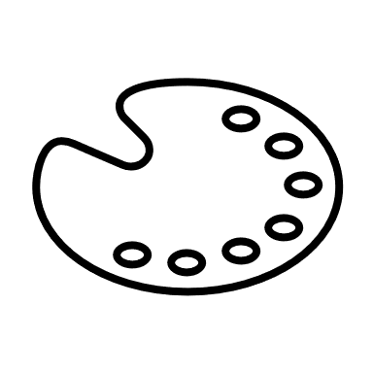

Short date (Y1-Y3),

Roman numeral date (Year 4-6)

Deeper learning and test-style tasks

Reasoning and problem-solving tasks

Varied fluency tasks

Share teaching slides

Extending knowledge

* To challenge learners, all children should be given the opportunity to complete deeper learning and test-style tasks
* Live marking (AfL) done throughout lesson

Reasoning and problem-solving

* Children complete a variety of reasoning and problem-solving questions
* Some children may need to continue using concrete resources or require adult for support
* Live marking (AfL) done throughout lesson

Fluency

* Children complete a variety of fluency questions
* Some children may need to continue using concrete resources or require adult for support
* Live marking (AfL) done throughout lesson

Input

* Follow ‘I do, We do, You do’ approach
  + **I do** – teacher fully models and explains
  + **We do** – teacher models another example, allowing input/discussions from children
  + **You do** – children complete example on whiteboards, independent or collaborative







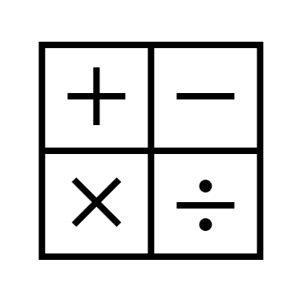



Mark and assess

Assessment

* Teacher marks books daily
* Teacher to update Bromcom weekly
* Interventions to be completed same day, where possible
* Give children opportunity to correct and revisit in red pen

Retrieval symbol written next to any retrieval practice

Questions stuck on left,

working out/ explanations on the right

Pencils and rulers for questions,

red pen for corrections and revisits

Working walls updated, daily

Bromcom assessment updated, weekly

**Maths Musts**

Retrieval starter



Retrieval

* Daily retrieval practice
* Questions should focus on year group essential knowledge (EK) objectives and gaps in knowledge identified from teacher assessment