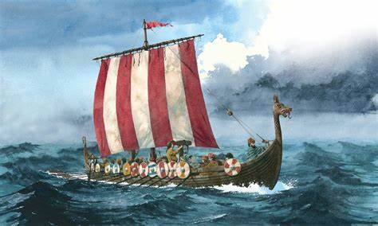
Hello Year 4s!

Your challenge over the next three weeks is to complete activities related to the Anglo-Saxons and Vikings in order to learn about this part of history. The result will be a comprehensive piece of work showing all you have learned; this can be presented as a written report, a word-processed report or a PowerPoint presentation.

Activity 1
Using the timeline cards provided create a timeline of significant events from 410AD to 1066AD.

Activity 2
Complete the sheet provided about Saxon Shore Forts. Use maps, including those online, to locate ‘Saxon shore forts’, built by the Romans in the middle of the 3rd century to repel the seaborne Saxon raiders.
Note: Saxon shore forts were Roman coastal defensive forts, built in response to the appearance of seaborne Saxon raiders from the middle of the 3rd century. The forts were built along the coast mostly on points that the Romans felt were vulnerable to invasion.

Activity 3
Research the everyday life of Anglo-Saxon settlers. Record your research in any way you choose. Focus on homes, farming, food, hierarchy within a kingdom, crime and punishment, beliefs, customs, fighting and clothing.
Note: From AD 600 onwards, the permanent settled population of Britain, a mixture of the indigenous people and the invading Saxons, became known as Anglo-Saxons.

Activity 4
Locate the following places on a map and find out the significance of them: Cadbury Castle, the Shropshire village of Wroxeter, Mitchell’s Fold Stone Circle, Glastonbury Tor, Tintagel in Cornwall and Slaughterbridge.

Activity 5
Find out where the Saxon invaders settled in Britain, searching for towns and villages that have names derived from Saxon words. Draw a sketch map of England to show where these towns and villages are located.
Note: One way to trace Saxon settlements is through place names such as -burh, -feld, -ing, -ton, -wick, -den and -ham.

Activity 6
Use maps of Europe to identify countries from which the Viking raiders came. Draw a sketch map of Europe to show their findings. Discover the importance of the city of York.
Note: The Vikings came from Norway, Sweden, and Denmark and raided as far as Russia. They even discovered Iceland! The Vikings captured the northern English city of York in AD 866, with the city becoming known as Viking ‘Jorvik’.

Activity 7
Research aspects of Viking life, such as ships, weapons, life for women and children, famous Vikings, homes, farming, warriors, explorations and treasures.
Note: The Viking Age in Britain began about AD 793 and lasted over 200 years. Bands of fierce raiders began to once again attack England’s shores just like the Anglo-Saxons had done 400 years before.

Activity 8
Research Viking beliefs about death and the afterlife. Compare the ways in which Vikings of different class and importance were buried, from magnificent Viking ship burials of the wealthy and important, to the underground chambers where poor peasants were buried. Produce a class set of questions and use research methods to find the answers.

Activity 9
Create a fact file for each different Viking god. If you are feeling particularly adventurous, try creating a set of Viking Gods Top Trumps cards.

Activity 10
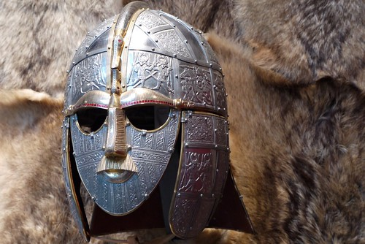
Create your final piece that brings together all of the knowledge you have gathered. In your work, include details about Anglo-Saxon life, Viking life and a comparison between the two. What were the similarities/differences? Just like we do at school, plan, draft, then edit, and improve your work checking carefully for punctuation and spelling errors.

I look forward to seeing your final pieces! Remember to keep accessing TT Rockstars and Prodigy for your maths work.

Mrs Page

