Spring Two

Phonics scheme letters and sounds
 |  | 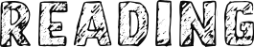 | 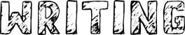
20.2.23 | Phase 3 assessment week  Said, like, have, so, do | 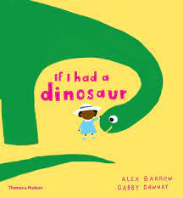 | - ‘My pet dinosaur’ caption writing  - Dinosaur labeling
27.2.23 | Phase 4  Consonant digraphs:  ch, sh, th, ng  some, come, were, there, little
6.3.23 | Phase 4  CCVCC/ CCCVC/ CCCVCC  some, come, were, there, little | 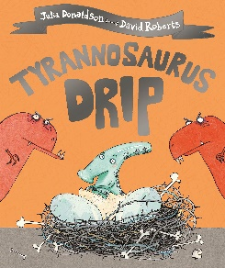 | - Herbivore dinner design for Tyranosourus drip, with labels  - Speech bubble writing
13.3.23 | Phase 4 consolidation  one, when, out, what
20.3.23 | Revist and consolidate Phase 3  Revisit phase 3 tricky words | 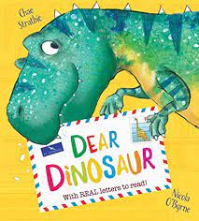 | - Letter writing  - Postcard writing  - Birthday card writing
27.3.23 | Revist and consolidate Phase 3  Revisit phase 3 tricky words

