EMERGENCY HOME LEARNING LINKS |  | Phonics learning at home will be provided through mixture of online games, interactive videos and suggested phonics activities provided through a teacher prepared ‘Daily Phonics Grid’.
04.01.2021 and  11.01.2021 | Phase 3 Consonant Diagraphs:  ch, sh, th, ng |  | 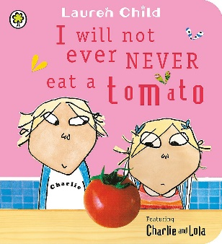 | - Likes and dislikes writing  ‘my favourite food’ and ‘my least favourite food’  - Speech/thought bubbles
Phase 3 Vowel Diagraphs:
ai, ee, oo (long and short)

18.01.2021  and  25.01.2021 | Phase 3 Vowel Diagraphs:  oa, ar, or, igh
Phase 3 Vowel Diagraphs:
ur, ow, oi, ear

01.02.2021  and  08.01.2021 | Phase 3 Vowel Diagraphs:  er, air, ure |  | 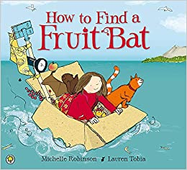
 | Phase 3 consolodation

