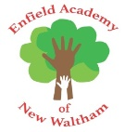

Phonics scheme letters and sounds
 |  | 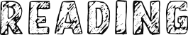 | 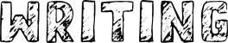
05.01.2022 | Phase 2 – Set 5:  l, ll, ss | 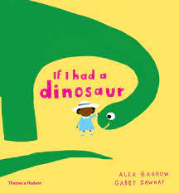 | - ‘My pet dinosaur’ caption writing  - Dinosaur labeling
10.01.2022 | Phase 2 Consolidation:  (including assessments)  a, b, c, ck, d, e, f, ff, g, h, i, k, l, ll, m, n, o, p, r, s, ss, t, u
17.01.2022 | Phase 3 - Set 6:  j, v, w, x | 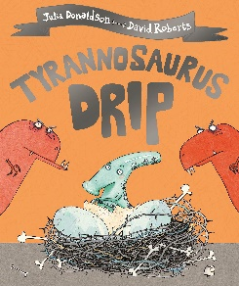 | - Herbivore dinner design for Tyranosourus drip, with labels  - Speech bubble writing
24.01.2022 | Phase 3 – Set 7:  y, z, zz, q
31.01.2022 | Consonant digraphs:  ch, sh, th, ng | 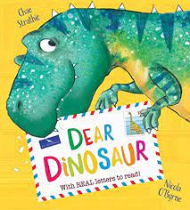 | - Letter writing  - Postcard writing  - Birthday card writing
07.02.2022 | Vowel digraphs:  ai, ee, igh, oa

