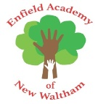

EMERGENCY HOME LEARNING LINKS |  | Phonics learning at home will be provided through mixture of online games, interactive videos and suggested phonics activities provided through a teacher prepared ‘Weekly Phonics Grid’.
22.02.2021 | Phase 3 Consolodation  General games and overlearning until full class returns on the 8th. |  | 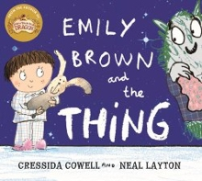  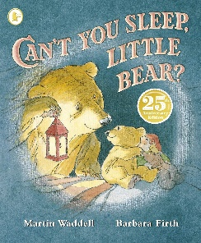 | - Sentence writing about the ‘cuddly’ the children will make  - Magic Medicine Recipe Writing  - Little Book Writing (what could Daddy Bear be reading about?)
01.03.2021 | Phase 3 Consolodation  Phase 3 Tricky Words Focus.
08.03.2021 | Phase 3 Consolodation  Consonant digraphs: ch, sh, th, ng |  | 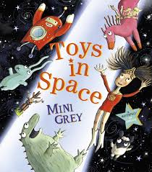  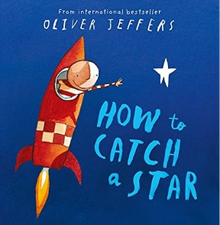 | - Captions about own star creation  - Book recount sentences  - Toy’s speech bubbles  - Lost toy label writing
15.03.2021 | Phase 3 Consolodation  Vowel digraphs: ai, ee, igh, oa, oo
22.03.2021 | Phase 3 Consolodation  Vowel digraphs: ar, or, ur, ow, oi |  | 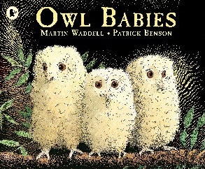  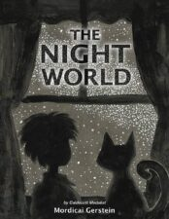 | - Letter to mummy owl  - Information text about owls  - Caption writing
29.03.2021 | Phase 3 Consolodation  Vowel digraphs: ear, air, ure, er

