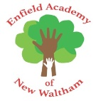

Phonics scheme letters and sounds
 |  | 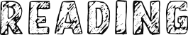
21.02.2022 | Bug Club Phonics Set 7 - 8 Sounds:  - y, z, zz, qu  - ch, sh, th, ng  Irregular words:  me, be, he, my, by, she, they | 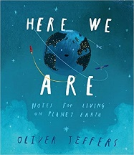 | - Caption Writing  - Embedding phonics sounds
28.02.2022
07.03.2022 | Bug Club Phonics Set 9 - 11 Sounds:  - ai, ee, igh, oa, oo (long), oo (short)  - ar, or, ur, ow, oi  - ear, air, ure, er  Irregular words:  we, are, you, all, was, give, live  Consolidate learning | 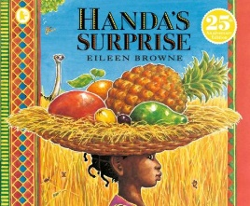 | - Summary Writing  - Diary Writing
14.03.2022
21.03.2022 |  | 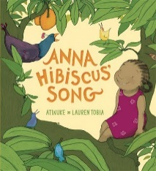 | - Animal Names and descriptions
28.03.2022

