Spring Two: Dangerous Dinosaurs

Phonics scheme Bug Club Phonics
The children will continue to explore phase 3 phonics. We will be focusing on the tricky words:
Me, be, are, they, my, by, she, you, was and all
15/04/2024 | Revisit Phase 3 we a focus on blending and reading | 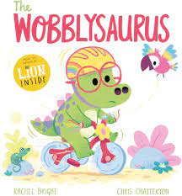 | - Character description of Wobblysaurus  - Children to create a wand that can take worries of trying new things away  - Sentence writing applying phase 3 sounds
22/04/2024 | Revisit Phase 3 we a focus on blending and reading | 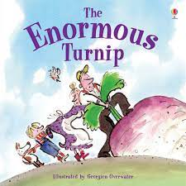 | - Act out the story  - Plan a sentence verbally  - Pick out CEW/HFW
29/04/2024 | Revisit Phase 3 we a focus on blending and reading |  | - Setting description  - Predictions of what will happen next  - Speech bubble writing
6/05/2024 | Revisit Phase 3 we a focus on blending and reading | 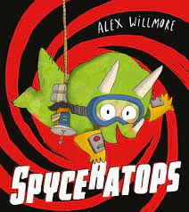 | - Children to become spys, what would they wear/do?  - Get the children to create and decribe their spy bag  - Apply handwritng knowledge
13/05/2024 | Revisit Phase 3 we a focus on blending and reading | 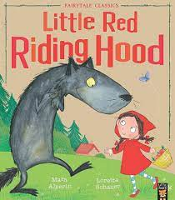 | - Charcter description  - Story maps  - Focus on spelling CVVC words
20/05/2024 | Revisit Phase 3 we a focus on blending and reading | 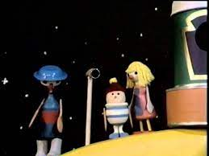 | - Discuss setting of ‘Button Moon’.  - Design a rocket to get them to the moon  - Begin to identify description/extend vocabulary

