 |  | 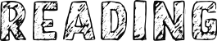 | 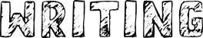
19.04.2021 | Phase 3 Consolidation  The first 2 weeks of the summer term will be spent recapping phase 3 vowel digraphs, revisiting phase 3 tricky words and consolodating grapheme ‘gaps’ that were identified through assessment. | 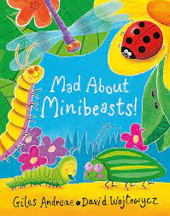 | - Minibeast Fact File  - Minibeast Alphabet
25.04.2021
02.05.2021 | Phase 4  • Recalling phase 2 & 3 graphemes  • Reading and spelling CVCC words  • Reading sentences  • Writing sentences with tricky words  • Reading adjacent consonants  Tricky words:  said so he she me we be | 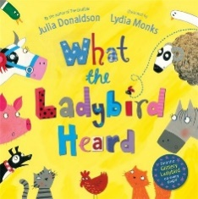 | - Caption/setence writing  - Wanted poster  - Mini book making
09.05.2021 | Phase 4  • Recalling phase 2 & 3 graphemes  • Reading and spelling CCVC words  • Reading sentences  • Writing sentences with CVCC/CCVC  tricky words  • Reading adjacent consonants  Tricky words:  said have like some come was you
16.05.2021 | Phase 4  • Recalling phase 2 & 3 graphemes  • Reading and writing words with  adjacent consonants  • Reading and making sentences  • High frequency words  • Reading adjacent consonants  Tricky words:  were there little one they all are | 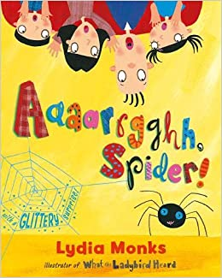 | - Message writing to the spider  - Label a diagram of a spider  - ‘Why is a spider a good pet?’
23.05.2021 | Phase 4  • Recalling phase 2 & 3 graphemes  • Reading and writing words with adjacent consonants  • Writing and reading sentences  • High frequency words  • Writing words with adjacent consonants  • Polysyllabic words  Tricky words:  do when out what my her

