 |  | 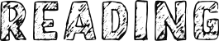
08.06.2022 | Phase 3  Recap Tricky Words and Trickier Digraphs  Phase 3 Phonics Assessments | 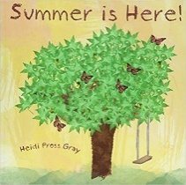  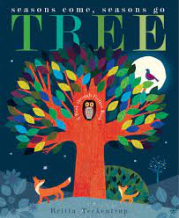 | - Signs of summer writing prompt – what are the signs of summer?
13.06.2022 | Phase 4  • Recalling phase 2 & 3 graphemes  • Reading and spelling CVCC words  • Reading sentences  • Writing sentences with tricky words  • Reading adjacent consonants  Tricky words:  said so he she me we be
20.06.2022 | Phase 4  • Recalling phase 2 & 3 graphemes  • Reading and spelling CCVC words  • Reading sentences  • Writing sentences with CVCC/CCVC  tricky words  • Reading adjacent consonants  Tricky words:  said have like some come was you | 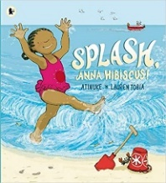 | - Postcard to Anna  - My favourite sea creature fact file
27.06.2022 | Phase 4  • Recalling phase 2 & 3 graphemes  • Reading and writing words with  adjacent consonants  • Reading and making sentences  • High frequency words  • Reading adjacent consonants  Tricky words:  were there little one they all are
04.07.2022 | Phase 4  • Recalling phase 2 & 3 graphemes  • Reading and writing words with adjacent consonants  • Writing and reading sentences  • High frequency words  • Writing words with adjacent consonants  • Polysyllabic words  Tricky words:  do when out what my her | 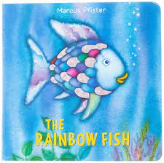  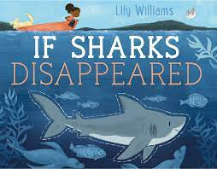 | - Rainbow Fish sentence writing – The Write Stuff  - If Sharks Disapeared Non-Fiction – The Write Stuff
11.07.2022 | Phase 4 General Consolidation
18.07.2022

