Week Commencing: | White Rose Phase
EVERY WEEK | Throughout the classroom environment, children are given opportunities to practice, embed and deepen their mathematical understanding as part of daily practice. Mathematical resources and challenges are constant within continuous provision, seeking to promote a love of mathematics and a genuine interest in mathematical exploration. We follow the White Rose Maths Scheme of learning, which divides learning into areas of focus in order for learning to delve deeply into specific skills, with clear progression throughout the year. In accordance with this, there are constant opportunities to gain an understanding of: the one-one principle, the stable-order principle, the cardinal principle, the abstraction principle and the order-irrelevance principle. The BBC Series ‘Number Blocks’ is used to support early number understanding; it is a fun favourite of the children!
 | WRM Guidance: | Teacher Directed Input Ideas: | Continuous Provision Ideas:
Week 1  W/C: 19.04.2021  Building 9 and 10 | Bonds to 10  The children explore number bonds to 10 using real objects in different contexts. E.g. There are 10 apples. How many in the tree and how many on the ground? 10 frames or egg boxes (with 10 holes) can be partially filled with objects and the children asked How many more do we need to make a full ten? Other manipulatives such as fingers, bead strings and number shapes are also useful for exploring bonds to 10 | Session One: Making 10 (MTC)  Session Two: Making 10 (MTC)  Session Three: https://www.coolmath4kids.com/manipulatives/ten-frame  Session Four: Ask the children to count out 10 double-sided counters or butter beans. Drop their counters onto a paper plate. How many are red? How many are yellow? Repeat. How many are red and yellow this time? Did anyone get 5 red and 5 yellow? Did anyone get all 10 red? | - You will need: Ten frame cards showing 1- 10 (5-and-a-bit and pair structure) Memory Game: Place the cards upside down. The children take turns to turn over 2 cards. When they find a pair which add to 10, they keep the cards. The player who collects the most pairs wins.  - Place 10 chairs into 5 rows of 2 to resemble the seats on a bus. Ask: How many passengers are there on the bus? How many more passengers could ride on the bus? How many are getting on or off at the next stop? How many are on the bus now?  - Hide 10 items (rubber ducks, beanbags etc.) around the outside area and chalk a large 10 frame onto the ground. As the children find the items, they put them into the 10 frame. Prompt the children to use the 10 frame to help them see how many they have found and how many are still hiding.
Week 2  W/C: 25.04.2021  Building 9 and 10 | 3D Shape  Children will naturally explore and manipulate 3-D shapes through their block play and modelling. Prompt them to consider which shapes stack and which shapes roll and why that is.  They should be given opportunities to build using a variety of shapes and to construct their own 3-D shapes in different ways.  Children can be introduced to the names of the shapes and be given opportunities to explore similarities and differences between them as they play and to sort them according to what they notice. | Session One: Matching Objects (MTC)  Session Two: Matching 3D objects with real life objects (MTC)  Session Three: Hold up an object for example a crisp tube or a cereal box. Which of the 3-D shapes is this like? Why is it like this? What other items have this shape?  Session Four: Sort the shapes into groups. Ask: ‘Why did you put these shapes together? How is this set different to this one? Is there another way we could sort them?’  Session Five: 3D Printing (MTC) | - Provide a variety of empty boxes, tubes, lids etc. Ask the children to make a model for a particular purpose. E.g. build a bridge for the 3 Billy Goats, a new chair for Baby Bear. Encourage them to tell you about their model. Which shapes were easy to fasten together? Which shapes were difficult to fasten together?  - Provide pictures of buildings such as castles, palaces, mosques, city-scapes. Ask the children to discuss the shapes they can see in the buildings? Encourage the children to design their own models and to extend these by adding arches, bridges and moats.  - Ask the children to make 3-D shapes using the dough. Ask: Which shapes are the easiest to make? Why? Which are harder to make? Why? How did you make the flat sides?
Week 3  W/C: 02.05.2021  Building 9 and 10 | Pattern (2)  Build on the children’s earlier AB pattern work by introducing more complex patterns. The children explore patterns which use items more than once in each repeat for example ABB, AAB, AABB, AABBB.  Again it is important that each pattern you model has at least three full units of repeat. The more units of repeat, the easier it is to identify and continue the pattern.  Encourage the children to say each pattern aloud and to create patterns around the edge of shapes as well as in straight lines. | Session One: Patterns (MTC)  Session Two: Show the children an AB pattern and a similar AAB pattern and ask them to tell you what they notice. What is the same and what is different? Repeat with a similar ABB pattern. What is different this time? Introduce patterns with a deliberate error. This could include an extra item, a missing item or a muddled unit of repeat. Can the children identify the mistake and put it right? https://www.coolmath4kids.com/manipulatives/ten-frame  Session Three: Go on a walk around the school grounds and ask the children to hunt for natural objects to make their patterns such as long sticks, short sticks, dandelions, daisies, leaves, pebbles etc. They could arrange their patterns in straight lines or around the edge of a hoop to create a circular pattern.  Session Four: Movement Patterns (MTC)  Session Five: Provide opportunities for the children to describe, continue and copy patterns including movement patterns along a line or around a circle: stand, sit, stand, sit, stand, sit. Hands on head, hands down, hands on head, hands down. Arms up, arms out, arms down, up, out, down etc. | - Provide the children with a range of loose parts such as buttons, beads, pebbles, shells, or seeds. They can use these to create a variety of different patterns. You can add variety by providing wavy lines, spirals and zig-zags for them to build their patterns along.  - Use 3-D shapes to press patterns into the dough. Can their friends tell which shapes they used and copy the patterns?  They can also make patterns on the dough using loose parts such as shells, stones, beads or buttons.  - Provide frames with a set number of spaces and cubes or counters in different colours. Ask the children to build patterns around the edge putting one item in each space. Ask them to try different patterns to investigate which will fit around the frame exactly and which won’t.
Week 4  W/C: 09.05.2021  To 20 and Beyond! | Building Numbers Beyond 10  Encourage the children to build and identify numbers to 20 (and beyond) using a range of resources. 10 frames, numicon, towers of cubes, rekenreks and bead strings all support the children to see that larger numbers are composted of full 10s and part of the next 10. | Session One: Number Patterns (MTC)  Session Two: Matching Pictorial with Numeral (MTC)  Session Three: Using a set of cards showing pictorial representations and matching numerals. Give one card to each child. Ask them to find their partner. Can they also arrange the cards in order?  Session Four: Ten Frame Fill (MTC)  Session Five: Show the children 11 using the numicon or 10 frame. What do the children notice? Can they see which number is represented? Now build 12. What’s the same? What’s different? Continue the pattern, ask the children to predict what numbers come next and how they could represent each number. What happens when they get to 20 and beyond? | - Can you put the peg on the correct number? (ALL NUMBER CARDS GO UP TO 20)  - Snakes and Ladders 1 – 20 numicon  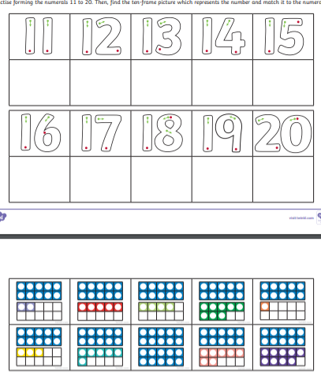  - Can you cut out and stick the correct Numicon with the teen number  - Provide black outlines of a cityscape for the children to fill using the number shapes. Can they see which number has filled each tower? Is there more than one way to do this? Can they design their own cityscape?  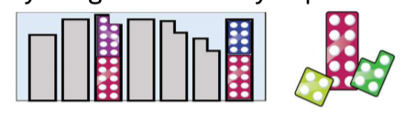
Week 5  W/C: 16.05.2021  To 20 and Beyond! | Counting Patterns Beyond 10  Provide regular opportunities for children to count on and back beyond 10. Representations and numerals can support children to count on and back and notice the repeating 1-9 patterns. Present representations which clearly show the full 10s and part of the 10, for example 14 is one full ten and four. Encourage the children to count on or back from different starting points. | Session One: I count you count: Begin by counting as you point to yourself. When you point to the children they continue the count. This is a great way of creating a rhythmic patterns can the children continue the count. For example I would say 4,5,6 and the children would carry on 7,8,9 then I would say 10, 11, 12 and then the children would carry on 13,14, 15 etc.  Session Two: Missing Number (MTC)  Session Three: Show the children the Numicon pictorial cards for 1 – 15 explain that Mrs Mann has taken one away, can you work out what the missing number is?  Session Four: Ordering Numerals (MTC)  Session Five: Bingo (MTC) | - Provide a set of birthday cards for different ages up to 20. Ask the children to peg the cards onto the washing line in ascending and descending order. During the day keep swapping them around.  - Provide a number track for each child. Children take turns to roll a dice if they roll 1 – 5, they collect the corresponding counters to fill their track. If they roll a 6 they miss a turn.  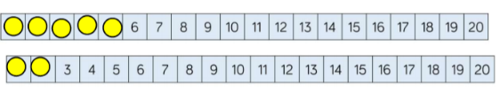
Week 6  W/C: 23.05.2021  To 20 and Beyond! | Spatial Reasoning (1)  Provide regular opportunities for the children to complete jigsaws and shape puzzles. They need opportunities to select and rotate shapes to fill a given space. Encourage them to explain why they chose a particular shape and why a different shape wouldn’t fit. | - Show the children a set of shapes and ask them to find the shape which matches the one you hold up. Add challenged by making the shapes more similar and changing the orientations.  - Read the book Which One Doesn’t Belong? Using the book as a prompt, ask the children to explain which shape is different to all the rest. Can they find more than one answer? Challenge them to find a reason why each of the images could be different to the rest.  - Make sure all the children have got the same amount of cubes and the same colour. Model making a model the children have to copy the model that you have made. Extend by giving them one more cube can they make the same mode.  - Ask the children to match your arrangement to the different tangram pictures talk about how you have to turn the different shapes around.  - Make a simple shape arrangement. Ask the children to finding your matching model. Make the models out of linking cubes.  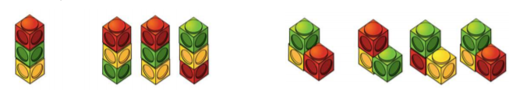 | - Which one doesn’t belong – Christopher Danielson  - Jigsaws and shape puzzles and tangrams  - Pattern blocks and Cuisenaire rods  - Geo boards  - Numicon and base board overlays

