Week Commencing: | White Rose Phase
EVERY WEEK | Throughout the classroom environment, children are given opportunities to practice, embed and deepen their mathematical understanding as part of daily practice. Mathematical resources and challenges are constant within continuous provision, seeking to promote a love of mathematics and a genuine interest in mathematical exploration. We follow the White Rose Maths Scheme of learning, which divides learning into areas of focus in order for learning to delve deeply into specific skills, with clear progression throughout the year. In accordance with this, there are constant opportunities to gain an understanding of: the one-one principle, the stable-order principle, the cardinal principle, the abstraction principle and the order-irrelevance principle. The BBC Series ‘Number Blocks’ is used to support early number understanding; it is a fun favourite of the children!
 | WRM Guidance: | Teacher Directed Input Ideas: | Continuous Provision Ideas:
Week 1  W/C: 15.04.2024  To 20 and Beyond | Building Numbers Beyond 10  Encourage the children to build and identify numbers to 20 (and beyond) using a range of resources. 10 frames, numicon, towers of cubes, rekenreks and bead strings all support the children to see that larger numbers are composted of full 10s and part of the next 10. | Session One: Number Patterns (MTC)  Session Two: Matching Pictorial with Numeral (MTC)  Session Three: Using a set of cards showing pictorial representations and matching numerals. Give one card to each child. Ask them to find their partner. Can they also arrange the cards in order?  Session Four: Ten Frame Fill (MTC)  Session Five: Show the children 11 using the numicon or 10 frame. What do the children notice? Can they see which number is represented? Now build 12. What’s the same? What’s different? Continue the pattern, ask the children to predict what numbers come next and how they could represent each number. What happens when they get to 20 and beyond? | - Can you put the peg on the correct number? (ALL NUMBER CARDS GO UP TO 20)  - Snakes and Ladders 1 – 20 numicon  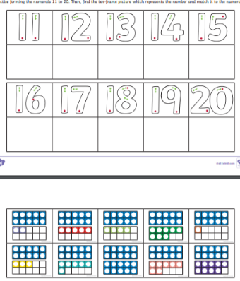  - Can you cut out and stick the correct Numicon with the teen number  - Provide black outlines of a cityscape for the children to fill using the number shapes. Can they see which number has filled each tower? Is there more than one way to do this? Can they design their own cityscape?  - 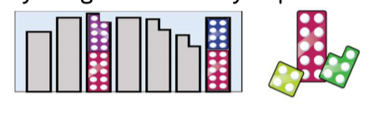
Week 2  W/C: 22.04.2024  To 20 and Beyond | Counting Patterns Beyond 10  Provide regular opportunities for children to count on and back beyond 10. Representations and numerals can support children to count on and back and notice the repeating 1-9 patterns. Present representations which clearly show the full 10s and part of the 10, for example 14 is one full ten and four. Encourage the children to count on or back from different starting points. | Session One: I count you count: Begin by counting as you point to yourself. When you point to the children they continue the count. This is a great way of creating a rhythmic patterns can the children continue the count. For example I would say 4,5,6 and the children would carry on 7,8,9 then I would say 10, 11, 12 and then the children would carry on 13,14, 15 etc.  Session Two: Missing Number (MTC)  Session Three: Show the children the Numicon pictorial cards for 1 – 15 explain that Mrs Mann has taken one away, can you work out what the missing number is?  Session Four: Ordering Numerals (MTC)  Session Five: Bingo (MTC) | - Provide a set of birthday cards for different ages up to 20. Ask the children to peg the cards onto the washing line in ascending and descending order. During the day keep swapping them around.  - Provide a number track for each child. Children take turns to roll a dice if they roll 1 – 5, they collect the corresponding counters to fill their track. If they roll a 6 they miss a turn.  - 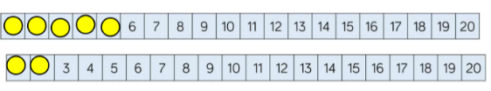
Week 3  W/C: 29.04.2024  How many now? | Add and take away  Children will use a range of strategies to explore adding and subtracting.  We will begin using ten frames and counters, as well as using first, then and now stories to support the children further,  We will look at patterns when adding one more and one less and begin to encourage the children to explain the methods they have used,. | Session One: Add more  Session Two: How many did I add?  Session Three: Take away using teddy bears  Session Four: How many did I subtract?  Session Five: Writing some simple number sentences using + and - signs | - Provide first, then and now frames and animals in a zoo to support the children in telling number stories.  - Children to be able to play on the Topmarks Robot one more and one less game (interactive resource)  - Children to use tens frames and counters to solve addition cards on the tables.  - In the roleplay children will have to take the washing off the line to solve the subtraction, inspired by story ‘Aliens Love Underpants’.
Week 4  W/C: 06.05.2024  Manipulate, compose and decompose | Position and 2D shapes  Children to rotate shapes in different ways, and notice how they have changed, encourage the children to discuss this with an adult.  Using playdough get the children to change the shape of shapes made, how can they do this? Use language like squeeze, change, stretch, alter.  Children to copy and create their own 2D pictures, can they identify the shapes they have used. Children to discuss what is special about these shapes? | Session One: Select a shape for a purpose  Session Two: Rotate shapes  Session Three: Manipulate shapes using playdough cutters and salt dough  Session Four: Explain how I have arranges shapes to my friend  Session Five: Compose shapes in different ways | - Children to use large paper to create print patterns using dinosaur footprints.  - Children to set up print patterns in the creative area for their friends to then complete.  - Use small world objects to create a physical repeated pattern.  - Children to plan and build large structures with the wooden blocks, can they identify the shapes they are using.  - Children to create their own shape pictures.
Week 5  W/C: 13.05.2024  Manipulate, compose and decompose | Position and 2D shapes  Children to rotate shapes in different ways, and notice how they have changed, encourage the children to discuss this with an adult.  Using playdough get the children to change the shape of shapes made, how can they do this? Use language like squeeze, change, stretch, alter.  Children to copy and create their own 2D pictures, can they identify the shapes they have used. Children to discuss what is special about these shapes? | Session One: Decompose shapes  Session Two: Copy 2D shape pictures  Session Three: Explore and make our own 2D shape pictures  Session Four: Find 2D shapes within 3D shapes  Session Five: Print with 3D shapes | - Children to use large paper to create print patterns using 3D shapes.  - Children to set up print patterns in the creative area for their friends to then complete.  - Use building blocks to create and plan different building shapes, can the children explain the shapes they have used and why?  - Children to go on shape hunts around the school and collect different shapes, how do these look different?
Week 6  W/C: 20.05.2024  Sharing and Grouping | Sharing and grouping within 10  Children to be able to understand the language sharing and grouping. Children to use animals to groups them in different ways, focusing on colour, size, number of legs, etc.  Children to be able to share the food between each other, get the children to check they have all got the same amount. | Session One: Explore sharing  Session Two: Children to share the food fairly and check  Session Three: Explore grouping  Session Four: Even and odd sharing  Session Five: Play with and build doubles | Children to share the food out at the teddy bear’s picnic.  Interactive sharing game on Topmarks, sharing the treats between the dogs ‘Fair Shares’.  Children to group the animals in the vets in different ways, discuss with an adult how they have grouped them and why.  Children to paint double spots on the ladybirds.

